AGRITWIN-GH: AGRICULTURAL DIGITAL TWIN FOR SMART GREENHOUSE HORTICULTURE OF TOMATO CULTIVATION
PROJECT REPORT
Submitted
By
ARJUN CHRISTOPHER Reg No: 2201112007
BHUVANALAKSHMI J P Reg No: 2201112009
VANTAPATI RAJA RAJESWARI Reg No: 2201112052

Under the guidance of
Dr. V. GOVINDASAMY
Professor
Department of Information Technology
to the Puducherry Technological University in partial fulfillment of the
requirement for the award of the degree
BACHELOR OF TECHNOLOGY
In
INFORMATION TECHNOLOGY



DEPARTMENT OF INFORMATION TECHNOLOGY
PUDUCHERRY TECHNOLOGICAL UNIVERSITY
PUDUCHERRY – 605014
APRIL 2026
DEPARTMENT OF INFORMATION TECHNOLOGY
PUDUCHERRY TECHNOLOGICAL UNIVERSITY
PUDUCHERRY
BONAFIDE CERTIFICATE

This is Certified that the project work entitled “AGRITWIN-GH: AGRICULTURAL DIGITAL TWIN FOR SMART GREENHOUSE HORTICULTURE OF TOMATO CULTIVATION” is a bonafide record of work done by ARJUN CHRISTOPHER (Reg No: 2201112007), BHUVANALAKSHMI J P (Reg No: 2201112009) and VANTAPATI RAJA RAJESWARI (Reg No: 2201112052) in fulfillment of the requirements for the award of the Degree of Bachelor of Technology in Information Technology of Puducherry Technological University. This work has not been submitted for the award of any other degree of this/or any other institution.

PROJECT GUIDE HEAD OF THE DEPARTMENT
[Dr. V. GOVINDASAMY] [Dr. V. GEETHA]

Submitted for the University Examination held on

INTERNAL EXAMINER EXTERNAL EXAMINER
ACKNOWLEDGEMENT
I am deeply indebted to Dr. V. GOVINDASAMY, Professor, Department of Information Technology, Puducherry Technological University, Pondicherry, for his valuable guidance throughout the tenure of this project.
I also express my heart-felt gratitude to Dr. V. Geetha, Head of the Department for giving constant motivation in succeeding my goal.
With profoundness I would like to express my sincere thanks to Dr. S. Mohan, Honourable Vice Chancellor, Puducherry Technological University, for his kindness in extending the infrastructural facilities to carry out my project work successfully.
I would be failing in my duty if I do not acknowledge the efforts of the Project Co-ordinator, Dr. M.S. Anbarasi and the Project Review Panel members, Dr. S. Kanmani, Dr. P. Boobalan, Dr. P. Maragathavalli, Dr. Santhi Baskaran, Dr. G. Santhi for shaping our ideas and constructive criticisms during project review.
I also express my thanks to all the Faculty and Technical Staff members of the IT department for their timely help and the Central Library for facilitating useful reference materials.
I would be failing in my duty if I don’t acknowledge the immense help extended by my friends, who have always been with me in all my trials and tribulations and encouraging me to complete.

ARJUN CHRISTOPHER Reg No: 2201112007
BHUVANALAKSHMI J P Reg No: 2201112009
VANTAPATI RAJA RAJESWARI Reg No: 2201112052

ABSTRACT
Greenhouse cultivation of high-value crops such as tomatoes faces persistent challenges related to environmental variability, delayed disease detection, inefficient resource utilization, and heavy dependence on reactive manual decision-making. Conventional greenhouse management systems often operate on static thresholds and lack predictive intelligence, making them incapable of anticipating dynamic environmental fluctuations or early-stage disease outbreaks. This limitation results in yield loss, compromised crop quality, and excessive consumption of essential resources such as water, energy, and fertilizers. Furthermore, the absence of integrated plant-health intelligence restricts timely intervention, thereby increasing operational uncertainty and reducing overall system efficiency. To address these limitations, this project presents AgriTwin-GH, a software-based, AI-powered digital twin framework for intelligent and adaptive greenhouse management. The framework constructs a virtual representation of greenhouse operations by integrating environmental data modeling with plant health analysis, enabling continuous monitoring, predictive forecasting, and proactive decision support. Unlike traditional approaches that rely heavily on physical sensor infrastructure, AgriTwin-GH operates using curated open-source greenhouse datasets and plant image data, ensuring cost-effective deployment, scalability, and flexibility for experimentation and real-world adaptation. The system incorporates advanced machine learning and deep learning techniques, including convolutional neural networks for crop growth stage classification and disease detection, as well as temporal models for forecasting environmental conditions and disease progression over short- and medium-term horizons. These capabilities enable early disease risk identification, dynamic assessment of crop health, and anticipation of unfavorable greenhouse conditions. A key component of the framework is the digital twin simulation layer, which performs “what-if” scenario analysis and validates control strategies before implementation, thereby ensuring operational safety and reliability. In addition, AgriTwin-GH integrates a predictive control-oriented decision mechanism that generates optimized recommendations for greenhouse actuation, considering both environmental targets and disease risk constraints. The system emphasizes practical usability by translating complex AI-driven outputs into simple, non-verbal operational alerts using intuitive visual signals, making it highly suitable for labor-intensive greenhouse environments, including those involving semi-skilled or illiterate workers. By transforming greenhouse operations from reactive responses to predictive and preventive management, the proposed framework enhances crop productivity, improves quality consistency, and significantly reduces unnecessary resource consumption. Overall, AgriTwin-GH provides a scalable, resource-efficient, and decision-centric digital twin solution for precision greenhouse horticulture. Its hardware-independent design, combined with predictive intelligence and user-centric interaction, makes it particularly suitable for resource-constrained and small-to-medium-scale farming systems, contributing to sustainable and technology-driven agricultural advancement.
Keywords
Smart Greenhouse, Time-Series Dataset, Plant Image Dataset, Growth Stage Classification, Disease Classification, Model Predictive Control, Environmental Forecasting, Disease Risk Prediction, Precision Agriculture, Multi-Modal Learning, Data-Driven Decision Support, Crop Health Monitoring, Disease Progression Modeling, Growth Progression Modeling, Resource Optimization, 3D Digital Twin, Virtual Greenhouse Simulation, WebGL Visualization

TABLE OF CONTENT
SL.  NO. | TITLE |  |  |  |  |  |  | PAGE NO.
 | ACKNOWLEDGEMENT |  |  |  |  |  |  | ii
 | ABSTRACT |  |  |  |  |  |  | iii
 | LIST OF FIGURES |  |  |  |  |  |  | vii
 | LIST OF TABLES |  |  |  |  |  |  | x
 | LIST OF ABBREVIATIONS |  |  |  |  |  |  | xi
1 | INTRODUCTION |  |  |  |  |  |  | 1
 | 1.1 | Overview of Digital Twin–based Greenhouse Management |  |  |  |  |  | 1
 | 1.2 | Overview of Techniques, Algorithms, Models, and Simulation Methodologies |  |  |  |  |  | 3
 |  | 1.2.1 |  | Data Preprocessing and Feature Engineering |  |  |  | 3
 |  | 1.2.2 |  | Convolutional Neural Networks |  |  |  | 3
 |  | 1.2.3 |  | Transfer Learning |  |  |  | 3
 |  | 1.2.4 |  | Efficientnet Architecture |  |  |  | 3
 |  | 1.2.5 |  | Image Data Augmentation |  |  |  | 4
 |  | 1.2.6 |  | Long Short-Term Memory |  |  |  | 4
 |  | 1.2.7 |  | Chronos |  |  |  | 4
 |  | 1.2.8 |  | Extreme Gradient Boosting |  |  |  | 4
 |  | 1.2.9 |  | Random Forest |  |  |  | 5
 |  | 1.2.10 |  | Ensemble Learning |  |  |  | 5
 |  | 1.2.11 |  | Histogram-Based Gradient Boosting |  |  |  | 5
 |  | 1.2.12 |  | Autoregressive with eXogenous Inputs Model |  |  |  | 5
 |  | 1.2.13 |  | Model Predictive Control |  |  |  | 5
 |  | 1.2.14 |  | Unity-Based Digital Twin Simulation |  |  |  | 6
 | 1.3 | Aligned Sustainable Development Goals |  |  |  |  |  | 6
2 | LITERATURE SURVEY |  |  |  |  |  |  | 8
 | 2.1 | Review of Related Works |  |  |  |  |  | 8
 | 2.2 | Inference From Literature Survey |  |  |  |  |  | 10
3 | PROPOSED AGRITWIN-GH SYSTEM |  |  |  |  |  |  | 13
 | 3.1 | High-level Architecture |  |  |  |  |  | 13
 | 3.2 | System Inputs and Outputs |  |  |  |  |  | 14
 |  | 3.2.1 | System Inputs |  |  |  |  | 14
 |  | 3.2.2 | System Outputs |  |  |  |  | 15
 | 3.3 | System Requirements |  |  |  |  |  | 16
 |  | 3.3.1 | Hardware Requirements |  |  |  |  | 16
 |  | 3.3.2 | Software Requirements |  |  |  |  | 16
 | 3.4 | Project Modules |  |  |  |  |  | 17
 |  | 3.4.1 | Data Processing and AI-based Crop Intelligence |  |  |  |  | 17
 |  |  | 3.4.1.1 |  |  | Overview of the Module |  | 17
 |  |  | 3.4.1.2 |  |  | Task-level Decomposition of the Module |  | 17
 |  |  | 3.4.1.3 |  |  | Module Implementation Details |  | 18
 |  | 3.4.2 | Predictive Analytics and Crop Health Forecasting |  |  |  |  | 24
 |  |  | 3.4.2.1 |  |  |  | Overview of the Module | 24
 |  |  | 3.4.2.2 |  |  |  | Task-level Decomposition of the Module | 25
 |  |  | 3.4.2.3 |  |  |  | Module Implementation Details | 25
 |  | 3.4.3 | Digital Twin Simulation and Intelligent Greenhouse Control |  |  |  |  | 36
 |  |  | 3.4.3.1 |  |  |  | Overview of the module | 36
 |  |  | 3.4.3.2 |  |  |  | Task-level Decomposition of the Module | 36
 |  |  | 3.4.3.3 |  |  |  | Module Implementation Details | 37
4 | RESULTS ANALYSIS AND SYSTEM OUTPUT |  |  |  |  |  |  | 48
 | 4.1 | Comparative Analysis with Existing System |  |  |  |  |  | 48
 |  | 4.1.1 |  |  | Description of Existing Systems |  |  | 48
 |  | 4.1.2 |  |  | Comparison Criteria |  |  | 49
 |  | 4.1.3 |  |  | Comparative Evaluation and System Improvements |  |  | 50
 | 4.2 | System Output Visualization and Interface Results |  |  |  |  |  | 51
 |  | 4.2.1 |  |  | Input Data Samples |  |  | 51
 |  | 4.2.2 |  |  | Model Training and Performance Results |  |  | 53
 |  | 4.2.3 |  |  | System Interface |  |  | 68
 |  | 4.2.4 |  |  | Log Files and Terminal Outputs |  |  | 71
 |  | 4.2.5 |  |  | 3D Greenhouse Environment Visualization |  |  | 72
5 | CONCLUSION |  |  |  |  |  |  | 75
 | DATASETS USED |  |  |  |  |  |  | 76
 | REFERENCES |  |  |  |  |  |  | 77

LIST OF FIGURES

FIGURE NO. | FIGURE TITLE | PAGE NO.
1.1 | Conceptual Digital Twin Architecture for Greenhouse Cultivation | 1
3.1 | High-Level Architecture Diagram of AgriTwin-GH | 14
3.2 | Task-Level Architecture of Data Processing and AI-Based Crop Intelligence Module | 18
3.3 | Data Processing Pipeline Architecture | 19
3.4 | Growth Stage Classification and Disease Detection Workflow | 24
3.5 | Task-Level Architecture of Predictive Analytics and Crop Health Forecasting Module | 25
3.6 | Weather Forecasting Model Architecture | 29
3.7 | Disease Progression Prediction Model Architecture | 32
3.8 | Growth Progression Prediction Model Architecture | 36
3.9 | Task-Level Architecture of Digital Twin Simulation and Intelligent Greenhouse Control Module | 37
3.10 | Closed-Loop Workflow of the Digital Twin Simulation and Control Process | 44
4.1 | Extract of the Dindigul Weather Dataset | 51
4.2 | Tomato Leaf Disease Classification Dataset Samples | 52
4.3 | Tomato Crop Growth Stages Dataset Samples | 52
4.4 | Phase-1 Warm-Up Training Results for Disease Classification Model | 53
4.5 | Phase-2 Fine-Tuning Results for Disease Classification Model | 53
4.6 | Phase-1 Warm-Up Training Results for Growth Stage Classification Model | 54
4.7 | Phase-2 Fine-Tuning Results for Growth Stage Classification Model | 54
4.8 | Processed Greenhouse Environmental Dataset Sample | 55
4.9 | Confusion Matrix of Tomato Disease Detection Model | 55
4.10 | Training Accuracy of the Disease Detection Model | 56
4.11 | Training Loss of the Disease Detection Model | 56
4.12 | Confusion Matrix of Tomato Growth Stage Classification Model | 57
4.13 | Training Accuracy of the Growth Stage Classification Model | 57
4.14 | Training Loss of the Growth Stage Classification Model | 58
4.15 | Exploratory Data Analysis of Observed Dindigul Weather Data from 2024 to 2025 | 59
4.16 | Chronos Model Warm-Up Training Phase Performance | 60
4.17 | Chronos Model Fine-Tuning Phase Performance | 60
4.18 | LSTM Training Performance across Individual Weather Parameters | 61
4.19 | Chronos Model Training Curve and Validation Accuracy after Fine-Tuning | 61
4.20 | Ensemble Weather Forecast Prediction versus Actual Values | 62
4.21 | LSTM Model Training Process for Disease Progression in Notebook Environment | 63
4.22 | LSTM Training Loss Curve for Disease Progression Model | 63
4.23 | GRU Model Training Process for Disease Progression in Notebook Environment | 64
4.24 | Performance Analysis of LSTM and GRU Best Model Checkpoints | 64
4.25 | GRU Training Loss Curve for Disease Progression Model | 65
4.26 | Actual versus Predicted Hours to Next Growth Stage | 65
4.27 | Confusion Matrix for 24-Hour Growth Stage Transition Prediction | 66
4.28 | Confusion Matrix for 48-Hour Growth Stage Transition Prediction | 66
4.29 | Training Performance of Random Forest and XGBoost for Growth Progression | 67
4.30 | LSTM Training of Growth Stage Progression Model | 67
4.31 | Greenhouse Dashboard Interface in Dark Mode | 68
4.32 | Greenhouse Dashboard Interface in Light Mode | 68
4.33 | Growth Intelligence Section in Detailed Insights Interface | 69
4.34 | Disease Intelligence Section in Detailed Insights Interface | 69
4.35 | Environmental Monitoring Section Showing Outdoor and Indoor Conditions | 69
4.36 | Monthly Resource Utilization and Cost Analysis Section | 70
4.37 | Manual Override Interface for Growth Stage and Actuator Control | 70
4.38 | FastAPI Endpoint Response in Terminal | 71
4.39 | Digital Twin Closed Loop Execution Log | 71
4.40 | Front View of 3D Greenhouse Environment | 72
4.41 | Internal Right-Side View of Greenhouse in Active State | 72
4.42 | Top-Left Perspective View of Greenhouse in Active State | 73
4.43 | Greenhouse Exterior View under Evening Conditions | 73
4.44 | Ripe Growth Stage Visualization inside 3D Greenhouse | 74

LIST OF TABLES
TABLE NO. | TABLE TITLE | PAGE NO.
4.1 | Comparative Analysis of Existing Systems and Proposed AgriTwin-GH Framework | 50

ABBREVIATIONS
ABBREVIATION | FULL FORM
AI | Artificial Intelligence
CNN | Convolutional Neural Network
RNN | Recurrent Neural Network
LSTM | Long Short-Term Memory
GRU | Gated Recurrent Unit
DT | Digital Twin
MPC | Model Predictive Control
VPD | Vapor Pressure Deficit
RH | Relative Humidity
CO₂ | Carbon Dioxide
EC | Electrical Conductivity
IoT | Internet of Things
HTTP | Hypertext Transfer Protocol
ML | Machine Learning
DL | Deep Learning
GUI | Graphical User Interface
API | Application Programming Interface
RGB | Red, Green, Blue
RF | Random Forest
ARX | AutoRegressive with eXogenous inputs
JSON | JavaScript Object Notation
WebGL | Web Graphics Library
XGBoost | eXtreme Gradient Boosting
3D | Three-Dimensional

CHAPTER 1

1. INTRODUCTION
1.1 OVERVIEW OF DIGITAL TWIN–BASED GREENHOUSE MANAGEMENT
Digital Twin technology enables the creation of virtual representations of physical systems that mirror real-world behavior in real time. By integrating data acquisition, system modeling, and intelligent analytics, a digital twin can analyze current conditions, predict future states, and support informed decision-making. This capability allows what-if analysis, reducing operational risk by validating decisions virtually before applying them to physical systems. The application of digital twins has expanded from industrial domains to areas such as energy systems and agriculture. In controlled-environment agriculture, particularly greenhouse cultivation, digital twins are highly relevant due to the strong dependence of crop growth on environmental parameters such as temperature, humidity, light intensity, carbon dioxide concentration, irrigation, and nutrient levels. Greenhouses enable year-round cultivation of high-value crops such as tomato and strawberry, but even minor deviations from optimal conditions can result in yield loss, quality reduction, or increased disease susceptibility. The conceptual working of a digital twin–based greenhouse system is illustrated in Fig. 2.1. The framework shows a continuous interaction between the physical greenhouse and its virtual counterpart. Environmental data collected from the greenhouse are transmitted to the digital twin, where system models and artificial intelligence algorithms analyze current conditions, predict future states, and evaluate control strategies. Based on this analysis, optimized decisions are fed back to the physical greenhouse, forming a closed-loop control system.
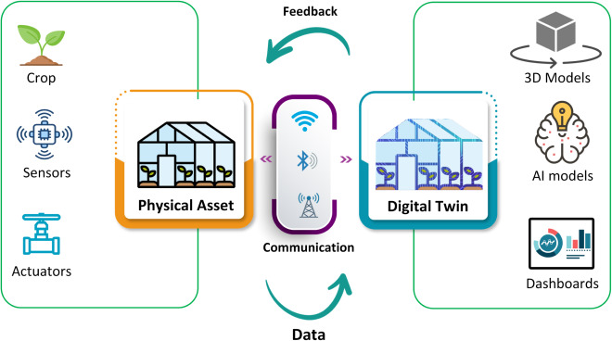
Fig. 1.1 Conceptual Digital Twin Architecture for Greenhouse Cultivation
Traditional greenhouse management practices are largely reactive and depend on manual observation, fixed threshold-based control, and operator experience. Corrective actions are often taken only after visible symptoms of plant stress or disease appear, leading to inefficient use of water, energy, fertilizers, and chemical treatments. Although greenhouse data are continuously collected, they are often underutilized for predictive analysis, limiting long-term system improvement.
Greenhouse systems are inherently complex, consisting of interacting subsystems such as climate control, ventilation, irrigation, lighting, and nutrient management. Control actions in one subsystem may unintentionally affect others, making static or rule-based strategies insufficient. In addition, uncertainties arising from weather variations, sensor noise, and biological variability among plants further complicate greenhouse management. Recent advances in data-driven modeling enable early identification of unfavorable environmental trends and disease risks. Digital twin–based management strengthens this capability by allowing virtual experimentation and safe evaluation of control actions before real-world implementation. Motivated by these advantages, this work proposes AgriTwin-GH, a software-based digital twin framework for intelligent greenhouse management focused on tomato and strawberry cultivation. The proposed system aims to support early risk detection, efficient resource utilization, and improved decision-making in greenhouse environments.
To extend beyond conceptual design, the proposed framework is implemented as a real-time, interactive system that bridges analytical modeling with practical deployment. The system operates through a continuous data-processing pipeline in which environmental conditions, plant health indicators, and predictive model outputs are processed and updated dynamically. These outputs are exposed through a backend application interface, enabling the digital twin to function as a live decision-support system rather than a static analytical model. A key feature of the implementation is the integration of a 3D virtual greenhouse environment developed using Unity, which provides an immersive visualization of greenhouse operations. This environment mirrors real-time system states, including crop growth stages, disease conditions, and actuator behaviors such as ventilation, irrigation, and lighting. The backend system continuously communicates updated greenhouse states to the 3D environment via API-based interaction, ensuring synchronization between computational predictions and visual representation. Furthermore, the system incorporates simulation-based validation within the digital twin, enabling evaluation of control strategies before real-world application. This ensures that recommended actions are both effective and safe, reducing operational risks. The implementation also supports temporal adaptation by dynamically reflecting variations such as time-of-day changes and evolving environmental conditions, thereby enhancing realism and decision accuracy. In addition to advanced analytics and visualization, the framework emphasizes practical usability through simplified human–machine interaction. Complex AI-driven insights are translated into intuitive, non-verbal signals such as color-coded indicators and symbolic representations, enabling easy interpretation by greenhouse workers without requiring technical expertise. This design approach ensures accessibility and usability in real-world agricultural environments.
Overall, the integration of conceptual digital twin modeling with real-time implementation demonstrates the feasibility of deploying AgriTwin-GH as a comprehensive, scalable, and user-centric solution. By combining predictive intelligence, simulation-based validation, and immersive visualization, the system transforms greenhouse management from reactive operation to proactive, data-driven decision-making, thereby improving crop productivity, resource efficiency, and operational sustainability.
1.2 OVERVIEW OF TECHNIQUES, ALGORITHMS, MODELS, AND SIMULATION METHODOLOGIES
1.2.1 DATA PREPROCESSING AND FEATURE ENGINEERING
Effective data preprocessing is essential for ensuring the quality and reliability of model inputs. The system processes multi-source greenhouse datasets, including environmental time-series data and plant image data. Missing values are handled using interpolation techniques, while noise and outliers are filtered using statistical methods.
Feature engineering is performed to derive agronomically relevant parameters such as Vapor Pressure Deficit (VPD) and dew point, which play a critical role in plant growth and disease development. Temporal alignment of datasets ensures consistency across environmental and plant-related variables, enabling accurate downstream modeling.
1.2.2 CONVOLUTIONAL NEURAL NETWORKS
Convolutional Neural Networks (CNNs) are a type of deep learning architecture specifically designed for image processing and computer vision tasks. CNNs are capable of automatically learning spatial features from images, making them highly suitable for analyzing visual data such as plant leaves, fruits, and crop images.
A CNN typically consists of convolution layers, pooling layers, and fully connected layers. The convolution layers extract important visual patterns such as edges, textures, and shapes, while pooling layers reduce the dimensionality of feature maps to improve computational efficiency. The final layers of the network perform classification based on the extracted features. CNNs have become the standard approach for image-based agricultural applications because they can accurately identify visual patterns associated with plant diseases, nutrient deficiencies, and growth stages.
1.2.3 TRANSFER LEARNING
Transfer learning is a technique in machine learning where a model trained on a large dataset is reused and adapted for a different but related task. Instead of training a deep learning model from scratch, a pre-trained model is used as a starting point and then fine-tuned using a smaller, task-specific dataset. This approach significantly reduces the amount of training data and computational resources required. Pre-trained models typically learn general visual features during initial training, which can then be applied to new problems with minimal modification. Transfer learning has become widely used in computer vision applications because it enables high model performance even when limited labeled data is available.
1.2.4 EFFICIENTNET ARCHITECTURE
EfficientNet is a modern deep learning architecture designed to improve the performance and efficiency of convolutional neural networks. Traditional CNN architectures often increase network depth or width to improve accuracy. EfficientNet introduces a compound scaling method that balances network depth, width, and input resolution to achieve better performance with fewer parameters. This balanced scaling approach allows EfficientNet models to achieve high accuracy while maintaining computational efficiency. As a result, EfficientNet architectures are widely used in image classification tasks where both performance and computational efficiency are important. EfficientNet models have demonstrated strong performance in various computer vision applications, including plant disease detection, object recognition, and medical image analysis.
1.2.5 IMAGE DATA AUGMENTATION
Image data augmentation is a technique used to artificially increase the size and diversity of image datasets used for training machine learning models. It involves applying various transformations to existing images to create new training samples.
Common augmentation techniques include rotation, flipping, scaling, cropping, and adjustments to brightness or contrast. These transformations simulate real-world variations that may occur during image acquisition, such as changes in camera angle, lighting conditions, or object orientation. By increasing dataset diversity, data augmentation helps improve the robustness of machine learning models and reduces the risk of overfitting.
1.2.6 LONG SHORT-TERM MEMORY
Long Short-Term Memory (LSTM) networks are employed for modeling temporal dependencies in greenhouse environmental data and disease progression. Unlike traditional neural networks, LSTM models are capable of retaining long-term dependencies through gated memory mechanisms, making them highly suitable for time-series forecasting tasks. In the proposed system, LSTM is used to analyze sequential environmental parameters such as temperature, humidity, and VPD to predict future greenhouse conditions.
Furthermore, LSTM is applied to model disease progression over time by learning patterns from historical environmental conditions and plant health indicators. The model predicts short-term disease severity trends (e.g., 24–48 hours), enabling early intervention and preventive decision-making. This temporal modeling capability significantly enhances the system’s ability to shift from reactive monitoring to predictive greenhouse management.
1.2.7 CHRONOS
Chronos, a transformer-based time-series foundation model, is utilized to capture complex temporal patterns across multiple environmental variables. Unlike traditional models, Chronos leverages pre-trained representations learned from diverse time-series datasets, enabling it to generalize effectively across varying greenhouse conditions. This makes it particularly useful for forecasting tasks involving non-linear and multi-dimensional dependencies.
1.2.8 EXTREME GRADIENT BOOSTING
XGBoost is employed as a powerful ensemble learning method for predictive modeling of greenhouse environmental conditions and disease risk estimation. It operates using gradient boosting over decision trees, enabling it to capture complex non-linear relationships between input features. In this system, XGBoost processes structured environmental data and engineered features such as VPD and dew point to generate accurate predictions.
Additionally, XGBoost provides feature importance scores, which help in identifying key environmental factors influencing plant health and disease development. This interpretability makes it valuable for decision support, allowing stakeholders to understand the impact of different parameters. Its robustness and efficiency make it well-suited for real-time predictive analytics in greenhouse environments.
1.2.9 RANDOM FOREST
Random Forest is used as a reliable ensemble learning technique for regression and classification tasks within the predictive analytics module. By constructing multiple decision trees and aggregating their outputs, Random Forest reduces overfitting and improves generalization performance. It is particularly effective for handling noisy and heterogeneous greenhouse datasets.
1.2.10 ENSEMBLE LEARNING
Ensemble learning is a machine learning paradigm that combines multiple individual models to improve overall predictive performance and robustness. Instead of relying on a single model, ensemble methods aggregate the outputs of multiple learners to reduce variance, bias, and overfitting. Common ensemble strategies include bagging, boosting, and stacking, each designed to enhance model accuracy by leveraging the strengths of different learning algorithms. In the context of greenhouse data, where environmental conditions are dynamic and noisy, ensemble learning provides a reliable approach for capturing complex and non-linear relationships among variables.
1.2.11 HISTOGRAM-BASED GRADIENT BOOSTING
Histogram-Based Gradient Boosting is utilized for efficient and scalable predictive modeling of large greenhouse datasets. This algorithm groups continuous features into discrete bins, significantly reducing computational complexity while maintaining high predictive accuracy. It is particularly advantageous for handling large-scale time-series data with multiple features.
1.2.12 AUTOREGRESSIVE WITH EXOGENOUS INPUTS MODEL
The AutoRegressive with eXogenous inputs (ARX) model is employed to construct the core dynamic model of the greenhouse system within the digital twin framework. ARX is a grey-box modeling approach that captures the relationship between current system states and external influencing variables. In the context of greenhouse modeling, the system states include environmental parameters such as temperature, humidity, and CO₂ levels, while exogenous inputs include control actions such as ventilation, irrigation, and lighting.
The ARX model enables the digital twin to simulate how environmental conditions evolve over time in response to control actions. By learning system dynamics from historical data, the model provides a computationally efficient approximation of real greenhouse behavior. This allows the system to perform predictive simulations and evaluate the impact of different control strategies before applying them in real-world scenarios.
1.2.13 MODEL PREDICTIVE CONTROL
Model Predictive Control (MPC) is implemented as the decision-making and optimization layer of the proposed system. MPC utilizes the ARX-based system model to predict future greenhouse states over a finite time horizon and determines optimal control actions by minimizing a predefined objective function. This objective function typically includes terms for environmental deviation, resource consumption, and disease risk, ensuring balanced and efficient greenhouse operation.
At each control step, MPC evaluates multiple possible control sequences and selects the one that best satisfies system constraints while achieving desired environmental targets. The receding horizon strategy ensures continuous adaptation to changing conditions. By integrating disease-aware penalties and environmental constraints, MPC enables proactive and optimized greenhouse management, significantly improving resource efficiency and crop health outcomes.
1.2.14 UNITY-BASED DIGITAL TWIN SIMULATION
A 3D virtual greenhouse environment is developed using the Unity engine to provide an interactive and immersive visualization of the digital twin system. This environment represents key greenhouse components, including crop growth stages, environmental conditions, and actuator states such as fans, vents, irrigation systems, and lighting. The 3D model mirrors the real-time state of the system, offering a visual interpretation of complex data.
The backend system communicates with the Unity-based environment through API integration, enabling real-time updates of greenhouse conditions and control actions. This synchronization allows users to observe the effects of predictive decisions and control strategies visually. The integration of 3D visualization enhances system interpretability, supports simulation-based validation, and improves user interaction, making the digital twin more accessible and effective for practical deployment.
1.3 ALIGNED SUSTAINABLE DEVELOPMENT GOALS
The integration of digital twin technology, artificial intelligence, and predictive analytics in greenhouse management contributes significantly to the broader objectives of sustainable development. Modern agriculture requires solutions that not only enhance productivity but also ensure efficient use of resources and support technological advancement. By enabling data-driven monitoring, forecasting, and decision-making, intelligent greenhouse systems play a vital role in addressing key sustainability challenges. The use of virtual modeling, simulation, and predictive control allows agricultural operations to shift from reactive practices to proactive and optimized management, thereby aligning with multiple Sustainable Development Goals (SDGs).
The framework strongly supports SDG 2: Zero Hunger by improving crop productivity, quality, and reliability in controlled-environment agriculture. Through early detection of plant diseases and accurate prediction of growth stages, the system enables timely interventions that minimize crop loss and enhance yield stability. Predictive insights into environmental conditions and plant health ensure that crops are maintained under optimal conditions, contributing to efficient food production. This capability is particularly important for high-value crops such as tomato and strawberry, where small variations in environmental factors can significantly impact output and quality.
In addition, the framework contributes to SDG 9: Industry, Innovation, and Infrastructure through the adoption of advanced computational technologies in agriculture. The use of digital twin modeling, machine learning algorithms, and real-time visualization through a virtual greenhouse environment represents a modern technological approach to agricultural management. This integration of intelligent systems enhances innovation in the agricultural sector and supports the development of scalable and efficient infrastructure. The accessibility of such systems, particularly those that operate without dependency on extensive physical sensor networks, further promotes the adoption of smart technologies in diverse farming contexts.
The system also aligns with SDG 12: Responsible Consumption and Production by promoting efficient utilization of critical agricultural resources such as water, energy, and fertilizers. Traditional greenhouse practices often result in overuse of resources due to uncertainty and lack of predictive control. In contrast, the integration of data-driven models and optimization strategies enables precise control of environmental parameters, reducing unnecessary consumption. By forecasting environmental conditions and evaluating control actions through simulation, the system ensures that resources are used optimally, thereby supporting sustainable production practices and minimizing environmental impact.
Overall, the alignment with these Sustainable Development Goals highlights the role of intelligent, data-driven greenhouse systems in advancing sustainable agriculture. By combining predictive intelligence, efficient resource management, and technological innovation, such systems contribute to improved food production, reduced environmental impact, and the development of modern agricultural infrastructure.

CHAPTER 2
2. LITERATURE SURVEY
2.1 REVIEW OF RELATED WORKS
The study by Elbasi et al. emphasize the importance of effective data preprocessing before applying machine learning models to agricultural datasets. The preprocessing stage involves several steps to transform raw agricultural data into a structured format suitable for model training [2]. Initially, noisy and mislabeled records are identified and removed to improve data reliability. The dataset is then balanced to ensure that each class label contains an equal number of samples, reducing bias during model training. To further enhance learning performance, the data records are randomly shuffled to provide a uniform distribution across the dataset. Feature selection is performed using correlation analysis to identify the most relevant attributes influencing agricultural outcomes. Additionally, new features are generated from existing attributes using statistical measures such as minimum, maximum, and range values to enrich the feature space. The dataset is then restructured into a consistent format and dimensionality reduction techniques are applied to eliminate redundant or less informative features. A study by Oad et al. proposed an advanced plant disease detection framework based on ensemble deep learning combined with explainable artificial intelligence (XAI). The primary objective of the research was to improve the accuracy and interpretability of automated plant disease diagnosis using leaf images [13]. The methodology integrates multiple deep convolutional neural network (CNN) architectures, including VGG16, VGG19, InceptionV3, and ResNet101V2, within an ensemble learning framework. Each model independently performs feature extraction and classification of plant leaf images. The outputs of these individual models are then aggregated using ensemble voting techniques such as hard voting and soft voting, where the final prediction is determined either by majority class votes or by combining prediction confidence scores. This ensemble strategy improves prediction robustness and minimizes the limitations of relying on a single deep learning model. The dataset used for training and evaluation was the PlantVillage dataset, which contains more than 54,000 images of healthy and diseased plant leaves across 38 disease classes and multiple crop species. Prior to model training, several image preprocessing and augmentation techniques were applied, including rescaling pixel values, rotation, zooming, shearing, and horizontal flipping, in order to improve model generalization and reduce overfitting. Each CNN architecture was trained using softmax activation for multi-class classification and categorical cross-entropy as the loss function, optimized using the Adam optimizer. Experimental results showed that the individual models achieved high classification accuracy, with VGG16 reaching approximately 91.9% accuracy, VGG19 around 88.2%, InceptionV3 about 88%, and ResNet101V2 achieving approximately 93.6% accuracy. Huo et al. proposed a deep learning-based framework for automatic identification of tomato growth stages in protected agriculture environments. The study addresses limitations of traditional monitoring methods that rely on manual observation, which are time-consuming, subjective, and inefficient for large-scale greenhouse cultivation [6]. To overcome these issues, the authors introduced a hybrid approach combining Generative Adversarial Networks (GANs) and Vision Transformer (ViT) models for accurate growth stage recognition. In the proposed methodology, the StyleGAN3 architecture is used to generate high-quality synthetic images of tomato plants at different growth stages. These generated images are combined with real images to augment the dataset, thereby increasing the diversity of training data and reducing the impact of limited sample availability in agricultural datasets. After dataset augmentation, the classification of tomato growth stages is performed using the Vision Transformer (ViT) model, a deep learning architecture that utilizes a self-attention mechanism to capture global relationships within image features. Unlike traditional Convolutional Neural Networks (CNNs), the ViT model processes images as sequences of patches and analyzes long-range dependencies between them, enabling improved recognition of complex visual patterns associated with plant growth stages. The model was trained on a dataset consisting of 2723 images of tomato plants across multiple growth phases, including sapling, flowering, fruiting, and maturity stages. The combined dataset containing both real and GAN-generated images significantly enhanced model performance compared to training with only original images. Experimental evaluation demonstrated that the proposed approach achieved highly accurate recognition results.
The study by Caroprese et al. proposes a deep learning-based framework (DL2F) for forecasting key environmental variables relevant to renewable energy systems using meteorological time-series data. The model integrates outputs from the Fifth-Generation Mesoscale Model (MM5) with historical climatic data and applies a Gated Recurrent Unit (GRU)-based recurrent neural network to refine predictions of parameters such as temperature, humidity, pressure, and solar irradiance [1]. The approach focuses on improving the accuracy of existing numerical weather prediction systems by learning temporal patterns and correcting systematic errors in MM5 forecasts. The model operates as a regression system, generating short-term forecasts over a limited horizon and demonstrating improved performance compared to standalone numerical models. However, the framework primarily relies on a single deep learning architecture and is designed to enhance existing forecasts rather than perform independent multi-model prediction or generate actionable decision-level outputs. The study on deep learning-based plant growth stage classification utilizes time-series sensor data combined with advanced neural network architectures to identify crop growth stages in precision agriculture settings. The framework leverages data from IoT sensors, remote sensing systems, and environmental monitoring to capture temporal and spatial dependencies in crop development [4]. Various deep learning techniques, including recurrent neural networks, attention mechanisms, and transformer-based models, are explored to model complex growth patterns and improve classification accuracy. The approach emphasizes scalability, multi-modal data integration, and computational efficiency, enabling real-time prediction across different crops and environmental conditions. Despite these advancements, the model primarily focuses on classifying current growth stages and does not explicitly model future stage transitions, temporal progression dynamics, or multi-task outputs such as time-to-transition or short-term growth forecasting. The study by Kanakala et al. presents a deep learning-based approach for detecting and classifying plant diseases using leaf image datasets. The methodology involves preprocessing a large-scale labelled dataset of plant leaf images and applying convolutional neural networks (CNN) and long short-term memory (LSTM) models to perform multi-class classification of diseases across different crop types [8]. The CNN model extracts spatial features from images through multiple convolutional and pooling layers, while the LSTM model is adapted to capture sequential patterns in feature representations. The models are evaluated using metrics such as accuracy, precision, recall, F1-score, and confusion matrix, with the CNN model achieving high classification performance. Although the study demonstrates effective automated disease detection, it is limited to static image-based classification and does not incorporate temporal progression modeling, severity prediction, or forecasting of future disease trends based on environmental conditions.
The study by Howard et al. presents an Industry 4.0-based digital twin framework for greenhouse systems, integrating IoT, AI, big data, and cloud computing to model and simulate greenhouse operations. The proposed system develops multiple interconnected digital twins representing climate compartments, energy systems, and production flow, enabling comprehensive simulation of greenhouse behavior under varying operational conditions. The framework focuses on optimizing production scheduling, energy consumption, and labor costs by considering factors such as weather forecasts, energy prices, and production deadlines [5]. Additionally, it introduces a distributed “system of systems” architecture that allows multiple digital twins to collaborate for improved decision-making and resource efficiency. However, the approach primarily emphasizes large-scale industrial optimization and system-level integration, with limited focus on crop-level intelligence, real-time disease prediction, or fine-grained adaptive control strategies that directly influence plant health and growth outcomes. The study by Subahi et al. proposes an intelligent IoT-based greenhouse monitoring and control system aimed at improving energy efficiency and maintaining optimal environmental conditions for crop growth. The system utilizes various sensors to monitor key parameters such as temperature, humidity, CO₂ levels, and light intensity, and employs cloud-based storage and processing for data analysis and decision support [15]. The framework introduces an automated temperature control mechanism that dynamically adjusts greenhouse conditions based on external weather and energy consumption patterns, including features such as sun-angle-based shading control and reference temperature generation. Furthermore, the system adopts a model-driven architecture to handle heterogeneous IoT data efficiently and supports long-term data analysis for improved greenhouse management. However, the proposed system mainly focuses on environmental monitoring and rule-based control, lacking advanced predictive intelligence, multi-objective optimization, and integration of crop-specific analytics such as disease detection or growth stage modeling. The study by Ghiasi et al. proposes a multi-objective optimization strategy for energy-efficient greenhouse climate control, focusing on minimizing energy consumption while maintaining suitable environmental conditions for plant growth. The framework incorporates optimization techniques and control scheduling for key greenhouse systems such as heating, cooling, lighting, CO₂ injection, and ventilation, using real-world weather data and convex optimization methods [3]. The results demonstrate significant improvements, achieving an average energy saving of approximately 27.55% annually and up to 43.13% on certain days compared to baseline control strategies. The study also highlights the role of advanced control techniques such as model predictive control (MPC), artificial intelligence models, and heuristic optimization algorithms in improving greenhouse efficiency. However, the approach is primarily centered on energy optimization and climate control, with limited consideration of real-time crop health dynamics, disease progression, or integrated decision systems that combine environmental, biological, and predictive intelligence for holistic greenhouse management.
2.2 INFERENCE FROM LITERATURE SURVEY
The literature review indicates that effective data preprocessing plays a critical role in improving the performance of machine learning models in agricultural applications. Previous studies have focused on preprocessing techniques such as noise removal, dataset balancing, feature selection, and statistical feature generation to transform raw agricultural data into structured datasets suitable for machine learning models. However, these approaches mainly focus on preparing datasets for model training rather than developing a comprehensive environmental data processing pipeline. In contrast, the proposed framework implements a unified greenhouse data processing architecture that integrates multi-source environmental data ingestion, temporal synchronization, and environmental feature engineering to generate standardized datasets suitable for intelligent greenhouse analysis. Existing research on plant disease detection has demonstrated that deep learning architectures, particularly convolutional neural networks and ensemble learning models, can achieve high accuracy in leaf disease classification tasks. Methods combining multiple CNN architectures and ensemble voting strategies have improved prediction robustness by leveraging complementary feature extraction capabilities of different models. Nevertheless, such approaches often involve high computational complexity and limited interpretability when deployed in real-world greenhouse monitoring systems. In the proposed system, disease detection is implemented using an EfficientNet-based deep learning model that provides high classification accuracy while maintaining computational efficiency suitable for real-time greenhouse monitoring environments. For tomato growth stage recognition, several studies have explored complex architectures such as transformer-based models and generative adversarial networks for improving classification performance. In contrast, the proposed work adopts an EfficientNet-based deep convolutional neural network architecture optimized for agricultural image analysis, enabling highly efficient feature extraction with reduced computational overhead. The EfficientNet model leverages compound scaling of network depth, width, and resolution to capture detailed morphological characteristics of tomato plants across different growth phases, resulting in improved classification accuracy and robust growth stage prediction suitable for intelligent greenhouse monitoring systems.
Most approaches rely on single-model deep learning architectures to perform short-term environmental forecasting. While these models are effective in capturing temporal patterns, they often lack robustness due to dependence on a single predictive technique and are typically limited to forecasting a small set of environmental variables. Additionally, these methods focus primarily on prediction accuracy and do not extend to generating decision-oriented outputs such as risk categorization or actionable insights. There is therefore a clear need for more comprehensive approaches that integrate multiple models, improve prediction reliability, and provide interpretable outputs suitable for real-time greenhouse decision support. Existing studies in plant growth analysis predominantly focus on identifying the current growth stage using deep learning models applied to time-series or multi-modal data. Although these approaches achieve high classification accuracy, they treat growth as a static problem and do not capture the dynamic and sequential nature of plant development. In particular, there is a lack of models that can predict future growth stages, estimate transition timelines, or provide multi-task outputs that reflect the progression behavior of crops. This highlights the need for advanced temporal modeling techniques that can incorporate sequence learning and generate forward-looking predictions to better support precision agriculture practices. The literature on plant disease analysis largely emphasizes image-based classification methods for detecting the presence of diseases at a given time. While these approaches are effective for identifying visible symptoms, they are inherently reactive and do not account for the temporal evolution of disease severity. Furthermore, most existing methods do not integrate environmental factors or historical trends, limiting their ability to forecast future disease risk. This indicates a significant gap in developing predictive frameworks that model disease progression over time, estimate future severity levels, and provide early warnings to enable proactive crop management.
Significant progress has been made in applying IoT, digital twin technologies, and optimization techniques for greenhouse and environmental management systems. Existing approaches successfully address aspects such as large-scale system modeling, environmental monitoring, and energy-efficient control. However, several critical limitations and research gaps remain. Firstly, most frameworks focus on system-level optimization and infrastructure efficiency rather than incorporating fine-grained, crop-level intelligence. The lack of plant-specific analytics limits the ability to make precise decisions that directly influence crop health, yield quality, and disease prevention. Secondly, many solutions rely on either rule-based control or single-model predictive techniques, which restrict adaptability under dynamic environmental conditions and reduce robustness when handling complex, real-world variability. Additionally, current systems often treat environmental control, energy optimization, and crop monitoring as separate components, lacking an integrated approach that combines these aspects into a unified decision-making framework. There is also limited emphasis on real-time predictive capabilities such as early disease detection, growth stage analysis, and proactive intervention strategies. Furthermore, while some approaches incorporate simulation and forecasting, they are primarily designed to enhance existing systems rather than generate independent, actionable insights for autonomous decision-making. Another notable gap is the insufficient use of multi-model or hybrid intelligent systems that can simultaneously optimize multiple objectives, including productivity, sustainability, and resource efficiency. Scalability and adaptability to varying operational conditions, especially in small- to medium-scale deployments, are also not comprehensively addressed. These limitations highlight the need for a more holistic, intelligent, and adaptive system that integrates environmental monitoring, predictive analytics, and crop-level decision support into a single framework, thereby enabling more precise, efficient, and autonomous management compared to existing approaches.

CHAPTER 3
3. PROPOSED AGRITWIN-GH SYSTEM
3.1 HIGH-LEVEL ARCHITECTURE
The AgriTwin-GH system is conceived as a comprehensive, integrated, and data-driven architecture that brings together multiple advanced technological domains, including environmental sensing, computer vision, predictive analytics, and intelligent control mechanisms, to enable efficient and smart greenhouse management. The system is carefully structured using a modular and layered architectural design, which ensures high scalability, adaptability, and flexibility. This design approach allows individual components to evolve independently while still maintaining seamless interoperability across the entire system. As a result, the architecture supports easy integration of new technologies, sensors, or models without disrupting the existing workflow, making it suitable for long-term deployment and continuous improvement. At a foundational level, the architecture is built to facilitate continuous and structured data flow from a variety of heterogeneous sources. These sources include environmental sensors that capture parameters such as temperature, humidity, soil moisture, and light intensity, as well as imaging devices that collect plant phenotypic data. The system efficiently manages this diverse data stream by organizing it into a unified pipeline, ensuring consistency and reliability. Once acquired, the raw data undergoes multiple stages of transformation, where it is cleaned, normalized, and prepared for further analysis. This preprocessing stage is crucial for eliminating noise, handling missing values, and aligning data formats, thereby enhancing the quality of downstream analytics. Following preprocessing, the system performs feature extraction, where meaningful patterns and attributes are derived from both time-series environmental data and image-based plant data. This dual-data integration enables the system to capture both temporal dynamics and visual characteristics of crop growth. By combining these perspectives, the architecture achieves a more comprehensive and holistic understanding of plant health and development. This enriched representation of data is then fed into advanced predictive models, which may include machine learning and deep learning algorithms designed to identify trends, classify plant conditions, and forecast future outcomes. The predictive modelling stage plays a central role in the system’s intelligence. It not only evaluates current greenhouse conditions but also anticipates future scenarios related to crop growth, disease progression, and environmental changes. This forward-looking capability transforms the system from a reactive monitoring tool into a proactive decision-support system. By predicting potential risks such as disease outbreaks or suboptimal growth conditions, the system enables early intervention strategies, significantly reducing crop loss and improving yield quality. Another critical aspect of the AgriTwin-GH architecture is its decision-making layer, where insights generated by predictive models are translated into actionable recommendations or automated control actions. These decisions may involve adjusting irrigation schedules, modifying ventilation, regulating temperature, or optimizing lighting conditions. The system ensures that these actions are aligned with the overall goal of maximizing resource efficiency while maintaining optimal crop health. A distinctive feature of this architecture is the integration of a digital twin, which serves as a virtual replica of the physical greenhouse environment. The digital twin allows the system to simulate various scenarios and validate potential control strategies before they are applied in the real world. This simulation-based approach enhances decision reliability and minimizes risks associated with direct intervention. By testing different strategies in a virtual environment, the system ensures that only the most effective and safe actions are implemented. Furthermore, the architecture emphasizes real-time responsiveness, enabling continuous monitoring and rapid adaptation to changing conditions within the greenhouse. This real-time capability is essential for maintaining precise control over environmental parameters and ensuring that crops receive optimal care at every stage of growth. The seamless integration of sensing, analytics, and control creates a closed-loop system that continuously learns and improves over time.
Fig. 3.1 illustrates the high-level architecture of the proposed AgriTwin-GH framework, depicting the flow of data from input acquisition to intelligent decision outputs. The architecture is structured into three primary layers: input data sources, core processing modules, and system outputs.
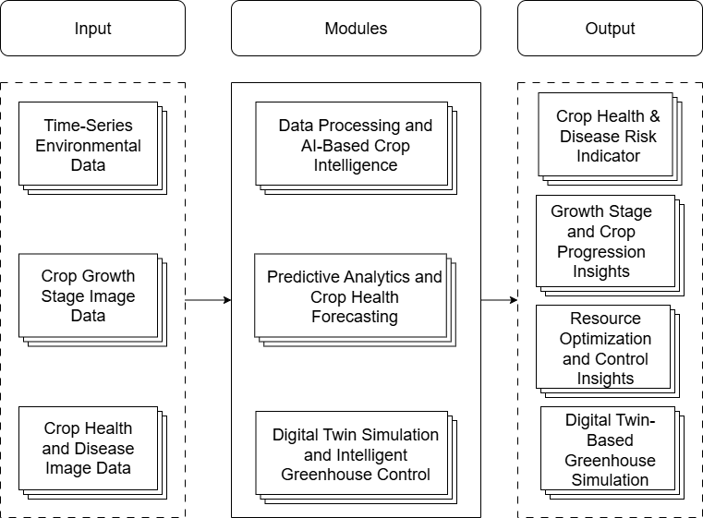
Fig. 3.1 High-Level Architecture Diagram of AgriTwin-GH
3.2 SYSTEM INPUTS AND OUTPUTS
3.2.1 SYSTEM INPUTS
The proposed system operates using data-driven inputs obtained from open-source datasets that emulate real greenhouse environments. These datasets act as virtual sensors, enabling experimentation and analysis without relying on physical sensor infrastructure, while still reflecting realistic greenhouse behavior.
A. Open-Source Environmental Data
The environmental dataset used in this study is derived from real-world weather observations collected for the Dindigul district of Tamil Nadu, India. The weather data for the years 2024 and 2025 were obtained using the Visual Crossing Weather API, which provides historical meteorological records including parameters such as temperature, humidity, solar radiation, and wind speed. These datasets represent actual environmental conditions of the region and serve as the primary source for environmental analysis within the system.
Using this real-world weather data as the foundation, an indoor greenhouse environmental dataset was generated to simulate greenhouse conditions. The derived dataset represents indoor greenhouse parameters influenced by the outdoor climate and includes variables such as indoor temperature, humidity, air velocity, solar radiation, carbon dioxide concentration, vapor pressure deficit, and leaf wetness indicators. Both the original API-based weather dataset and the generated indoor greenhouse dataset are utilized as environmental inputs for further analysis and system modeling.
B. Open-Source Plant Image Data
Plant image datasets related to tomato cultivation are used to assess crop health and growth stages. These images include healthy and diseased leaves and different growth phases. Image data enable visual identification of disease symptoms and crop development, strengthening plant health analysis.
3.2.2 SYSTEM OUTPUTS
The system produces outputs that support predictive decision-making and intelligent greenhouse management.
A. Crop Health and Disease Risk Indicator
This output provides an overall assessment of plant health and disease risk by combining environmental data and image-based analysis. It supports early detection of potential disease conditions and preventive greenhouse management.
B. Growth Stage and Crop Progression Insights
The system identifies the current growth stage of crops and provides detailed insights into growth progression over time. In addition to stage classification, it offers predictive information such as transition probability to the next stage, estimated time for stage progression, and overall crop development trends, enabling better planning and intervention decisions.
C. Resource Optimization and Control Insights
The system generates recommendations for optimized usage of critical greenhouse resources such as water, energy, and CO₂. By analyzing environmental conditions and crop requirements, it supports efficient actuator control decisions, reducing wastage while maintaining optimal growth conditions.
D. Digital Twin-Based Greenhouse Simulation
The system provides a real-time digital replica of the greenhouse environment through a digital twin. This virtual model reflects current environmental conditions, crop states, and actuator behaviors, allowing simulation, visualization, and validation of control strategies before actual implementation.
3.3 SYSTEM REQUIREMENTS
3.3.1 HARDWARE REQUIREMENTS
The proposed system is primarily software-driven and does not require specialized physical infrastructure. However, for efficient model training, simulation, and real-time processing, the following hardware configuration is recommended:
- Processor: Intel Core i5/i7 or higher (or equivalent AMD processor)
- RAM: Minimum 8 GB (16 GB recommended for model training and simulation tasks)
- Storage: Minimum 20 GB free disk space (SSD preferred for faster data access)
- GPU (Optional): NVIDIA GPU with CUDA support for accelerated deep learning model training
- Display: Standard monitor with minimum resolution of 1366 × 768
- Network: Stable internet connection for API access and data retrieval
The system is designed to operate efficiently on standard computing devices, ensuring accessibility and scalability without dependency on high-end hardware.
3.3.2 SOFTWARE REQUIREMENTS
The system is developed using a combination of machine learning frameworks, web technologies, and simulation tools. The required software components are as follows:
- Operating System: Windows / Linux (Ubuntu recommended) / macOS
- Programming Language: Python 3.9 or higher
- Environment Management: Python virtual environment / Conda / uv
- Libraries: NumPy, Pandas, PyArrow, FastParquet
- Database: PostgreSQL with SQLAlchemy ORM
- Environment Configuration: python-dotenv, PyYAML
- Libraries: OpenCV, Pillow
- Deep Learning: TensorFlow, Keras, PyTorch, PyTorch Lightning
- Classical ML: Scikit-learn, XGBoost, LightGBM
- Time-Series Forecasting: PyTorch Forecasting, NeuralForecast, Chronos Forecasting, Statsmodels
- Hyperparameter Optimization: Optuna
- Model Explainability: SHAP
- Libraries: Matplotlib, Seaborn
- Framework: FastAPI
- Server: Uvicorn
- Validation: Pydantic
- HTTP Client: HTTPX
- Testing: Pytest
- Libraries: Diffusers, Transformers, Accelerate
- Version Control: Git for code management and collaboration
The software stack ensures modularity, scalability, and seamless integration between data processing, predictive modeling, and digital twin simulation components.
3.4 PROJECT MODULES
3.4.1 DATA PROCESSING AND AI-BASED CROP INTELLIGENCE
3.4.1.1 OVERVIEW OF THE MODULE
The Data Processing and AI-Based Crop Intelligence Module forms the foundation of the AgriTwin-GH system by transforming raw greenhouse data into actionable crop intelligence. It integrates environmental dataset preparation with image-based plant analysis to support accurate monitoring of crop conditions inside the greenhouse. Through unified data processing, crop growth stage classification, and plant disease detection, the module enables reliable interpretation of both environmental and visual crop information. By combining data preprocessing techniques with deep learning models, this module provides the essential insights required for subsequent predictive analytics and digital twin–based greenhouse management.
3.4.1.2 TASK-LEVEL DECOMPOSITION OF THE MODULE
The Data Processing and AI-Based Crop Intelligence module integrates heterogeneous data sources, including time-series environmental data, external weather inputs, and plant phenotypic image data, and processes them through a sequence of well-defined tasks. It ensures data quality through preprocessing and standardization, followed by the application of advanced AI models for crop growth stage classification and plant disease detection.
Fig. 3.2 illustrates the task-level decomposition of the Data Processing and AI-Based Crop Intelligence Module in the AgriTwin-GH system. It shows how environmental and plant image data are processed to perform data preparation, crop growth stage classification, and plant disease detection.
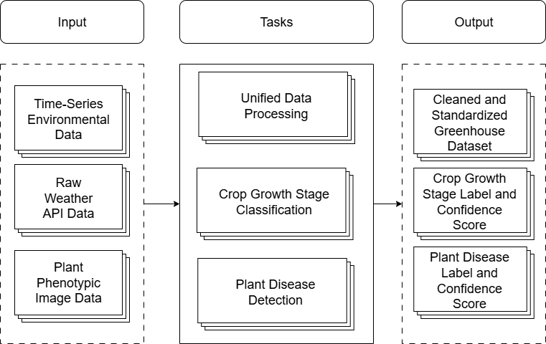Fig. 3.2 Task-Level Architecture of Data Processing and AI-Based Crop Intelligence Module
3.4.1.3 MODULE IMPLEMENTATION DETAILS
A. Unified Data Processing
The Unified Data Processing Pipeline is used to transform heterogeneous environmental data into a standardized greenhouse dataset suitable for downstream AI analysis. Initially, raw environmental information is collected from external weather API data sources, which may contain incomplete records, inconsistent timestamps, and noise typical of real-world agricultural datasets. This data is first passed to the Data Ingestion component, where the system collects and integrates incoming environmental measurements into the internal processing framework. The next stage performs Data Validation and Cleaning, where corrupted entries, inconsistent values, and anomalous measurements are identified and corrected or removed. Following this, the Missing Value Handling stage ensures that incomplete records are properly treated using appropriate imputation strategies so that the dataset remains consistent and usable for machine learning applications. The processed data then undergoes Temporal Synchronization, where all environmental parameters such as temperature, humidity, carbon dioxide concentration, and light intensity are aligned along a consistent time axis to maintain accurate temporal relationships between variables. Finally, the Feature Engineering stage derives meaningful environmental indicators and structured variables that better represent greenhouse conditions. The result of this pipeline is a Standardized Greenhouse Dataset, which serves as a reliable and structured input for subsequent AI-based crop intelligence models within the AgriTwin-GH platform.
Fig. 3.3 illustrates the Data Processing Pipeline Architecture, showing how raw environmental data from weather API sources is ingested, validated, cleaned, temporally synchronized, and transformed through feature engineering to generate a standardized greenhouse dataset for AI-based crop analysis.
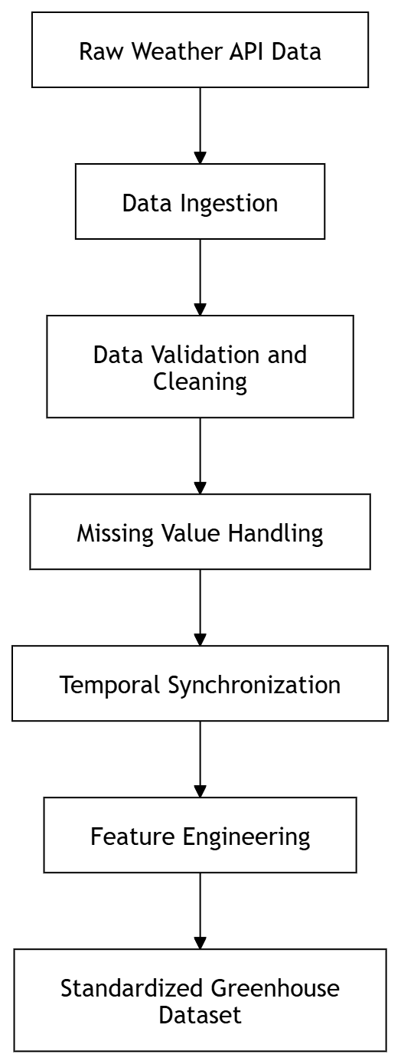
Fig. 3.3 Data Processing Pipeline Architecture
B. Indoor Environmental Feature Calculation
The data processing demonstration illustrates how raw outdoor weather data is transformed into a structured indoor greenhouse dataset used by the AgriTwin-GH system. The input data contains environmental variables such as temperature, humidity, wind speed, solar radiation, and timestamps, which are collected from weather datasets for the Dindigul region. These measurements are first standardized and expanded into hourly records to simulate continuous greenhouse monitoring conditions.
Using these environmental inputs, several greenhouse features are derived to represent realistic indoor cultivation conditions. Outdoor temperature and solar radiation are used to estimate indoor temperature, while outdoor humidity and temperature variation are used to compute indoor humidity levels. Similarly, outdoor wind speed is converted into indoor air velocity, representing the reduced airflow inside the greenhouse structure. Based on the calculated indoor environmental variables, additional agronomic indicators are extracted. Indoor temperature and humidity are used to compute dew point temperature, and together they are also used to calculate the Vapor Pressure Deficit (VPD), which indicates plant transpiration stress levels. Furthermore, high indoor humidity sustained for multiple hours is used to derive a leaf wetness proxy indicator, which helps identify potential disease-favorable conditions inside the greenhouse.
The final processed dataset contains key greenhouse parameters including indoor temperature, indoor humidity, indoor air velocity, CO₂ concentration, solar radiation, vapor pressure deficit (VPD), dew point temperature, and leaf wetness indicators. This standardized dataset serves as the primary environmental input for subsequent AI-based modules in the AgriTwin-GH system.
Using the environmental parameters obtained from the weather API, several greenhouse environmental variables and agronomic indicators are derived through the following mathematical formulations.
a. Indoor Temperature Calculation
Indoor temperature is estimated based on outdoor temperature and solar radiation intensity.
Daytime Condition:
(2)
(1)
$$ΔT=0.02×SolarRadiation \\ IndoorTemp=OutdoorTemp+ΔT$$
Nighttime Condition:
(3)
$$IndoorTemp=OutdoorTemp+1.5$$
b. Indoor Humidity Calculation
Indoor humidity is estimated based on the effect of temperature variation and evapotranspiration.
Daytime Condition:
(4)
$$IndoorHumidity=OutdoorHumidity-(0.5×ΔT)+0.4$$
Nighttime Condition:
(5)
$$IndoorHumidity=OutdoorHumidity+5$$
c. Indoor Air Velocity
Indoor air velocity is derived from outdoor wind speed.
(6)
IndoorAirVelocity = OutdoorWindSpeed×0.1
d. Indoor CO₂ Concentration
CO₂ levels vary between daytime and nighttime conditions due to plant physiological processes.
Daytime:
(7)
$$IndoorCO2​=400-(0.05×SolarRadiation)$$
Nighttime:
(8)
$$IndoorCO2​=440$$
e. Dew Point Temperature
Dew point temperature is estimated using a simplified approximation.
(9)
$$DewPoint=IndoorTemp-5(100-IndoorHumidity)​$$
f. Vapor Pressure Deficit (VPD)
VPD is calculated to measure plant transpiration and moisture stress.
Saturation Vapor Pressure:
(10)
$$SVP = 0.6108 * e^{\left\{\frac{17.27T}{T + 237.3}\right\}}$$
Actual Vapor Pressure:
(11)
$$AVP = SVP * \left(RH/100\right)$$
Vapor Pressure Deficit:
(12)
$$VPD=SVP-AVP$$
Where,
T = Indoor Temperature (°C)
RH = Indoor Relative Humidity (%)
g. Leaf Wetness Proxy Indicator
Leaf wetness is detected based on sustained high humidity levels.
(13)
$$LeafWetness=1 if IndoorHumidity>85\% for ≥ 3 consecutive hours$$
Otherwise:
(14)
$$LeafWetness=0$$
C. Crop Growth Stage Classification
The crop growth stage classification module is designed to automatically identify the developmental phase of tomato plants using image-based deep learning techniques. Accurate growth stage recognition is a critical component of intelligent greenhouse management, as it directly influences irrigation scheduling, nutrient supply, environmental control strategies, and harvest planning. Manual monitoring of plant stages is inefficient and subjective, particularly in large-scale greenhouse environments, necessitating an automated and reliable classification approach.
The system processes plant images through a structured pipeline consisting of preprocessing, feature extraction, classification, and probability estimation. Initially, raw images are standardized through resizing, normalization, and format alignment to ensure consistent input to the neural network. The classification task involves categorizing plant images into six biologically distinct growth stages: Seedling, Early Vegetative, Flowering Initiation, Flowering, Unripe Fruit, and Ripe Fruit. These stages are characterized by gradual morphological transitions such as leaf expansion, bud emergence, flowering structures, and fruit maturation with colour changes.
For this task, EfficientNetB3 is selected as the backbone architecture due to its superior capability in capturing fine-grained visual features. Growth stage classification requires sensitivity to subtle variations in plant structure, texture, and especially colour transitions (e.g., green to red during ripening). EfficientNetB3, with its increased depth, width, and resolution scaling compared to smaller variants, provides enhanced representational power, making it well-suited for distinguishing closely related growth stages.
The model architecture consists of a pre-trained EfficientNetB3 backbone followed by a custom classification head. The head includes a global average pooling layer to reduce spatial dimensions, followed by fully connected dense layers with ReLU activation, batch normalization for training stability, and dropout layers to mitigate overfitting. The final layer uses a softmax activation function to produce probability scores across the six growth stage classes. A two-phase training strategy is employed. In the first phase, the EfficientNetB3 backbone is frozen, and only the classification head is trained to learn task-specific mappings. In the second phase, selective upper layers of the backbone are unfrozen and fine-tuned with a reduced learning rate, enabling the network to adapt pre-trained features to greenhouse-specific variations such as lighting, plant density, and camera angles.
Data augmentation is applied cautiously to preserve biologically meaningful features. Since colour is a critical indicator of growth stages, aggressive transformations are avoided. Augmentation techniques include minor rotations, brightness adjustments, and limited zoom operations. This ensures robustness while maintaining essential visual characteristics. To address class imbalance across growth stages, class weighting is incorporated into the loss function, ensuring balanced learning. The model outputs probability distributions over all growth stages, enabling confidence-based decision-making.
D. Plant Disease Detection
The plant disease detection module focuses on identifying and classifying diseases affecting tomato plants using image-based deep learning techniques. Early detection of plant diseases is essential for preventing infection spread, minimizing crop loss, and ensuring optimal yield. Traditional manual inspection methods are time-consuming, require expert knowledge, and often fail to detect diseases at early stages. This module addresses these challenges by enabling automated, real-time disease identification using computer vision.
The system processes leaf images through a deep learning pipeline that includes preprocessing, feature extraction, classification, and probability estimation. Images are resized, normalized, and standardized before being fed into the neural network. The classification task involves identifying six categories: Early Blight, Late Blight, Leaf Mold, Powdery Mildew, Spider Mites infestation, and Healthy Leaf. Each disease exhibits distinct visual patterns such as lesions, discoloration, fungal growth, or texture changes, which the model learns to recognize.
For this task, EfficientNetB0 is selected as the backbone architecture. Unlike growth stage classification, disease detection primarily depends on recognizing localized patterns such as spots, textures, and irregularities on leaf surfaces. These features are less complex in terms of global structure but require efficient pattern recognition. EfficientNetB0 provides an optimal balance between computational efficiency and accuracy, making it suitable for real-time deployment scenarios within greenhouse systems.
The model architecture consists of a pre-trained EfficientNetB0 backbone followed by a custom classification head. The head includes global average pooling, dense layers with ReLU activation, batch normalization, and dropout layers to enhance generalization. The final layer applies a softmax activation function to produce probability scores for each disease class.
The training process follows a two-stage transfer learning approach. Initially, the backbone is frozen, and only the classification layers are trained. Subsequently, the upper layers of the backbone are unfrozen and fine-tuned using a lower learning rate to improve feature specialization for disease-specific patterns.
Data augmentation plays a significant role in improving model robustness for disease detection. Since disease patterns are less sensitive to global colour consistency compared to growth stages, more aggressive augmentation techniques can be applied. These include rotations, horizontal and vertical flips, zooming, brightness and contrast adjustments, and random cropping. This enhances the model’s ability to generalize across varying environmental conditions and imaging perspectives. Class imbalance is addressed through weighted loss functions, ensuring that rare disease classes receive adequate attention during training. The model is trained using categorical cross-entropy loss, similar to the growth stage classification task. The output of the model is a probability distribution over all disease classes, enabling both classification and confidence estimation.
E. AI-Based Crop Intelligence Workflow
The AI-based crop intelligence workflow illustrates how plant image data is processed through a series of computer vision and deep learning operations to perform crop growth stage classification and plant disease detection in the AgriTwin-GH system. Initially, plant image data collected from greenhouse crops is passed through image preprocessing and augmentation stages to improve input consistency and increase dataset diversity. The processed images are then analyzed using a convolutional neural network–based feature extraction process, where important visual patterns related to plant structure and leaf conditions are extracted. These features are subsequently processed by the EfficientNet deep learning model, which serves as the primary classification architecture. The model simultaneously performs two analytical tasks: identifying the crop growth stage of tomato plants and detecting potential plant diseases affecting greenhouse crops. The outputs generated from these tasks are then combined to produce meaningful crop intelligence results such as growth stage labels and plant disease labels that support greenhouse crop monitoring and management.
Fig. 3.4 illustrates the Growth Stage Classification and Disease Detection workflow, showing how plant image data is processed through preprocessing, augmentation, CNN-based feature extraction, and the EfficientNet model to generate crop growth stage predictions and plant disease detection results.
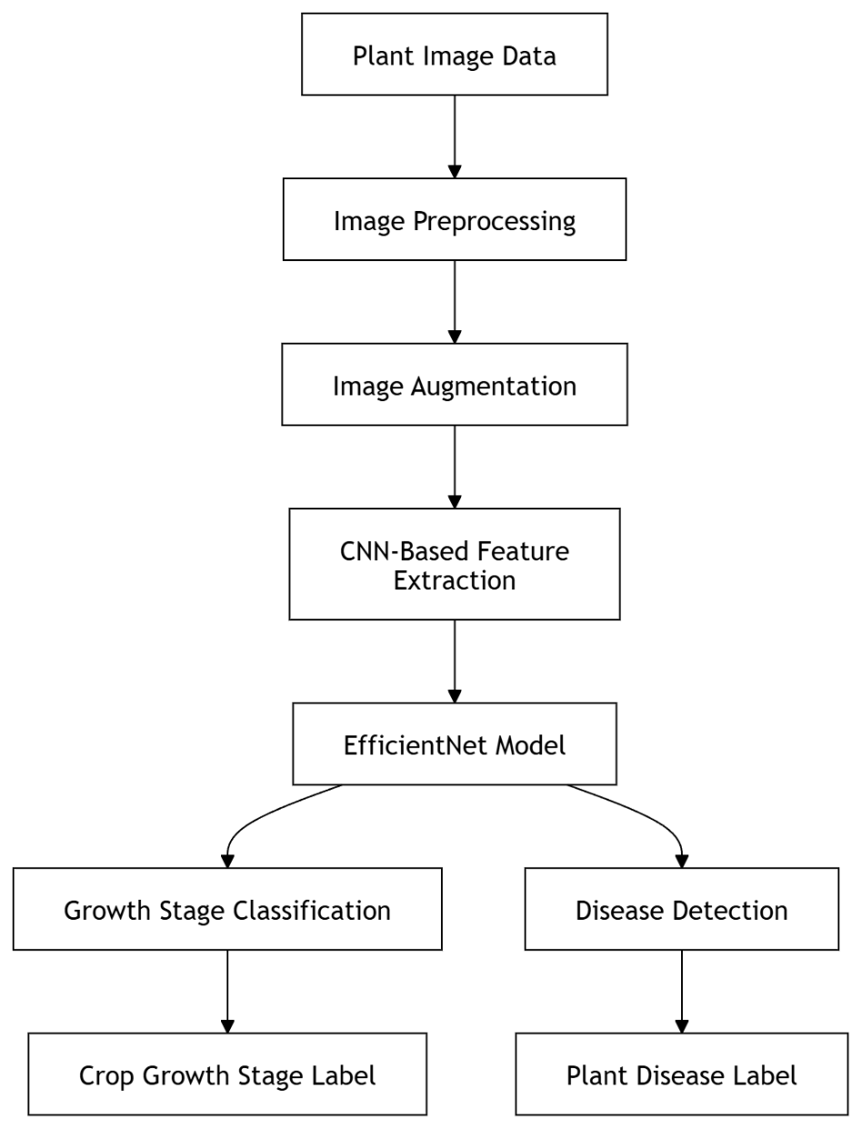
Fig. 3.4 Growth Stage Classification and Disease Detection Workflow
3.4.2 PREDICTIVE ANALYTICS AND CROP HEALTH FORECASTING
3.4.2.1 OVERVIEW OF THE MODULE
The Predictive Analytics and Crop Health Forecasting module comprises three interconnected models: a weather forecasting model, a crop growth progression model, and a disease progression model. The weather forecasting model predicts short-term environmental conditions inside the greenhouse, providing critical inputs for downstream analysis. The growth progression model analyzes temporal patterns in plant development to estimate future growth stages and transition timelines. The disease progression model evaluates current infection levels and predicts future severity and trends for multiple diseases using historical environmental and crop data. Together, these models enable data-driven, forward-looking insights that support proactive decision-making and form the predictive backbone of the digital twin and control system.
3.4.2.2 TASK-LEVEL DECOMPOSITION OF THE MODULE
The Predictive Analytics and Crop Health Forecasting Module is designed to transform greenhouse data and intermediate crop analysis outputs into actionable, forward-looking insights. By leveraging time-series modeling and integrated predictive techniques, the module supports proactive decision-making in greenhouse management.
Fig. 3.5 illustrates the task-level decomposition of the Predictive Analytics and Crop Health Forecasting Module. The module analyzes greenhouse environmental data and crop analysis outputs to predict disease risk, forecast growth progression, and estimate future environmental conditions.
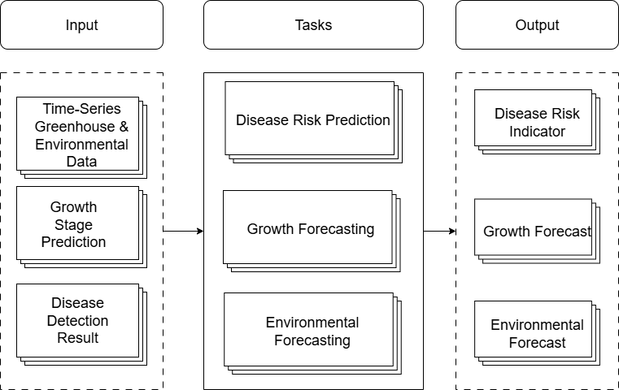
Fig. 3.5 Task-Level Architecture of Predictive Analytics and Crop Health Forecasting Module
3.4.2.3 MODULE IMPLEMENTATION DETAILS
A. Environmental Condition Forecasting
The greenhouse weather forecast model in AgriTwin-GH is implemented as a hybrid multi-model forecasting framework designed to predict short-term indoor environmental conditions at 24-hour and 48-hour horizons. Its primary objective is to estimate future values of key climate variables such as air temperature, relative humidity, wind speed, and solar radiation, while also optionally classifying future sky-condition labels. These forecasts are essential because greenhouse control decisions cannot rely only on current readings; instead, the system must anticipate how the internal environment will evolve so that irrigation, ventilation, fogging, cooling, and other control actions can be planned proactively. For this purpose, the model is built as an ensemble of three complementary forecasting paradigms: a pretrained transformer-based time-series foundation model named Chronos-T5-small, a gradient-boosted tree-based forecasting component using XGBoost, and a sequence learning component based on Long Short-Term Memory (LSTM) networks. Together, these models provide a robust balance between global temporal understanding, structured tabular learning, and local sequential pattern modeling.
The implementation begins with historical greenhouse environmental data collected as a chronological time series. For this project, the weather source corresponds to Dindigul District data from 2024–2025, organized as daily observations with variables such as datetime, temp, humidity, windspeed, solarradiation, conditions, sunriseEpoch, and sunsetEpoch. The data is split chronologically into training, validation, and test subsets in a 70:15:15 ratio. This chronological split is a critical design choice because weather forecasting is inherently temporal; the model must learn only from past observations and be evaluated on unseen future periods, thereby avoiding look-ahead bias. Before training, the raw series is cleaned, missing values are handled, temporal continuity is ensured, and calendar-related attributes are extracted.
A major part of the implementation lies in feature engineering, because raw environmental values alone cannot adequately describe seasonality, temporal momentum, volatility, or deviations from normal climatic behavior. The model therefore constructs cyclical time features using sine and cosine encodings of day-of-year, month, and day-of-week so that periodic seasonal patterns can be learned without artificial discontinuity between the end and beginning of cycles. It also introduces region-specific seasonal flags for Dindigul, partitioning the year into Hemant, Grishma, Varsha, and Sharad periods to explicitly encode climatological shifts relevant to local agricultural conditions. In addition, lag features are created at 1, 2, 3, 7, 14, and 30 days, allowing the model to exploit autocorrelation in each target variable. Rolling mean, standard deviation, minimum, and maximum statistics over 7-day, 14-day, and 30-day windows are also computed to capture short-term and medium-term climate trends and variability. These rolling statistics are shifted appropriately to prevent data leakage from future values.
Beyond conventional temporal features, the implementation includes climatological normals and anomaly-based features. Monthly and weekly average baselines are computed for each target variable, and anomaly terms are then derived as the difference between the observed value and the typical value for that time of year. This is agriculturally meaningful because plant stress and disease dynamics often depend not only on absolute conditions, but also on whether those conditions are abnormally high or low relative to seasonal expectation. The model also derives solar geometry features, including day length from sunrise and sunset times and normalized solar radiation, which help capture the relationship between incoming light and seasonal daylight cycles. Another important innovation is the inclusion of interaction features such as temperature–humidity and wind–solar combinations, enabling the model to learn compound environmental effects rather than treating each variable independently.
For variables with unstable or sparse behavior, especially humidity and wind speed, the implementation adds volatility-aware descriptors. These include rate-of-change or momentum terms over multiple temporal spans, rolling volatility clusters, lag-based autocorrelation proxies, and regime indicators that distinguish high-variability periods from more stable ones. This is particularly useful because difficult variables often show abrupt shifts and irregular dynamics that cannot be captured well through simple lags alone. By explicitly modeling volatility regimes and momentum, the forecasting pipeline improves discrimination between genuine predictable signals and noise. All generated features are saved through a feature configuration file so that the exact same preprocessing logic can be reproduced during inference.
The first forecasting family in the implementation is Chronos-T5-small, a pretrained time-series foundation model based on the T5 transformer architecture. Chronos functions analogously to a language model, but for numerical sequences: it reads past time-series values and learns to generate future ones by leveraging general temporal representations acquired during large-scale pretraining. In this implementation, Chronos is fine-tuned on the greenhouse environmental series using a 30-day context window and is trained to forecast the next two steps, corresponding to 24-hour and 48-hour predictions. Fine-tuning is executed in two phases. During the warm-up phase, the encoder is frozen and only the decoder and output head are trained using a learning rate of 1e-3, which stabilizes adaptation and protects pretrained knowledge from abrupt distortion. During the second phase, all parameters are unfrozen and full fine-tuning is performed at a lower learning rate of 1e-4 while monitoring validation MAPE. The final Chronos outputs serve two purposes: they participate directly in the ensemble’s final predictions, and they are also reused as meta-features for the XGBoost and LSTM models, thereby transferring pretrained temporal knowledge into the other model families.
The second model family is XGBoost, implemented as a direct multi-step forecasting framework. Instead of recursively forecasting one step and feeding that result back for later steps, the pipeline trains separate models for each target–horizon pair. Because there are four numerical targets and two forecast horizons, eight XGBoost models are trained in total. This direct strategy avoids recursive error accumulation and allows each model to specialize in a specific prediction task. A strong technical contribution in this implementation is per-column variable-specific regularization. Different climate variables exhibit very different noise levels and predictability characteristics, so the same tree depth and regularization strength would be suboptimal for all. Temperature and solar radiation are modeled with moderate tree depth and regularization, humidity is assigned shallower depth and stronger penalties due to higher volatility, and wind speed is given extremely shallow trees with very strong L1/L2 regularization because it is sparse and highly noise-prone. The windspeed configuration, with depth reduced to a stump-like structure and high lambda and alpha values, is specifically intended to force the model to learn only the most reliable feature interactions instead of overfitting spurious fluctuations.
XGBoost training itself is performed in two stages. A warm-up booster is first trained with shallow trees, fewer boosting rounds, and a higher learning rate to establish a stable initial model. This is followed by a fine-tuning phase with more estimators, lower learning rate, per-variable depth selection, and variable-specific regularization. Early stopping on validation MAE is used to halt boosting once further trees cease to improve generalization. Importantly, the XGBoost models do not rely only on raw environmental features; they consume the complete engineered feature set, including lag statistics, anomaly descriptors, seasonal flags, interaction features, and Chronos meta-features. As a result, the XGBoost branch is particularly effective at exploiting structured feature interactions and non-linear relationships that are difficult to capture through purely sequential models.
The third forecasting family is the LSTM component, which is implemented as a recurrent sequential regressor. Unlike XGBoost, which learns from the last available feature vector, the LSTM explicitly processes a sequence of the previous 30 days. The implementation uses two stacked LSTM layers with 128 hidden units, followed by layer normalization and a feed-forward prediction head. A key architectural refinement is that separate LSTM models are trained for each target–horizon pair rather than one model jointly predicting both horizons. This means eight LSTM models are produced in total. The reason for this design is that 24-hour and 48-hour forecasting difficulties are not equivalent: a joint model tends to compromise between the easier short-horizon task and the harder long-horizon task, whereas separate models allow horizon-specific regularization. The 48-hour models are assigned additional dropout to handle the higher uncertainty of longer-range prediction, and variable-specific learning rates are also used so that stable variables such as temperature can train more aggressively while volatile variables such as humidity and wind speed are optimized more cautiously.
The LSTM models are trained on sliding windows, with each sample consisting of the last 30 days of engineered features and a single future target value for one specific horizon. A separate StandardScaler is fit for each variable–horizon pair using only training data. The training objective uses Huber loss with delta equal to 1.0, which is more robust than plain mean squared error because it behaves quadratically for small errors but linearly for large deviations, making it well suited to weather data where occasional outliers or extreme fluctuations can otherwise dominate optimization. The optimizer is Adam with weight decay, the learning rate follows cosine annealing, gradient clipping is applied to maintain stable recurrent training, and early stopping is used to prevent overfitting. The implementation explicitly notes that LSTM was preferred over a Temporal Fusion Transformer because the available dataset size is relatively small, around a few hundred effective daily samples after feature construction, and TFT was found less stable and more prone to underfitting in this low-data setting.
Once Chronos, XGBoost, and LSTM predictions are available, the final forecast is generated through an ensemble blending stage. Rather than assigning fixed manual weights, the implementation uses Optuna with a Bayesian Tree-Parzen Estimator sampler to optimize blending coefficients for each target and horizon independently. The ensemble therefore learns weights​ subject to non-negativity and unit-sum constraints, minimizing validation MAPE. This per-target, per-horizon weighting is a major strength of the implementation because different variables benefit from different forecasting mechanisms. For example, temperature at 24 hours is dominated by XGBoost, temperature at 48 hours leans more toward LSTM, humidity at 48 hours relies more on Chronos, and solar radiation is strongly LSTM-dominant, especially at the shorter horizon. This demonstrates that the final system is not a simple average of models, but an adaptive ensemble whose blending logic itself is data-driven.
An auxiliary Random Forest classifier is also trained for each horizon to convert numerical environmental forecasts into categorical sky-condition labels such as sunny, partly cloudy, overcast, or rainy. This classifier uses the predicted numerical variables along with temporal context to generate a discrete condition output, improving interpretability for later dashboard and decision-support layers. After training, the implementation exports all artifacts required for deployment, including the main LSTM bundle, fine-tuned Chronos weights, XGBoost model files, scalers, label encoder, feature configuration, climate normals, ensemble weights, evaluation metrics, and a reusable inference loader. The inference pipeline reconstructs the exact preprocessing steps, runs all three model families, applies the learned ensemble weights, and outputs the final 24-hour and 48-hour climate forecasts in a deployment-ready form.
Overall, the weather forecast implementation in AgriTwin-GH is not a single algorithm but a carefully engineered hybrid forecasting system. Chronos contributes global temporal priors from large-scale pretraining, XGBoost captures structured feature interactions with variable-aware regularization, and LSTM learns sequential dependencies through horizon-specific recurrent modeling. The use of advanced feature engineering, chronological validation, model-specific hyperparameter strategies, Optuna-based ensemble optimization, and deployment-oriented artifact management makes the module technically deep and operationally suitable for integration with crop forecasting, disease prediction, the digital twin, and later model predictive control layers.
Fig. 3.6 illustrates the high-level workflow of the weather forecasting model, including data preprocessing, feature engineering, multiple model training, ensemble fusion, and generation of future environmental forecasts.
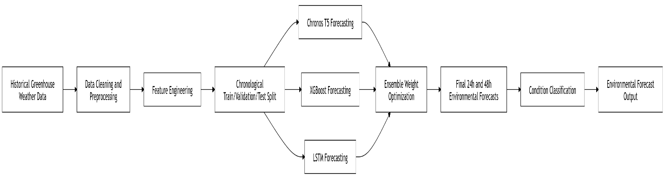
Fig. 3.6 Weather Forecasting Model Architecture
B. Disease Risk Prediction
The tomato disease progression model in AgriTwin-GH is implemented as a time-series disease forecasting pipeline that predicts how greenhouse tomato diseases evolve over the next 24 hours by combining current infection status, temporal environmental patterns, and disease-specific severity behavior. The model is designed to answer three operational questions simultaneously for each disease at every timestamp window: whether the disease is currently present, what its future infection severity will be after 24 hours, and whether the disease trend should be interpreted as absent, emerging, reducing, stable, or worsening. Unlike a simple disease classifier that detects only the present condition, this implementation focuses on progression modeling, making it suitable for preventive greenhouse management where intervention must occur before visible damage escalates.
The implementation begins with an hourly synthetic yet physically plausible disease progression dataset stored in long format, where each timestamp contains multiple rows, one for each disease. Each row includes the disease identity and its current infection percentage at that time. Since machine learning models require fixed-width structured input, the data is transformed from long format into wide format through a pivoting process. After this transformation, each timestamp becomes a single row containing separate disease-specific columns such as current presence flags, current severity values, future severity targets, and derived trend labels. This restructuring is essential because it allows the model to learn across all diseases within one unified feature space while preserving disease-wise output separation. The diseases are dynamically discovered from the dataset itself and encoded into structured groups, which makes the implementation extensible if the disease list changes later.
A major implementation component is future target construction. The notebook uses a 24-hour forecasting horizon and a history window of 24 hourly steps, meaning that the past 24 hours are used to predict disease behavior in the next 24 hours. Future severity targets are generated through time shifting, and disease trend labels are derived using a rule-based function rather than a separate classification head. This is a deliberate technical choice. Instead of training a neural network to directly output the five trend categories, the system first predicts future severity numerically and then infers trend logically from the difference between current and future severity. Two important parameters govern this logic: severity_delta = 3.0, which defines the minimum change required to call a disease worsening or reducing, and severity_floor = 0.5, which defines values below which infection is treated as effectively zero. This floor is critical because very small severity outputs may appear as 0.0 when rounded, and without such thresholding the system could incorrectly label negligible noise as an emerging disease. In this design, if both current and future severities are near zero the trend is absent, if current severity is near zero but future severity exceeds the floor the trend is emerging, if the future severity is sufficiently lower the trend is reducing, if the change is small the trend is stable, and if the increase exceeds the threshold the trend is worsening. This rule-based layer improves interpretability and ensures biologically meaningful output behavior.
Before model fitting, the implementation performs a feature encoding pipeline to ensure all model inputs are numeric and leakage-free. Categorical variables are detected and one-hot encoded, while target columns are excluded from the predictor matrix. An integrity check is then run to verify that no object or text data types remain in the encoded feature matrix. The dataset is split chronologically into training, validation, and test subsets using a 70:15:15 policy. This time-based split is essential for forecasting realism, because using random splits in sequential disease data would leak future structure into training and lead to overly optimistic performance estimates. The implementation therefore mimics real deployment, where only past observations are available when predicting future disease behavior.
To establish strong reference performance, the notebook first trains two baseline models using HistGradientBoosting. For current disease presence, it uses a MultiOutputClassifier wrapped around HistGradientBoostingClassifier, enabling simultaneous yes/no prediction for multiple diseases. For future severity forecasting, it uses a MultiOutputRegressor with HistGradientBoostingRegressor, producing one regression output per disease. These baseline models are trained on a lagged flat feature matrix generated from the previous 24 hours of data. In other words, the past 24 hourly observations are flattened into tabular lag features so that gradient boosting can still exploit temporal context even though it is not a sequence model in the recurrent sense. The baseline is technically important for two reasons: it provides a strong non-deep learning benchmark, and it offers stable future severity predictions that are later reused for hybrid evaluation-time blending. The future severity baseline outputs are clipped to the range [0, 100] to maintain physical realism, since disease severity is represented as an infection percentage and cannot be negative or exceed full infection.
The core deep learning implementation is based on recurrent neural networks, specifically LSTM and GRU architectures. The notebook constructs sequence tensors, where each sample corresponds to a rolling 24-hour observation window aligned to the final timestamp of that window. These sequence inputs are scaled using a feature scaler fitted only on training data and then applied to validation and test sets, preventing leakage while stabilizing optimization. The recurrent architecture is designed as a two-head multi-task model. A shared temporal encoder first processes the 24-hour sequence and learns latent representations of short-term disease evolution, environmental influence patterns, and cross-disease temporal dependencies. This shared encoder then branches into two task-specific heads. This shared-backbone, dual-head design is efficient because both tasks depend on the same temporal dynamics; current presence and future severity are not independent problems but linked aspects of disease progression. By learning them together, the encoder captures richer disease-state representations than would be possible with fully separate models.
The training process includes several safeguards, EarlyStopping to halt training when validation performance stops improving, ReduceLROnPlateau to decrease the learning rate when optimization stagnates, and ModelCheckpoint to preserve the best-performing LSTM and GRU weights. These callbacks are especially important in sequential greenhouse data because recurrent models can otherwise overfit easily, particularly when disease transitions are sparse or class distributions are imbalanced. The notebook trains both LSTM and GRU variants under the same pipeline and then automatically selects the globally best deep model by comparing validation losses, ensuring that architecture choice is evidence-driven rather than fixed by assumption.
Another technically important part of the implementation is the evaluation-stage enhancement used to address weak future-severity regression quality. The notebook notes that future R² can sometimes become negative, meaning the deep model’s future severity predictions are performing worse than a simple mean predictor. To improve this without retraining the recurrent network, the implementation introduces validation-tuned blending between LSTM future predictions and baseline future predictions. This is a strong practical technique because it preserves the trained deep model and its checkpoints while still improving regression robustness through calibrated fusion with the stable gradient-boosting baseline. In effect, the recurrent model contributes temporal pattern sensitivity, while the baseline contributes conservative tabular stability.
The evaluation framework is comprehensive and task-specific. For disease presence, the model is assessed using micro-F1, macro-F1, ROC-AUC, PR-AUC, and Brier score, capturing not only classification correctness but also ranking quality and probability calibration. For future severity regression, the implementation computes MAE, RMSE, R², explained variance score, and median absolute error. For disease trend, performance is summarized using trend macro-F1, since trend labels are generated from the predicted and current severity values rather than directly produced by a softmax classifier. Additional diagnostic plots are exported, including ROC and precision-recall curves for presence, residual histograms for future severity, and parity plots comparing predicted and actual future infection percentages. These diagnostics are essential for understanding whether the model is well calibrated, biased toward under- or over-prediction, or struggling on specific disease outputs.
The deployment-oriented implementation also includes a real-time inference demo and a practical scenario simulation. In the inference step, the latest 24-hour window is passed through the selected model to generate per-disease present-state and next-24-hour predictions, reproducing how the system would behave in live greenhouse operation. In the scenario simulation stage, environmental stressors such as humidity, airflow, and VPD are modified to observe how disease progression outputs change before and after the simulated disturbance. This is particularly relevant for AgriTwin-GH because it links predictive modeling to actionable greenhouse interpretation rather than leaving the model as a purely offline analytical tool. The artifact export process saves baseline models, best LSTM and GRU checkpoints, the selected final model, sequence scaler, deep-model metrics, comparison tables, configuration snapshots, training curves, and other diagnostics inside a structured run-specific artifact directory. This makes the implementation reproducible, auditable, and directly portable into later digital twin and control workflows.
Overall, the disease progression model is implemented as a hybrid forecasting and interpretation system rather than a single monolithic predictor. HistGradientBoosting baselines provide strong tabular references for presence and severity, recurrent LSTM and GRU models learn temporal disease evolution from 24-hour sequential windows, and a biologically informed trend logic layer converts raw severity forecasts into operationally meaningful trend categories. The addition of floor-aware rule derivation, chronological validation, hybrid deep-baseline blending, and structured artifact export gives the module both technical depth and practical robustness, making it suitable for proactive disease risk management within the AgriTwin-GH predictive pipeline.
Fig. 3.7 illustrates the high-level workflow of the disease progression model, including data transformation, feature encoding, sequence modeling, and prediction of disease presence, severity, and future trends.
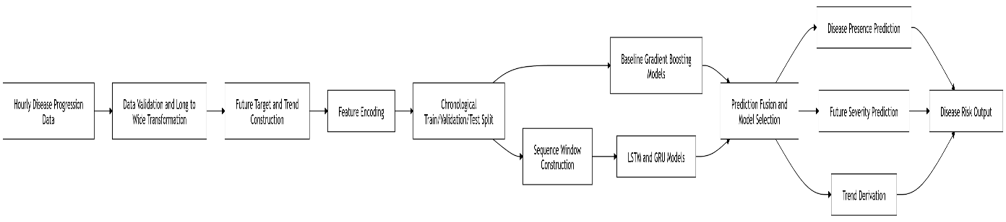
3.7 Disease Progression Prediction Model Architecture
C. Growth Progression Forecasting
The tomato growth progression model is implemented as a sequence-based multi-task learning framework that predicts how tomato plants advance through biologically ordered developmental stages using greenhouse sensor data alone. Instead of treating growth analysis as a single classification problem, the implementation models progression as a richer temporal forecasting task. For every hourly observation window, the system predicts five related outputs simultaneously: the current growth stage, the next stage in the development sequence, the estimated number of hours remaining until the next transition, whether a stage transition will occur within 24 hours, and whether it will occur within 48 hours. This design makes the model operationally valuable because it does not only describe the plant’s present condition, but also provides forward-looking estimates that can support timing-sensitive greenhouse decisions such as nutrient adjustment, flowering support, fruit development management, and harvest preparation.
The implementation uses a processed realistic hourly time-series dataset. Each row represents one hour in the lifecycle of a tomato plant and includes fields such as timestamp, cycle identifier, stage label, indoor temperature, indoor humidity, solar radiation, and indoor CO₂ concentration. A key structural concept in this pipeline is the growth cycle. Each cycle corresponds to a complete plant life trajectory from seedling to ripe fruit, and the dataset contains multiple such cycles. This allows the model to learn temporal progression patterns across many plant instances while later being evaluated on entirely unseen cycles.
A rigorous cycle validation stage is included before training begins. Each cycle is checked for minimum sequence length, monotonic timestamps, duplicate hourly records, illegal stage reversals, and stage completeness. This is especially important because tomato growth is biologically ordered and cannot move backward from flowering to seedling, for example. Cycles containing stage reversals or severely corrupted temporal structure are removed, while cycles with missing intermediate stages are flagged but may still be retained if they remain useful for learning. This integrity-checking logic improves the biological validity of the training data and prevents the network from learning impossible transitions.
The target-construction stage is one of the core technical strengths of the implementation. For every timestamp within a cycle, the notebook looks forward through future rows of that same cycle to compute five progression-related supervision targets. These include next_stage, hours_to_next_stage, transition_within_24h, transition_within_48h, and stage_progress_fraction, where the last variable measures how far the plant has progressed within its current stage. This transforms raw chronological greenhouse observations into a structured progression-learning problem. The design is biologically meaningful because plant development is not instantaneous; a plant can remain in a stage for a variable duration, and predicting the residual time to the next stage is as important as identifying the class label itself. The model therefore learns not only discrete stage identities but also the tempo of stage evolution. Rows at the end of the final ripe stage naturally lack forward transitions and may carry NaN for future-target fields, which the training and evaluation logic handles appropriately.
Feature engineering is extensive and is designed to expose both environmental state and developmental momentum. In addition to raw greenhouse variables such as temperature, humidity, light, and CO₂, the model derives rolling statistics over 6-hour, 12-hour, and 24-hour windows to capture local environmental trends. Lag features are computed so that the model can explicitly see recent values from prior hours and infer whether climate variables are rising, stable, or falling. Several biologically motivated engineered features are also included.
To make the data compatible with recurrent deep learning, the implementation transforms the hourly time series into sliding windows of fixed length. A 24-hour sequence length is used, meaning that the model always receives the previous 24 hours of observations when generating its five outputs. This design is deliberate because a full day-night cycle captures important greenhouse periodicity, including temperature and humidity oscillations, light exposure timing, and short-term physiological responses. Each window becomes one training sample in a 3D tensor, where each slice preserves ordered temporal structure. This sequence-based framing is what allows the network to detect stage progression not merely from single environmental snapshots, but from patterns of change across time.
The dataset is split into training, validation, and test subsets at the cycle level using a 70:15:15 policy. This is a technically important choice. If rows were split randomly, windows from the same plant cycle could leak into both train and test sets, producing unrealistically optimistic evaluation. By splitting by cycle, the model is forced to generalize to completely unseen plant lifecycles. After the split, feature scaling is applied using StandardScaler, fitted only on the training data and then reused for validation and test sets. This prevents leakage from future samples while stabilizing neural network optimization by ensuring that features with very different numerical ranges, such as CO₂ and temperature, are normalized into comparable scales.
Before training the main deep network, the implementation establishes reference baselines. A Random Forest classifier is trained to predict current stage from flattened sequence data, and an XGBoost regressor is trained to predict hours to next stage from the same flattened representation. These baselines are not sequence-aware in the recurrent sense, but they provide strong tabular benchmarks. Their presence is important methodologically because they show whether the more complex temporal model truly adds value. The Random Forest also produces feature importance statistics, which help identify which engineered variables contribute most strongly to growth-state discrimination. By comparing the LSTM against these baselines, the notebook quantifies the benefit of temporal representation learning rather than assuming it.
The core model is a multi-output LSTM architecture. Its backbone consists of two stacked LSTM layers, the first LSTM layer has 128 hidden units and returns sequences, while the second compresses the temporal information into a final summary representation with 64 units. This output then passes through batch normalization, a dense layer with ReLU activation, and dropout at 30% to reduce overfitting. The shared temporal backbone is then followed by five specialized heads, one for each task. The current_stage and next_stage heads perform six-class classification over the ordered tomato stages. The hours_to_next head performs continuous regression of time remaining to the next transition. The trans_24h and trans_48h heads model binary transition probabilities for the respective forecasting windows. This architecture is a classic multi-task design in which one shared sequence encoder learns general growth dynamics, while task-specific heads specialize in different but related outputs.
The choice of LSTM is particularly appropriate because growth progression is inherently sequential and depends on prior states. Unlike feedforward models that treat each input independently, LSTM networks maintain an internal memory state that can carry forward information about earlier conditions and temporal context. This allows the model to infer not only where the plant is now, but how it got there and how close it is to its next developmental transition. The implementation explicitly frames this as multi-task learning because all five outputs are produced in a single forward pass from a shared backbone. This improves data efficiency and encourages shared latent representations: for example, learning hours to next stage helps the model infer transition probabilities, while learning current and next stage jointly helps it understand progression directionality. The architecture is therefore not just compact, but functionally synergistic.
The training configuration uses task-appropriate objectives. The classification heads for current stage and next stage use categorical cross-entropy. The hours_to_next regression head uses Huber loss, which is more robust than plain mean squared error when occasional large prediction errors occur. The transition outputs are documented as binary outputs, and the implementation also applies post-processing rules during inference so that these probabilities remain logically consistent with the predicted hours-to-next-stage value. In particular, if the model predicts that the next transition is more than 24 hours away, the 24-hour transition probability is forcibly set to zero, and similarly for 48 hours. This is a valuable consistency mechanism because it prevents contradictory outputs such as “220 hours to transition” alongside a large 24-hour transition probability. Class weighting is also incorporated so that rare stages, such as ripe fruit, are not ignored relative to longer-duration stages such as early vegetative development.
Model training uses several safeguards that are standard in robust deep-learning practice. EarlyStopping halts training when validation performance stops improving, ReduceLROnPlateau lowers the learning rate when progress stalls, and ModelCheckpoint stores the best model weights observed during training even if later epochs degrade. A tf.data.Dataset pipeline is used to deliver data efficiently in batches, and the full epoch-wise loss and metric history is stored in both CSV and JSON form. This makes the training process auditable and reproducible. The notebook then evaluates the trained model on the held-out test set using classification metrics such as accuracy, precision, recall, F1 score, and confusion matrices for the stage outputs, alongside MAE, RMSE, and MAPE for the hours-to-transition regression output. The transition outputs are evaluated with classification metrics and ROC-AUC. This evaluation design recognizes that the model solves a mixed task involving both classification and regression, and therefore requires heterogeneous metrics rather than a single score.
The implementation also includes inference utilities and deployment-oriented artifact export. A set of helper functions preprocess new sensor data, rebuild the latest 24-hour sequence window, apply the saved scaler, decode stage indices back to stage names, and return a human-readable progression forecast. In addition to the trained Keras model, the pipeline saves the scaler, inference configuration, full prediction CSVs, summary reports, evaluation plots, class distributions, and per-run logs into a structured artifact folder under the model run ID. This makes the system suitable not only for experimentation but also for later integration into the AgriTwin-GH pipeline, where progression forecasts can be passed to the digital twin and, subsequently, to the MPC layer.
Overall, the tomato growth progression module is implemented as a biologically aware temporal forecasting system rather than a static stage classifier. It combines rigorous data standardization, cycle-level validation, future target construction, rich engineered features, sequence-window modeling, baseline benchmarking, and a five-head LSTM-based multi-task network. Because it predicts both discrete stage identities and the timing of future transitions, the model provides technically deep and practically useful progression intelligence for greenhouse decision support.
Fig. 3.8 illustrates the high-level workflow of the growth progression model, showing data validation, feature engineering, sequence modeling, and multi-task prediction of plant growth stages and transitions.
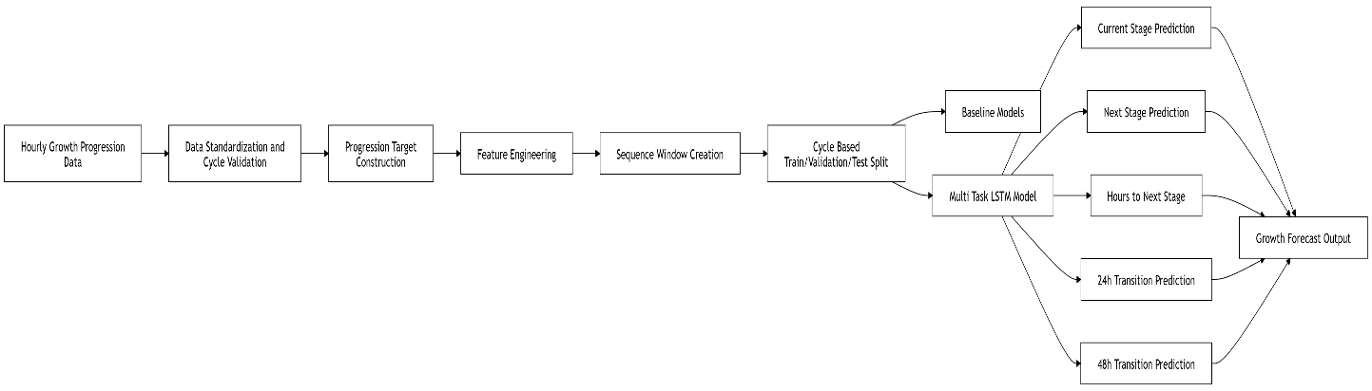 Fig. 3.8 Growth Progression Prediction Model Architecture
3.4.3 DIGITAL TWIN SIMULATION AND INTELLIGENT GREENHOUSE CONTROL
3.4.3.1 OVERVIEW OF THE MODULE
Module 3 focuses on the development and integration of an intelligent greenhouse control system using a digital twin–driven approach. It combines environmental forecasts, crop growth progression, disease progression, and real-time greenhouse conditions to simulate and optimize greenhouse operations. A digital twin closed-loop simulation continuously predicts the greenhouse state, while a Model Predictive Control (MPC) framework generates optimal actuator decisions for maintaining ideal crop conditions. The system is supported by a backend API and frontend interface for real-time monitoring and operator interaction, along with a 3D greenhouse visualization for intuitive representation of system behavior. Additionally, the module produces historical summaries for performance evaluation, resource tracking, and decision analysis.
3.4.3.2 TASK-LEVEL DECOMPOSITION OF THE MODULE
To systematically organize the functionalities of the module, the overall system is structured into distinct task components that capture the flow from input data to final outputs. This decomposition helps in clearly identifying the role of each subsystem, including simulation, control, integration, and visualization, while ensuring seamless interaction between them. It also provides a clear mapping between the data inputs, processing stages, and resulting outputs, enabling better understanding, implementation, and evaluation of the complete greenhouse digital twin system.
Fig. 3.9 illustrates the task-level decomposition of the Digital Twin Simulation and Intelligent Greenhouse Control Module. It presents how predictive outputs and real-time greenhouse data are used to simulate greenhouse conditions and support intelligent control and monitoring.
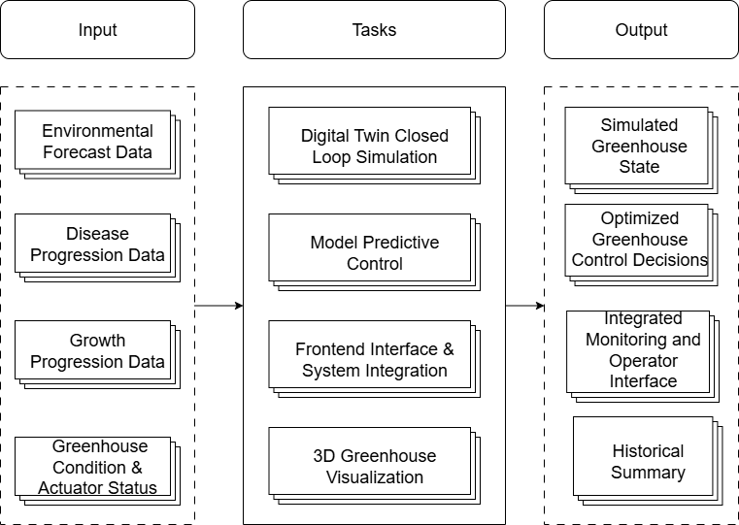
Fig. 3.9 Task-Level Architecture of Digital Twin Simulation and Intelligent Greenhouse Control Module
3.4.3.3 MODULE IMPLEMENTATION DETAILS
A. Model Predictive Control
The Model Predictive Control (MPC) serves as the core decision-making layer responsible for optimizing greenhouse operations under dynamic environmental and crop conditions. It operates by continuously predicting future greenhouse states over a finite horizon and computing optimal actuator actions that minimize deviations from desired crop-specific conditions while respecting operational constraints. The MPC framework integrates multiple heterogeneous inputs, including environmental forecasts, disease progression outputs, crop growth stage information, and real-time greenhouse sensor data, into a unified fused state representation. This fused state forms the basis for predictive modeling and optimization, enabling the controller to anticipate future system behavior rather than reacting only to current conditions.
The greenhouse system is modeled using a discrete-time state transition framework, where the state vector consists of key environmental and crop-related variables such as temperature, humidity, CO₂ concentration, soil moisture, light intensity, vapour pressure deficit (VPD), and leaf wetness. The control input vector includes actuator variables such as fan speed, vent opening, heater output, irrigation rate, LED intensity, fogger operation, and CO₂ injection. The system dynamics are represented using an Auto-Regressive with eXogenous inputs (ARX) model, which allows efficient prediction of future states based on current conditions, control inputs, and external disturbances.
The general ARX-based state transition equation is:
(15)
$$x_{i}\left[k+1\right]= α_{i}x_{i}\left[k\right]+ Σ β_{ij}u_{j}\left[k\right]+ Σ γ_{im}d_{m}\left[k\right]+ ε_{i}$$
where $x_{i}\left[k\right]$ represents the i-th state variable at time step k, $u_{j}\left[k\right]$ represents the j-th control input, $d_{m}\left[k\right]$ represents external disturbances such as outdoor weather, α_{i} is the state persistence coefficient, $β_{ij}$ ​ represents actuator influence, $γ_{im}$ represents disturbance influence, and $ε_{i}$ captures modeling uncertainty.
Among the state equations, the indoor temperature dynamics are particularly critical and are modeled as:
(16)
$$T\left[k+1\right]= α_{T}T\left[k\right]+ γ_{ext}\left(T_{ext}\left[k\right]- T\left[k\right]\right)+ γ_{sol}S\left[k\right]+ β_{heat}u_{heater}+ β_{fan}u_{fan}+ β_{vent}u_{vent}$$
where T[k] is indoor temperature, T_{ext}[k] is outdoor temperature, S[k] is solar radiation, and actuator terms represent heating and cooling effects. Similar formulations are used for humidity, CO₂, and light intensity, while soil moisture follows a water balance equation and derived variables such as VPD are computed analytically:
(17)
$$VPD = \left(1 -\frac{RH}{100}\right)× SVP\left(T\right)$$
where RH is relative humidity and SVP(T) is the saturation vapor pressure at temperature T.
The MPC optimization problem is formulated as a finite-horizon cost minimization:
(18)
$$\min{J\left(u\right)}= Σ_{\left\{k=0\right\}}^{\left\{N-1\right\}}l\left(x_{k}, u_{k}, u_{\left\{k-1\right\}}\right)+ V_{f\left(x_{N}\right)}$$
where N is the prediction horizon, ℓ(⋅) is the running cost, and $V_{f\left(x_{N}\right)}$ is the terminal cost. This formulation ensures that both immediate and future system behavior are optimized.
The running cost is a composite objective that includes multiple agronomic and operational components. The most important component is the setpoint tracking cost:
(19)
$$l_{track}= Σ m_{i}w_{i}{\left(\frac{x_{k}^{i}- x*^{i}}{σ_{i}}\right)}^{2}$$
where $x_{k}^{i}$ is the predicted state, $x*^{i}$ is the desired setpoint for the current growth stage, $σ_{i}$ ​ is a normalization factor, w_{i} is a weighting factor, and m_{i} is a modifier based on environmental context. This ensures balanced penalization across variables with different physical units.
Additional cost terms include energy consumption:
(20)
$$l_{energy}= Σ c_{j}u_{j}^{2}$$
water usage:
(21)
$$l_{water}= c_{w}u_{irrigation}^{2}$$
and actuator smoothness:
(22)
$$l_{smooth}= Σ λ_{j}{\left(u_{j\left[k\right]}- u_{j\left[k-1\right]}\right)}^{2}$$
These terms ensure efficient resource usage and prevent abrupt actuator changes.
A critical feature of the MPC implementation is the incorporation of disease risk into the optimization. Disease risk is estimated based on environmental conditions using a sigmoid-type function:
(23)
$$R_{disease}=\frac{1}{1 + e^{\left\{-\left(a_{1}RH + a_{2}LW + a_{3}T + a_{4}VPD + b\right)\right\}}}$$
where RH is humidity, LW is leaf wetness, T is temperature, VPD is vapour pressure deficit, and a_{i}, b are model parameters. This risk is then included as a penalty term in the cost function, enabling the controller to proactively avoid conditions favorable to disease development.
The optimization is subject to constraints that ensure safe and feasible operation. These constraints ensure that actuator commands remain within physical limits and that predicted states stay within agronomically safe ranges.
The MPC operates in a receding horizon manner, meaning that at each time step only the first control action from the optimized sequence is applied, and the optimization is repeated at the next step using updated state information. This allows continuous adaptation to disturbances and model uncertainties. A fallback baseline controller is also implemented to ensure robustness. In case of optimization failure or infeasibility, rule-based control logic is used based on priority conditions such as temperature thresholds, humidity levels, soil moisture deficits, and disease risk indicators.
Overall, the MPC implementation integrates predictive modeling, constrained optimization, disease-aware decision making, and stage-specific control into a unified framework. By leveraging both physical models and AI-driven insights, it enables intelligent, adaptive, and efficient greenhouse control, forming the central intelligence of the digital twin system.
B. Digital Twin Closed Loop Simulation
The Digital Twin (DT) simulation loop forms the execution backbone of the greenhouse intelligence system. Its purpose is to maintain a continuously evolving virtual greenhouse that mirrors greenhouse behaviour step by step, predicts the effect of actuator decisions, and feeds those predictions back into the control pipeline. The architecture is organized into three main parts: input, simulation core, and output. The input side provides greenhouse initial state, weather sequence, disease context, growth context, and image observations. The simulation core is handled by the DT loop and Digital Twin Engine, while the output side records diagnostics, summary artifacts, and real-time state updates for the API, frontend dashboard, and 3D greenhouse client. The same greenhouse ARX model and MPC logic used in the control module are reused here, ensuring that the digital twin and the controller are mathematically consistent with one another.
A major strength of the DT layer is that it supports both production and simulation execution. In production mode, it can consume real sensor and image data through the database and storage stack; in DT closed-loop mode, it can run completely without a database by generating a synthetic initial greenhouse state and synthetic outdoor weather. This makes the full system testable and demonstrable on a standalone machine while still preserving the exact same greenhouse physics and control logic. The loop is therefore not a simplified demo pipeline; it is a full execution layer that reuses the same MPC solver, ARX greenhouse model, disease-aware decision logic, and runtime state handling used in the integrated system.
At the data-structure level, the DT loop is built around four main objects: DTStepInput, DTDiagnostics, DTStepOutput, and DTLoopStepResult. DTStepInput contains the current greenhouse state, actuator action, weather state, crop growth stage, disease-risk score, disease classification, disease severity, step index, and timestamp. This is the complete input packet for one simulation step. DTDiagnostics stores all detailed outputs produced around the transition, such as energy consumed, water used, recomputed disease risk, state delta, setpoint error, effect attribution, bounds clamping, and disease-environment flags. DTStepOutput contains the predicted next greenhouse state together with diagnostics and a full snapshot. Finally, DTLoopStepResult wraps the entire step result at loop level, including whether MPC ran, whether an emergency MPC update was forced, whether an image refresh occurred, and what weather and action were used at that step. This structured design is important because the digital twin does not merely compute a next state; it also produces fully traceable evidence explaining why that state changed.
The DT loop runs on a multi-rate schedule. The simulation step itself advances every 5 minutes, the MPC optimizer runs every 15 minutes, and image-based observation is refreshed every 30 minutes. In practical terms, this means the digital twin physics evolves at every step, but the expensive optimization and CNN image inference are executed less frequently. The cadence is defined by fixed step-count conditions. Since each basic simulation step corresponds to 5 minutes, 3 steps give 15 minutes and 6 steps give 30 minutes. This design reduces computational cost while preserving responsiveness. On non-MPC steps, the previous actuator action is reused. On non-image steps, the previous image observation remains active. This makes the DT loop computationally efficient without breaking the closed-loop continuity of the greenhouse simulation.
The DT loop progression is fundamentally closed-loop because the output of one step becomes the input of the next. If the current greenhouse state at step kkk is xkx_kxk​, the control action is uku_kuk​, and the weather disturbance is wkw_kwk​, then the digital twin engine computes the next state as:
(24)
$$x_{\left\{k+1\right\}}= f\left(x_{k}, u_{k}, w_{k}\right)$$
where $f\left(⋅\right)$is the greenhouse transition function implemented by the ARX-based physics model. After the step is completed, the loop assigns the new state back into the running system, so that the next iteration starts from $x_{\left\{k+1\right\}}$​ rather than from the original input dataset. This state chaining is the defining principle of the closed-loop simulation. It allows long-term greenhouse evolution to emerge naturally from repeated interaction between control decisions, weather disturbances, and plant-environment dynamics.
Inside each 5-minute step, the Digital Twin Engine executes an eight-phase workflow. First, it updates greenhouse climate using the greenhouse transition model. Second, it recomputes disease risk from the post-step environmental state. Third, it calculates effect attribution, decomposing each state change into natural and actuator-driven contributions. Fourth, it checks disease-environment flags such as excessive humidity or wet leaf conditions. Fifth, it computes energy and water usage for the step. Sixth, it calculates variable-wise state deltas. Seventh, it detects whether any state hit a physical bound and had to be clamped. Eighth, it computes setpoint error by comparing the actual new greenhouse state against the stage-specific target profile. The result of these phases is a next greenhouse state enriched with explainable diagnostics rather than only a bare physical prediction.
The greenhouse transition itself is based on the same ARX model used by the MPC module. The general ARX state update equation used for DT simulation is:
(25)
$$x_{i}\left[k+1\right]= α_{i}x_{i}\left[k\right]+ Σ β_{ij}u_{j}\left[k\right]+ Σ γ_{im}d_{m}\left[k\right]+ ε_{i}$$
where $x_{i}\left[k\right]$ is the i-th greenhouse state variable at step k, $u_{j}\left[k\right]$ is the j-th actuator input, $d_{m}\left[k\right]$ is the m-th external disturbance, $α_{i}$ is the self-decay or persistence coefficient, $β_{ij}$ is the actuator influence coefficient, $γ_{im}$ is the disturbance gain, and $ϵ_{i}$ is process noise or model uncertainty. In the DT layer, this equation is not reimplemented independently; instead, the DigitalTwinEngine delegates all physical state propagation to GreenhouseTransitionModel which guarantees that the digital twin and MPC prediction model remain identical.
Among the individual greenhouse equations, the temperature dynamics are especially important because temperature directly affects crop stress, humidity interaction, and disease favourability. The temperature update equation is:
$$T\left[k+1\right]= α_{T}T\left[k\right]+ γ_{ext}\left(T_{ext}\left[k\right]- T\left[k\right]\right)+ γ_{sol}S\left[k\right]+ β_{heat}u_{heater}+ β_{fan}u_{fan}+ β_{vent}u_{vent}$$
where T[k] is current indoor temperature, T_{ext}[k] is external temperature, S[k] is solar radiation, $u_{heater}$ is heater output, $u{}_{fan}$ is fan speed, and $u_{vent}$ is vent opening. $α_{T}$ thermal persistence, $γ_{ext}$​ models heat exchange with the outside environment, $γ_{sol}$ models solar gain, and the β terms represent actuator effects. Positive heater gain raises temperature, while fan and vent terms reduce temperature.
(26)
Humidity dynamics are modeled in a similar ARX form:
(27)
$$H\left[k+1\right]= α_{H}H\left[k\right]+ γ_{ext}\left(H_{ext}\left[k\right]- H\left[k\right]\right)+ β_{fog}u_{fogger}+ β_{fan}u_{fan}+ β_{vent}u_{vent}+ ET$$
where H[k] is indoor humidity, H_{ext}[k] is outdoor humidity, $u_{fogger}$​ is fogger duty, and ET is evapotranspiration baseline. Here, $α_{H}$ captures humidity persistence, $γ_{ext}$​ models external moisture exchange, and the $β$terms represent the humidifying or drying contributions of actuators. This equation is particularly important because humidity strongly drives disease risk, especially in tomato greenhouse conditions.
Soil moisture is updated through a water-balance form:
(28)
$$SM\left[k+1\right]= α_{sm}SM\left[k\right]+ β_{irr}u_{irr}-λ_{ET}\max\left(T\left[k+1\right]- 15, 0\right)$$
where SM[k] is soil moisture at step k, $u_{irr}$​ is irrigation quantity, $α_{sm}$ is moisture persistence, $β_{irr}$​ is irrigation gain, and $λ_{ET}$​ is evapotranspiration loss coefficient. The term $max\left(T\left[k+1\right]- 15, 0\right)$ indicates that moisture loss increases only when temperature exceeds a baseline threshold, reflecting stronger plant and soil evaporation under warmer conditions.
The CO₂ model is given by:
(29)
$$C\left[k+1\right]= α_{C}C\left[k\right]+ β_{inj}u_{CO2}+ β_{plant}ϕ_{light\left[k\right]}+ β_{vent}u_{vent}+ γ_{vent}u_{vent}\left(C_{amb}- C\left[k\right]\right)$$
where C[k] is greenhouse CO₂ concentration, $u_{CO2}$ is valve opening for CO₂ injection, $u_{vent}$ is vent opening, $C_{amb}$​ is ambient outdoor CO₂, and $ϕ_{light}$ is light factor. This equation models both active CO₂ injection and losses through ventilation, while also accounting for crop uptake dependence on available light. Light itself is modeled as an instantaneous quantity:
(30)
$$L\left[k+1\right]= γ_{sol}S\left[k\right]+ β_{LED}u_{LED}$$
where L[k+1] is light intensity, S[k] is solar radiation, and $u_{LED}$ intensity. This is described as memoryless because light at the current step depends only on current solar and LED contribution, not on previous light values.
The DT layer also computes derived agronomic indicators after the physical state update. One of the most important is Vapour Pressure Deficit (VPD), which is recomputed from post-step temperature and humidity. The guide states that VPD is based on the Tetens equation, which can be expressed as:
$$VPD = e_{s}\left(T\right)\left(1 -\frac{RH}{100}\right)$$
where $e_{s}\left(T\right)$ is saturation vapour pressure at temperature T, and RH is relative humidity in percent. VPD is important because it summarizes the drying demand of air and strongly influences transpiration, leaf wetness, and disease favourability. Alongside VPD, a leaf-wetness proxy is also recomputed from humidity, temperature, and dew-point proximity.
(31)
A particularly important analytical component of the DT engine is disease-risk recomputation. After each greenhouse step, disease risk is recalculated from the new predicted environmental state rather than simply copied from the previous step. The complete guide describes this as a sigmoid-based multi-factor score. In report form, it can be expressed as:
(32)
$$R_{disease}= w_{1}σ\left(H; c_{H}, s_{H}\right)+ w_{2}σ\left(LW; c_{LW}, s_{LW}\right)+ w_{3}σ\left(T; c_{T}, s_{T}\right)+ w_{4}\left(1 - σ\left(VPD; c_{V}, s_{V}\right)\right)$$
where $R_{disease}$​ is the recomputed disease-risk score, H is indoor humidity, LW is leaf wetness, T is indoor temperature, VPD is vapour pressure deficit, $w_{i}$​ are weighting coefficients, and σ(⋅) is a sigmoid function parameterized by center c and slope s. This formulation allows the DT to identify disease-favourable environments even when no immediate visible disease symptom has been refreshed from image analysis.
The digital twin also produces effect attribution, which is one of the most technically valuable outputs because it explains why each state changed. For temperature, the change can be decomposed as:
(33)
$$ΔT = \left(p_{decay}^{T}- 1\right)T + p_{ext}^{T}\left(T_{ext}- T\right)+ p_{solar}^{T}solar + p_{heat}^{T}u_{heat}+ p_{fan}^{T}u_{fan}+ p_{vent}^{T}u_{vent}$$
where ΔT is the stepwise temperature change and the p coefficients correspond to decay, external exchange, solar heating, heater effect, fan cooling, and vent cooling. Similar decompositions are computed for humidity, soil moisture, CO₂, and light. These values are written into the diagnostic structure so that the system can later explain, for example, whether a temperature rise was mainly due to solar loading or heater operation, or whether humidity dropped due to fan operation or vent opening.
Resource accounting is another major part of the DT simulation loop. For each 5-minute step, the digital twin computes both electrical energy use and water consumption from the active actuators. The generic power-based step energy formula is:
(34)
$$E_{step}= sum\left(P_{j}u_{j}Δt\right)$$
where $E_{step}$​ is step energy consumption in kWh, $P_{j}$​ is the rated power of actuator j, $u_{j}$ is the normalized actuator level, and Δt is the step duration in hours. Water accounting is expressed as:
(35)
$$W_{step}= q_{irr}Δt$$

where $W_{step}$​ is step water use and $q_{irr}$ is the irrigation flow or irrigation quantity term. These per-step values are aggregated across the loop and stored in diagnostics, summaries, and historical snapshots. This makes the DT loop useful not only for environmental prediction but also for later cost and efficiency analysis.
To preserve crop realism over long simulation runs, the DT loop includes automatic growth-stage progression. If the plant has remained in a stage for its configured duration, the stage is advanced automatically. After the transition, the current stage is replaced with the next stage and the stage-hour counter is reset. This ensures that the DT loop can simulate the full crop journey from seedling to ripe stage over a long horizon rather than remaining fixed in one growth stage indefinitely. The loop also supports event-triggered MPC re-solve. Even though MPC is normally executed every 15 minutes, the system checks after each DT step whether the new greenhouse state has crossed emergency thresholds. This allows the loop to combine scheduled optimization with reactive safety intervention. This event logic makes the DT loop more robust than a strictly fixed-timing controller. Finally, the DT loop is fully integrated with the runtime system.
Fig. 3.10 illustrates the step-by-step closed-loop execution of the digital twin system, showing how greenhouse state data, predictive control, simulation, diagnostics, and runtime updates are continuously connected in a feedback cycle.
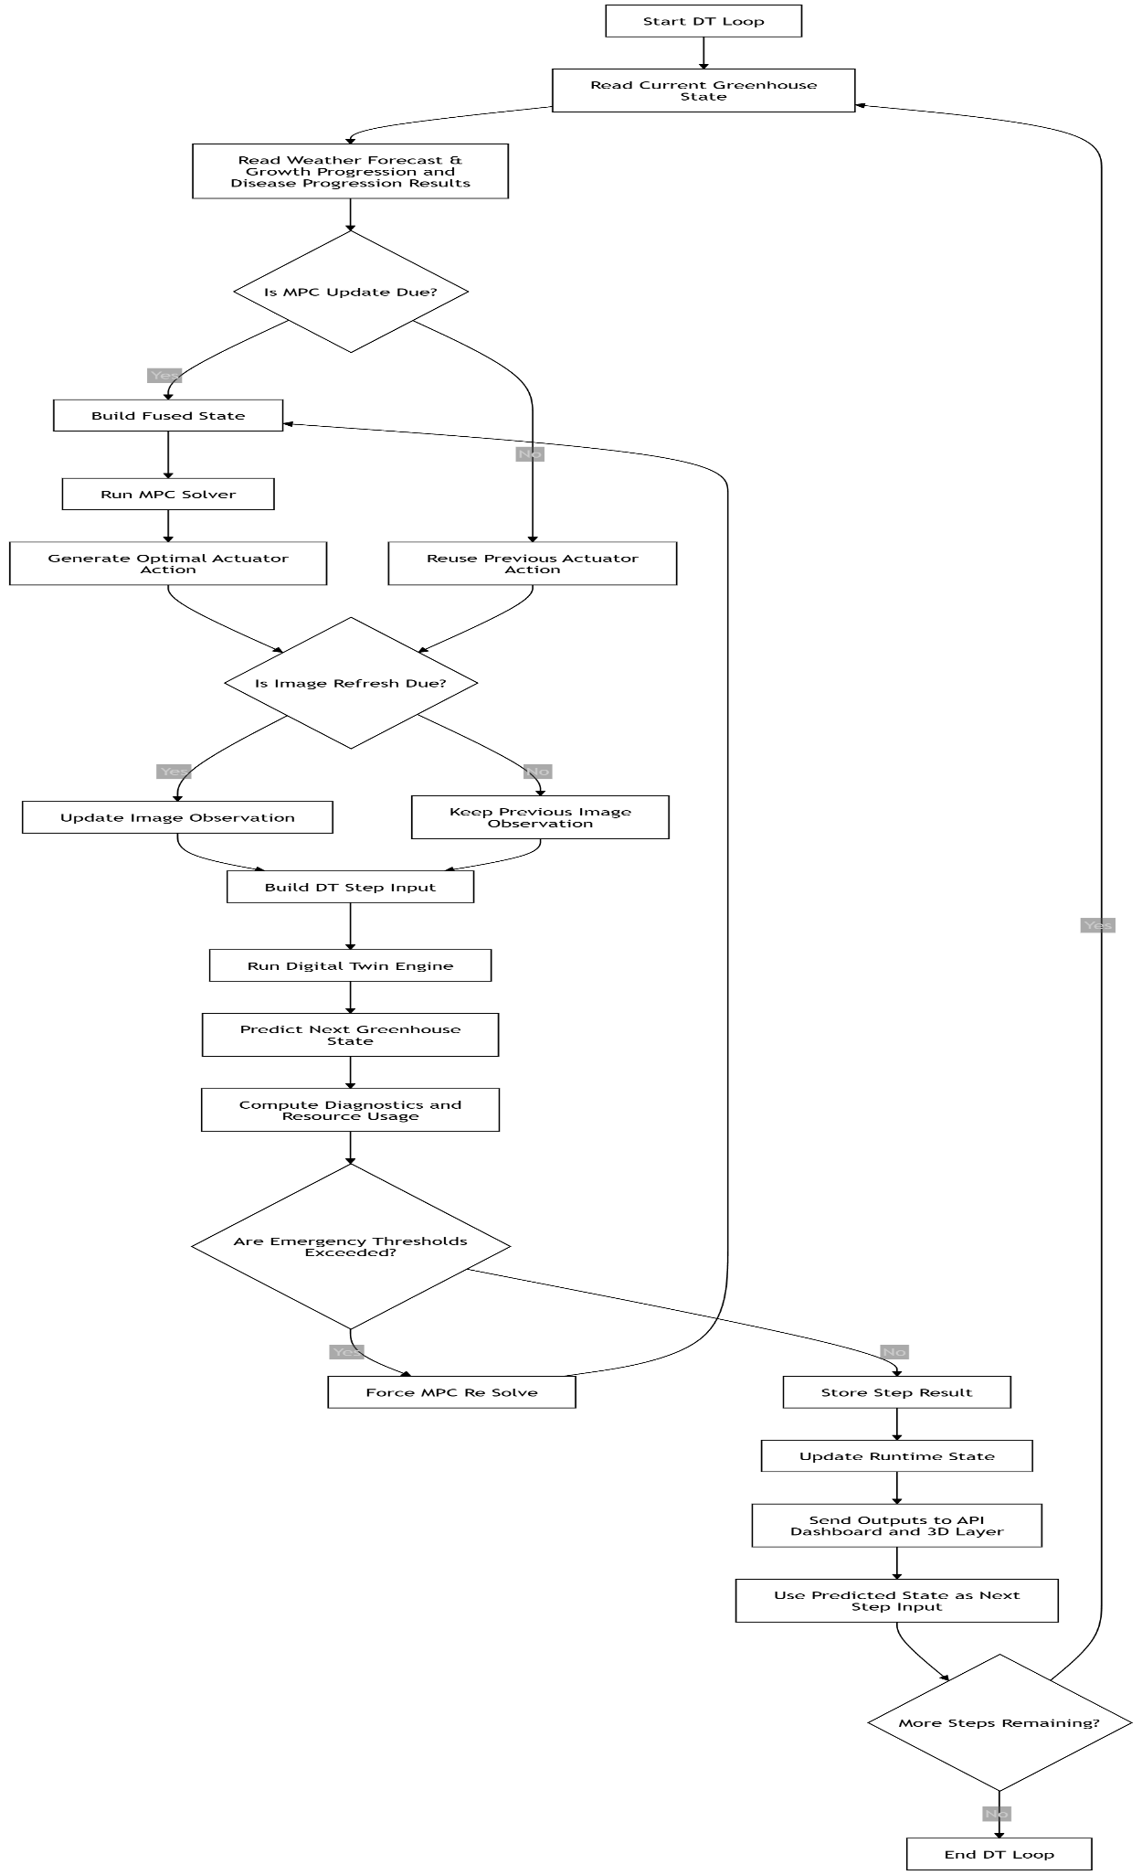
Fig. 3.10 Closed-Loop Workflow of the Digital Twin Simulation and Control Process
C. Frontend Interface and System Integration
The frontend, API layer, and monthly snapshot system together form the presentation, interaction, and long-term analytics layer of the digital twin system. These components ensure that the continuously evolving greenhouse state, produced by the simulation and control loop, is made accessible, interpretable, and actionable for users while also being preserved for historical analysis and performance evaluation.
The frontend interface acts as the primary visualization and interaction layer of the system. It is designed to present real-time greenhouse intelligence in a structured and intuitive manner, enabling users to monitor system behavior without directly interacting with complex backend logic. The interface displays the current greenhouse state, including environmental variables such as temperature, humidity, CO₂ concentration, soil moisture, and light intensity, along with derived indicators like crop growth stage, disease risk level, and overall crop health status. In addition to real-time values, the frontend also visualizes trends such as resource usage, actuator activity, and system stability over time. The interface is structured into multiple sections, including a current dashboard view, a detailed insights view, and a manual configuration panel. The dashboard focuses on high-level indicators such as current stage, next stage transition, actuator status, and resource consumption, while the detailed insights section provides deeper analytical outputs such as predicted disease risk over the next 24 hours, environmental forecasts, and growth transition probabilities. The frontend also supports user interaction through manual override controls, allowing adjustment of actuator settings, growth stage assumptions, and simulation time parameters. These inputs are passed to the backend to influence subsequent control decisions, ensuring a human-in-the-loop capability within the system.
The API layer serves as the communication bridge between the frontend, the digital twin loop, and the control logic. It exposes structured endpoints that allow external components to retrieve the latest greenhouse state, submit user configurations, and access system diagnostics. The API is designed to be lightweight and responsive, ensuring that frontend requests do not interfere with the continuous execution of the simulation loop. To achieve this, the system maintains a runtime state store that holds the most recent completed simulation step. When a request is received, the API returns this latest state instead of triggering new computations, thereby maintaining real-time responsiveness. The API supports multiple categories of data exchange, including real-time state retrieval, actuator configuration updates, system metrics access, and historical data queries. It also ensures proper validation of incoming data, such as checking actuator bounds, verifying growth stage inputs, and maintaining consistency of time-based parameters. Additionally, the API plays a crucial role in integrating the digital twin with external components such as the 3D greenhouse visualization layer. It provides a simplified state representation that can be directly consumed by rendering engines, including actuator states, environmental conditions, and crop stage information, enabling synchronized visual updates of the greenhouse environment.
The monthly snapshot system is responsible for long-term data aggregation, summarization, and performance tracking. While the digital twin loop generates high-frequency step-level data, storing all such data continuously would be inefficient and difficult to analyze. To address this, the system periodically aggregates simulation outputs into structured monthly summaries. Each snapshot captures key performance indicators such as total energy consumption, total water usage, average environmental conditions, actuator utilization patterns, and cumulative disease risk exposure. These summaries are computed by aggregating step-level metrics over a defined time window, typically one month, and storing them in a structured format suitable for reporting and analysis. The snapshot system also tracks crop lifecycle progression, including time spent in each growth stage, stage transition timings, and any anomalies observed during the cycle. This enables retrospective analysis of system performance and supports evaluation of control strategies under different environmental conditions.
In addition to numerical aggregation, the snapshot system provides comparative insights by analyzing variations across different time periods. For example, it can highlight whether resource consumption increased due to higher external temperatures or whether disease risk was reduced due to improved humidity control. These insights are essential for validating the effectiveness of the predictive control strategy and for identifying areas of improvement. The snapshot outputs are also used by the frontend to generate historical charts and reports, allowing users to visualize long-term trends in greenhouse performance. Furthermore, the snapshot system ensures that the digital twin maintains a balance between real-time responsiveness and historical traceability, making it possible to both monitor current conditions and evaluate past system behavior in a structured manner.
Overall, the frontend, API, and monthly snapshot components together transform the digital twin from a purely computational system into a complete, user-interactive, and analytically rich platform. The frontend provides intuitive visualization and control, the API ensures seamless and efficient data exchange, and the snapshot system enables long-term performance evaluation. This integration ensures that the system is not only capable of predictive control but also supports monitoring, decision-making, and continuous improvement over time.
D. 3D Greenhouse Visualization
The 3D greenhouse model component is developed using Unity, which provides a powerful real-time rendering environment for creating interactive and visually rich simulations. The virtual greenhouse is designed as a detailed digital replica of a controlled agricultural environment, where all structural elements, actuators, and crop representations are modeled to reflect real-world behavior. Unity enables the integration of physics-based interactions, lighting systems, animation control, and scripting logic, allowing the greenhouse environment to dynamically respond to data received from the digital twin system.
The 3D scene includes key greenhouse components such as plant beds, ventilation systems, exhaust fans, irrigation pipelines, artificial lighting units, and structural frames. Each of these elements is directly linked to corresponding system variables and actuator states. For instance, vent panels open and close based on ventilation control signals, fans rotate with varying speeds depending on airflow intensity, irrigation systems activate during watering cycles, and lighting systems adjust brightness based on environmental and control inputs. These visual mappings ensure that every control action computed by the predictive control system is immediately reflected in the virtual environment, providing a clear and intuitive understanding of system behavior.
The model is deployed as a web-accessible application using Unity WebGL technology. The WebGL build process converts the Unity project into a browser-compatible format using WebAssembly and JavaScript, enabling the 3D greenhouse environment to run directly within a web browser without requiring additional software installation. This approach ensures high accessibility, allowing users to interact with the digital twin visualization from any device with a standard browser. The WebGL deployment includes optimized asset compression, efficient rendering pipelines, and performance tuning to maintain smooth interaction even in resource-constrained environments.
Crop growth visualization within the 3D environment is implemented using stage-based modeling techniques. Each growth stage—such as seedling, vegetative, flowering, and fruiting—is represented by distinct plant models or transformation states. Unity’s animation and transformation capabilities are used to either switch between models or smoothly transition between stages using scaling and morphing techniques. This allows the virtual crops to visually evolve over time in synchronization with the growth stage predictions generated by the system, providing a realistic representation of plant development.
Environmental simulation is further enhanced through dynamic lighting and time-of-day effects. Unity’s lighting engine is used to simulate realistic daylight cycles, where the intensity, angle, and color of light change based on the simulated time. Morning, afternoon, evening, and night conditions are visually distinguishable, improving realism and helping users understand temporal variations in greenhouse conditions. Additional visual cues, such as subtle mist effects during high humidity or irrigation events, can be incorporated to represent environmental changes more intuitively.
The integration between the digital twin system and the 3D environment is achieved through a real-time data exchange mechanism using API-based communication. The backend system periodically sends the current greenhouse state, including environmental parameters, actuator states, crop stage, and timestamp. Unity scripts receive this data and update the scene accordingly by modifying object properties, triggering animations, and adjusting environmental effects. This ensures that the virtual greenhouse remains synchronized with the underlying simulation and control logic, effectively acting as a visual extension of the digital twin. Time synchronization is handled using the simulation timestamp provided by the backend. Each update cycle corresponds to a discrete simulation step, allowing the 3D environment to progress in alignment with the digital twin loop. The system also supports manual time override, enabling users to simulate different time periods for testing and demonstration purposes. This flexibility allows for visualization of various scenarios, such as different growth stages or environmental conditions, without waiting for real-time progression.
The Unity-based 3D model also incorporates visual feedback mechanisms to represent system states and alerts. Instead of relying solely on textual information, the system can use color changes, object highlights, or animation cues to indicate normal, warning, or critical conditions. For example, stable operation may be represented by a consistent visual state, while abnormal conditions such as high disease risk or environmental imbalance can trigger noticeable visual indicators. This aligns with the system’s design principle of intuitive, non-verbal communication. Performance optimization is an important consideration in the WebGL deployment. The model uses optimized meshes, texture compression, and efficient rendering techniques to reduce computational load.
Overall, the use of Unity and WebGL enables the creation of a highly interactive, accessible, and realistic 3D greenhouse visualization. This component transforms abstract simulation data into a tangible visual experience, allowing users to observe system behavior, understand control actions, and monitor crop development in real time. By integrating seamlessly with the digital twin and control system, the 3D model enhances system transparency, usability, and decision-making capabilities in smart greenhouse management.
CHAPTER 4
4. RESULTS ANALYSIS AND SYSTEM OUTPUT
4.1 COMPARATIVE ANALYSIS WITH EXISTING SYSTEM
4.1.1 DESCRIPTION OF EXISTING SYSTEMS
A. Traditional Greenhouse Systems
Traditional greenhouse systems primarily rely on manual intervention or fixed rule-based control mechanisms to regulate environmental conditions such as temperature, humidity, and irrigation. These systems operate in a reactive manner, where corrective actions are taken only after deviations from desired conditions are observed. While they are simple to implement and require minimal technological infrastructure, they lack the capability to analyze data, predict future conditions, or assess crop health. As a result, they are inefficient in handling dynamic environmental changes and often lead to suboptimal resource utilization and delayed response to crop stress or disease.
B. IoT-Based Smart Greenhouse Systems
IoT-based greenhouse systems enhance traditional approaches by incorporating sensors to continuously monitor environmental parameters such as temperature, humidity, soil moisture, and light intensity. These systems enable real-time data acquisition and remote monitoring, often coupled with automated control mechanisms for irrigation and climate regulation. Although they improve operational efficiency and reduce manual effort, their functionality is largely dependent on sensor availability and reliability. Additionally, most IoT-based systems focus on monitoring and basic automation, offering limited predictive capabilities and lacking advanced decision-support mechanisms for crop health and disease management.
C. AI-Based Crop Monitoring Systems
AI-based systems leverage machine learning and deep learning techniques to analyze agricultural data, particularly for tasks such as plant disease detection, growth stage classification, and yield prediction. These systems utilize image processing and time-series data analysis to provide insights into crop health and development. While they offer significant improvements in accuracy and early detection compared to conventional methods, they are often designed for specific tasks and operate as standalone modules. This lack of integration limits their ability to support comprehensive greenhouse management, as they do not typically incorporate environmental control or system-level optimization.
D. Digital Twin-Based Greenhouse Systems
Digital twin-based systems represent an advanced approach by creating virtual replicas of physical greenhouse environments, enabling simulation, monitoring, and optimization of greenhouse operations. These systems often integrate predictive models and control strategies such as Model Predictive Control (MPC) to improve climate regulation and resource efficiency. However, most existing digital twin implementations rely heavily on real-time sensor data for accurate synchronization with the physical system, making them costly and infrastructure-intensive. Furthermore, their application is often limited to environmental control, with less emphasis on integrating crop-level intelligence such as disease detection and growth analysis within the same framework.
4.1.2 COMPARISON CRITERIA
To systematically evaluate the effectiveness of existing greenhouse management approaches and highlight the contributions of the proposed AgriTwin-GH framework, a set of key comparison criteria is defined based on functional, technological, and operational capabilities. These criteria focus on assessing how well each system supports intelligent, efficient, and scalable greenhouse management.
Monitoring capability is considered a fundamental criterion, as it determines the system’s ability to collect and analyze environmental and crop-related data. Traditional systems offer limited monitoring, whereas modern systems incorporate real-time data acquisition from multiple sources. Prediction and forecasting capability is another critical factor, reflecting the system’s ability to anticipate future environmental conditions, crop growth stages, and potential risks using data-driven models.
Disease detection capability evaluates whether the system can identify plant diseases at early stages using image processing or AI-based techniques. Control strategy is also an important parameter, distinguishing between reactive systems that respond to changes after they occur and predictive systems that proactively optimize greenhouse conditions. The integration of artificial intelligence and machine learning is assessed to understand the level of intelligence embedded within the system for analysis, decision-making, and automation.
Digital twin integration is included as a criterion to evaluate whether the system supports virtual modeling and simulation of greenhouse operations, enabling validation of control actions before real-world implementation. Real-time adaptability measures the system’s ability to dynamically adjust to changing environmental conditions and system inputs. Cost and infrastructure requirements are considered to assess the feasibility of deployment, particularly in resource-constrained environments, where dependence on extensive sensor networks may be a limitation.
Scalability is another key criterion, indicating the system’s ability to be extended across different crops, greenhouse setups, and geographical conditions. Finally, decision-support capability evaluates whether the system provides actionable insights and recommendations to assist users in making informed management decisions. Together, these criteria provide a comprehensive basis for comparing existing systems with the proposed AgriTwin-GH framework.
Table 4.1 presents a comparative evaluation of existing greenhouse management systems and the proposed AgriTwin-GH framework based on key functional and technological criteria.

Table 4.1 Comparative Analysis of Existing Systems and Proposed AgriTwin-GH Framework
Criteria | Traditional Systems | IoT-Based Systems | AI-Based Systems | Digital Twin Systems | AgriTwin-GH (Proposed)
Monitoring Capability | Basic manual monitoring | Real-time sensor-based monitoring | Data-driven monitoring | Real-time + virtual monitoring | Multi-source intelligent monitoring
Prediction Capability | Not available | Limited | Available (model-based) | Available | Advanced multi-model forecasting
Disease Detection | Not supported | Not supported | AI-based detection | Limited | Integrated AI-based detection
Control Strategy | Reactive | Semi-automated | Advisory | Predictive (MPC-based) | Predictive + MPC & Simulation-based control
AI/ML Integration | Not used | Minimal | Core component | Moderate | Fully integrated AI framework
Digital Twin Integration | Not available | Not available | Not available | Available | Sensor-independent digital twin
Real-Time Adaptability | Low | Moderate | Moderate | High | High with predictive adjustment
Scalability | Low | Moderate | Moderate | High | High and flexible
Decision Support | Not available | Limited | Moderate | High | Intelligent decision-support system
4.1.3 COMPARATIVE EVALUATION AND SYSTEM IMPROVEMENTS
The comparative analysis highlights several limitations in existing greenhouse management systems, particularly in terms of integration, intelligence, and proactive decision-making. Traditional systems lack automation and rely heavily on manual intervention, making them inefficient in dynamic environments. IoT-based systems improve monitoring capabilities but remain dependent on sensor infrastructure and offer limited predictive intelligence. AI-based approaches, while effective in specific tasks such as disease detection or crop analysis, often operate in isolation without integration into a complete greenhouse control framework. Similarly, existing digital twin systems provide simulation and optimization capabilities but are typically reliant on continuous sensor inputs and do not fully incorporate crop-level intelligence. These gaps indicate a lack of unified systems that combine environmental monitoring, predictive analytics, and intelligent control within a single framework. AgriTwin-GH addresses these limitations by integrating multi-source data processing, AI-based crop intelligence, and a sensor-independent digital twin into a cohesive system. It enables predictive and proactive decision-making by forecasting environmental conditions, detecting early signs of crop stress and disease, and validating control strategies through virtual simulation before real-world execution. This holistic approach not only enhances operational efficiency and resource optimization but also reduces infrastructure dependency, making the system more scalable and practical for real-world agricultural deployment.
4.2 SYSTEM OUTPUT VISUALIZATION AND INTERFACE RESULTS
4.2.1 INPUT DATA SAMPLES
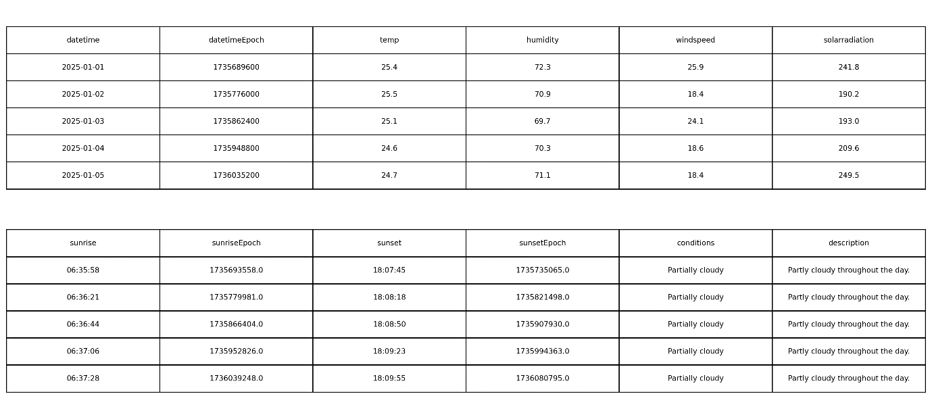
Fig. 4.1 Extract of the Dindigul Weather Dataset
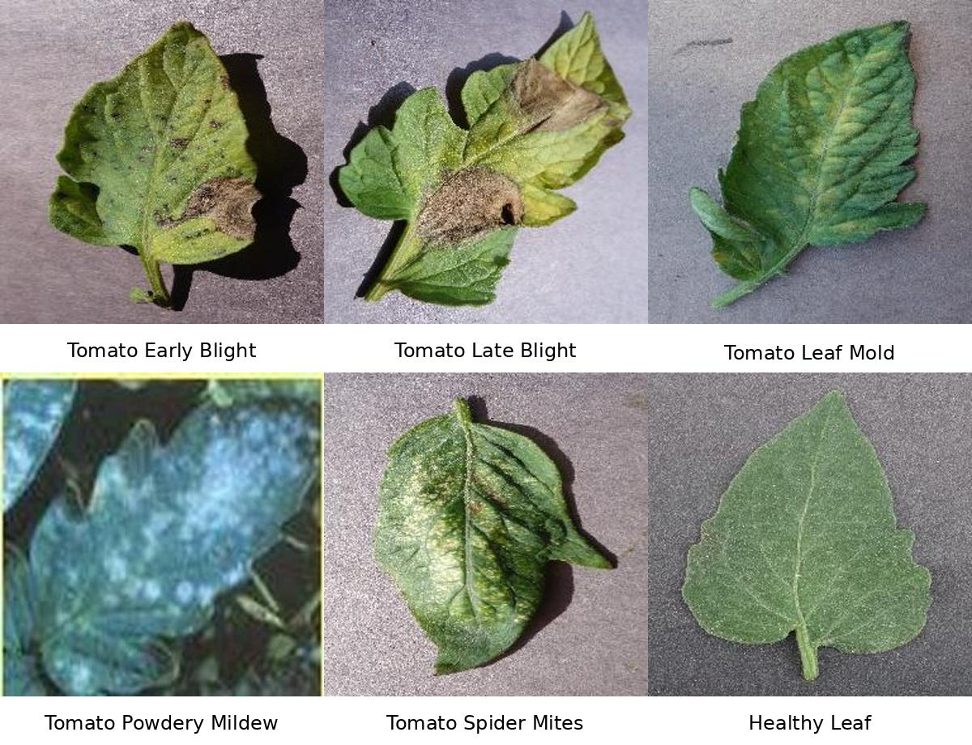
Fig. 4.2 Tomato Leaf Disease Classification Dataset Samples
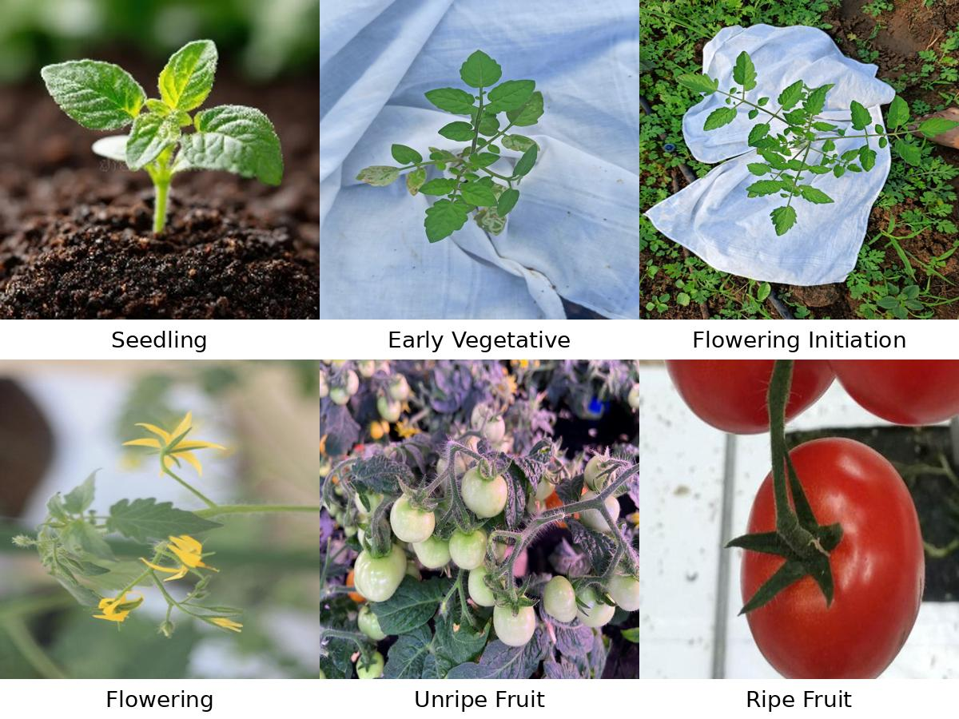
Fig. 4.3 Tomato Crop Growth Stages Dataset Samples

4.2.2 MODEL TRAINING AND PERFORMANCE RESULTS
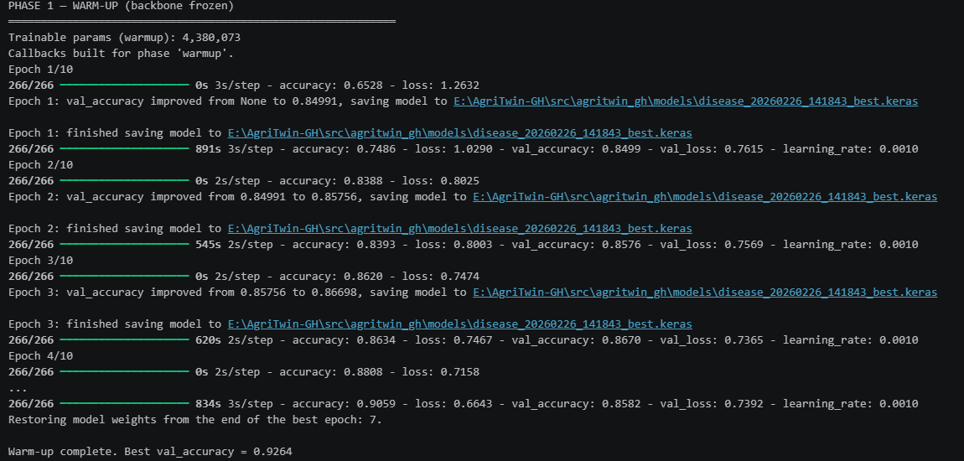
Fig. 4.4 Phase-1 Warm-Up Training Results for Disease Classification Model
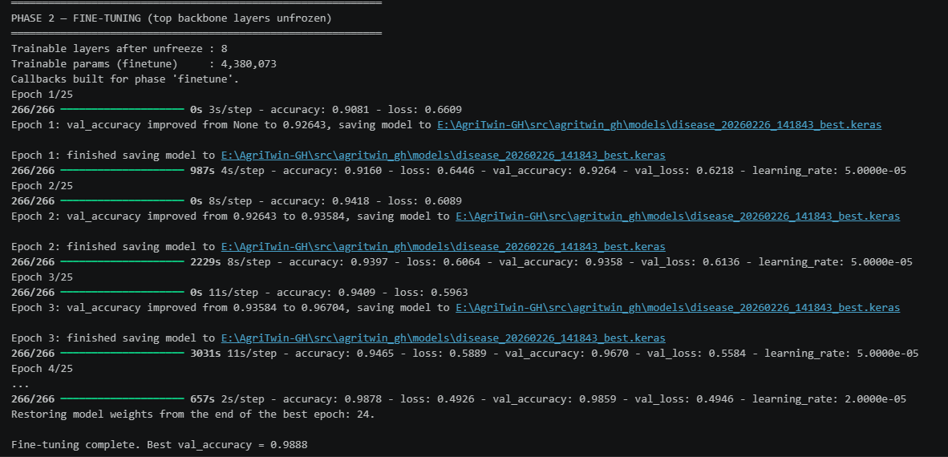
Fig. 4.5 Phase-2 Fine-Tuning Results for Disease Classification Model
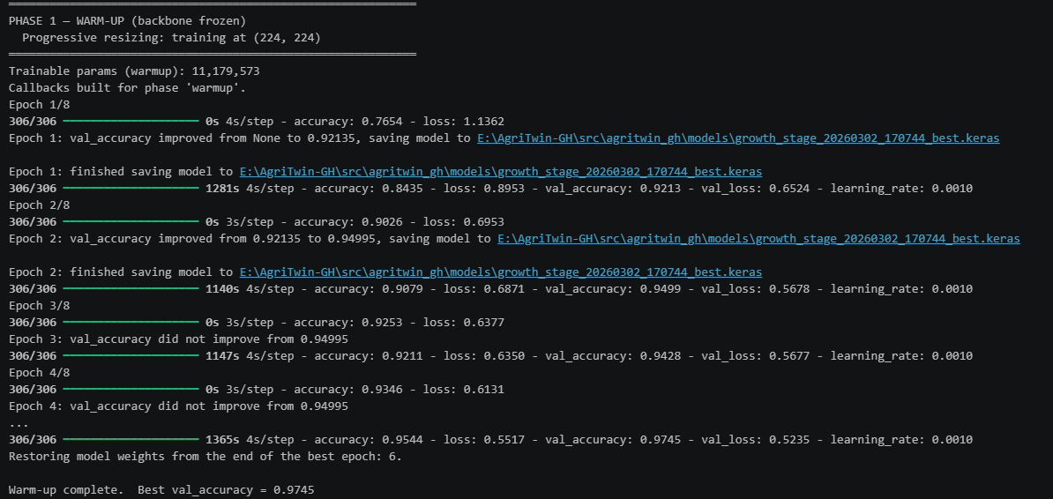
Fig. 4.6 Phase-1 Warm-Up Training Results for Growth Stage Classification Model
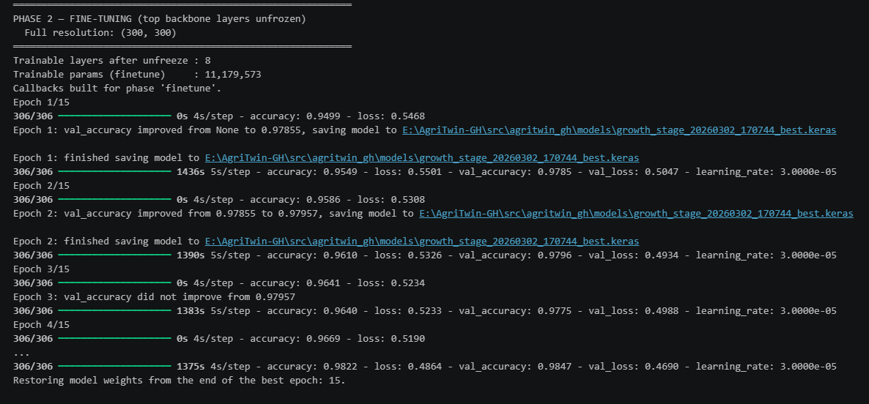
Fig. 4.7 Phase-2 Fine-Tuning Results for Growth Stage Classification Model
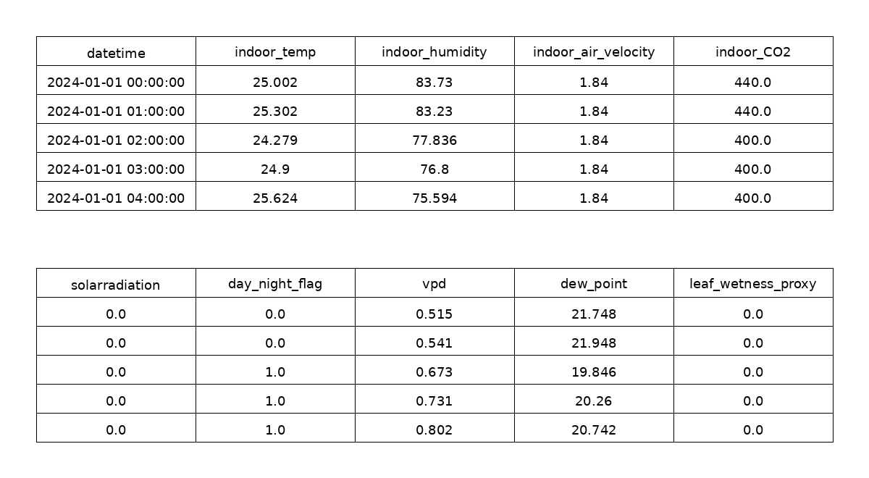
Fig. 4.8 Processed Greenhouse Environmental Dataset Sample
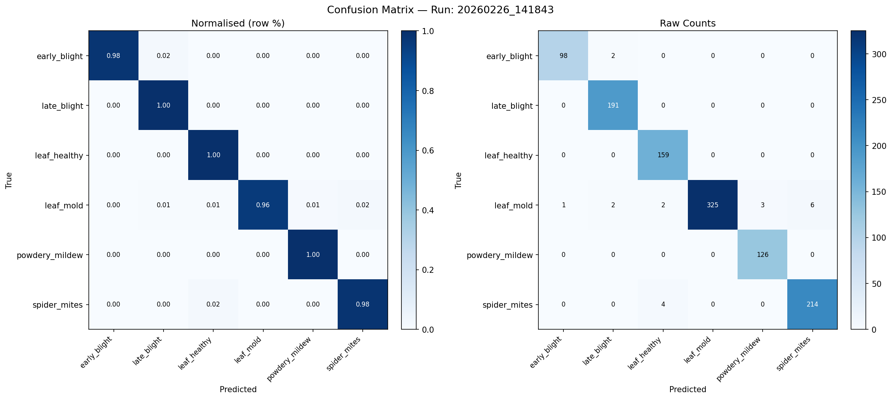
Fig. 4.9 Confusion Matrix of Tomato Disease Detection Model
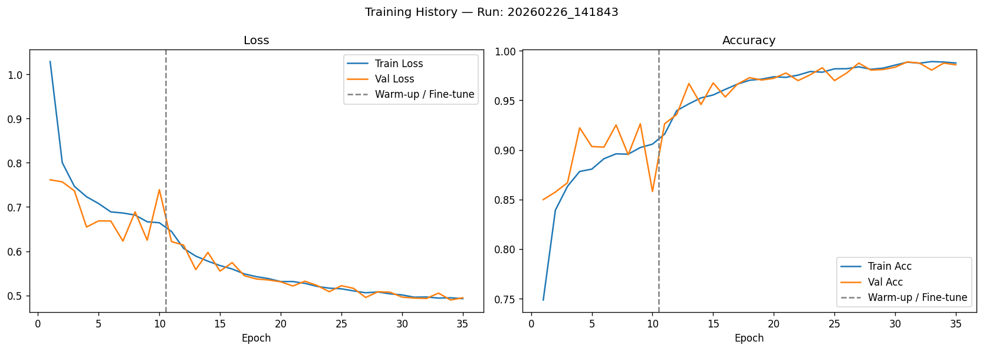
Fig. 4.10 Training Accuracy of the Disease Detection Model

Fig. 4.11 Training Loss of the Disease Detection Model
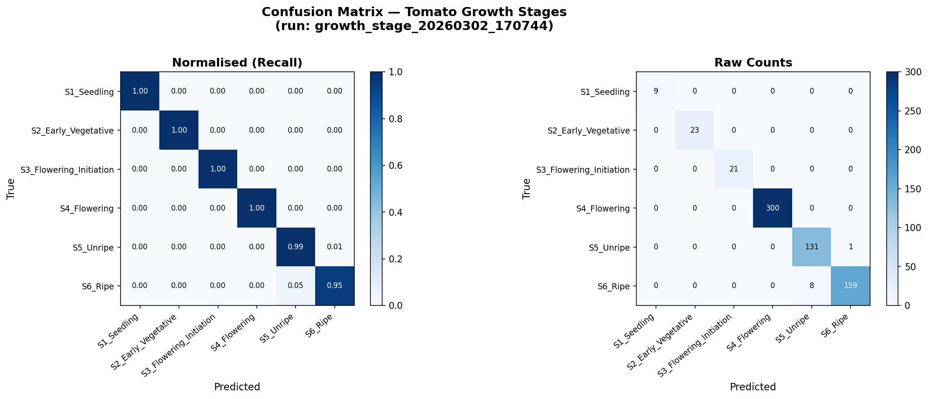
Fig. 4.12 Confusion Matrix of Tomato Growth Stage Classification Model
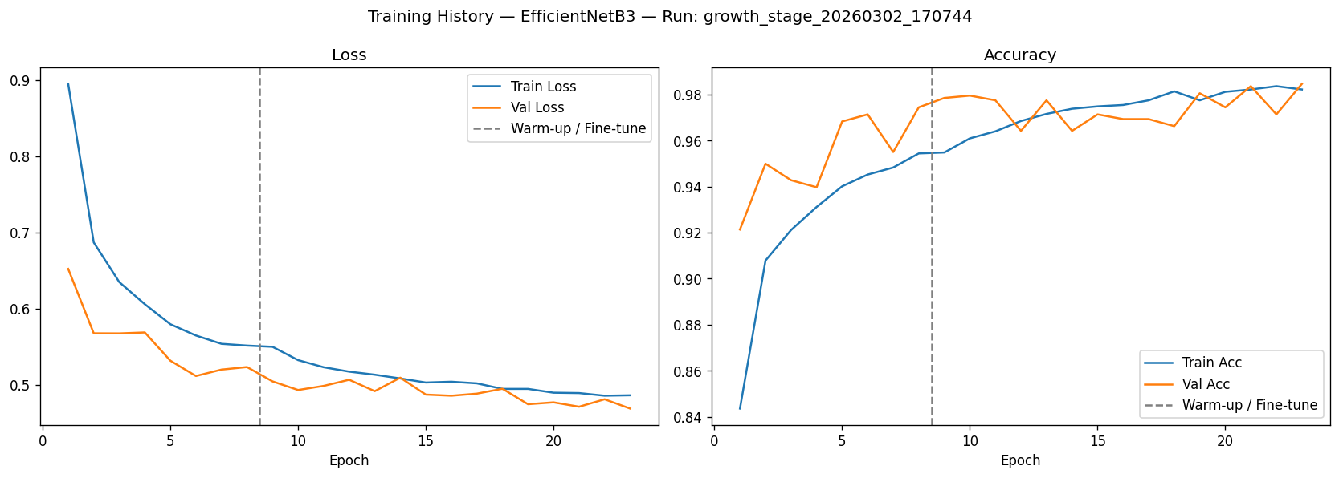
Fig. 4.13 Training Accuracy of the Growth Stage Classification Model

Fig. 4.14 Training Loss of the Growth Stage Classification Model
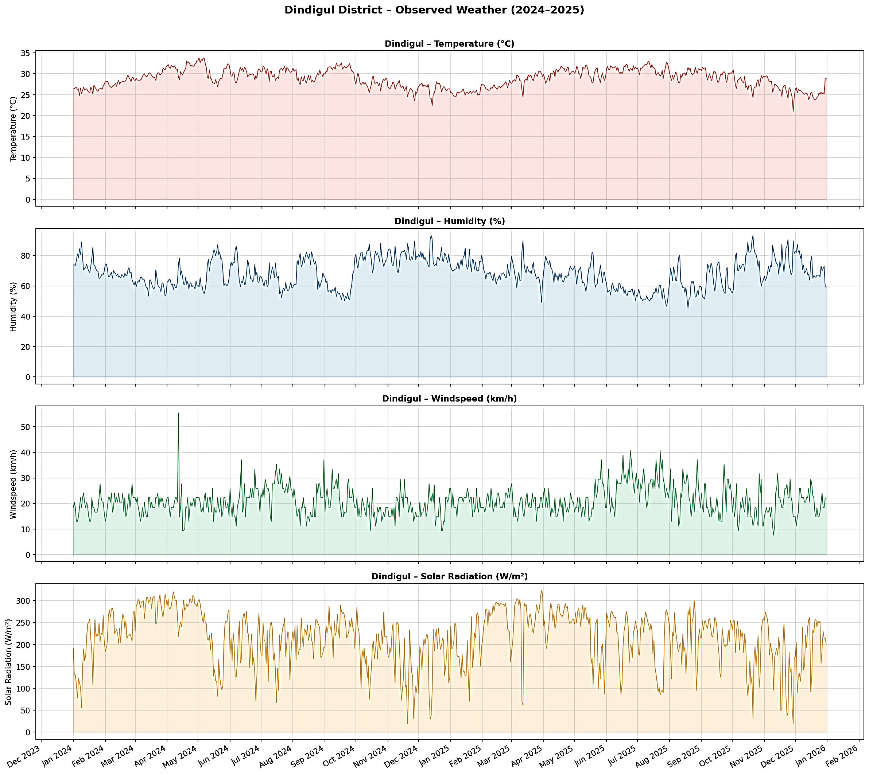
Fig. 4.15 Exploratory Data Analysis of Observed Dindigul Weather Data from 2024 to 2025
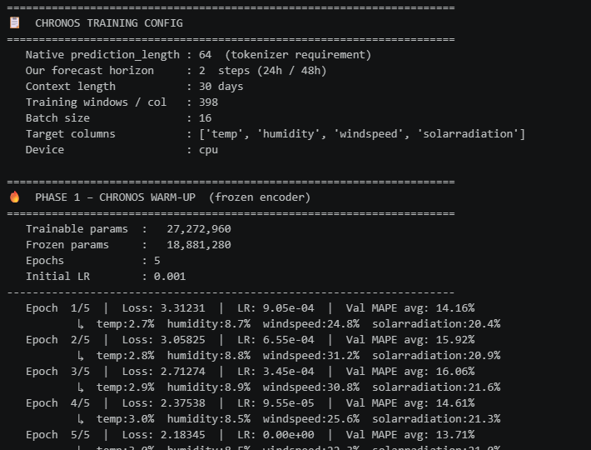
Fig. 4.16 Chronos Model Warm-Up Training Phase Performance
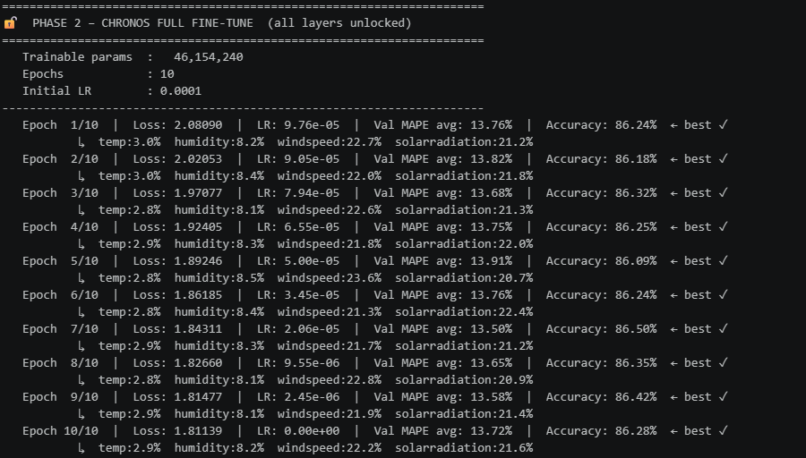
Fig. 4.17 Chronos Model Fine-Tuning Phase Performance
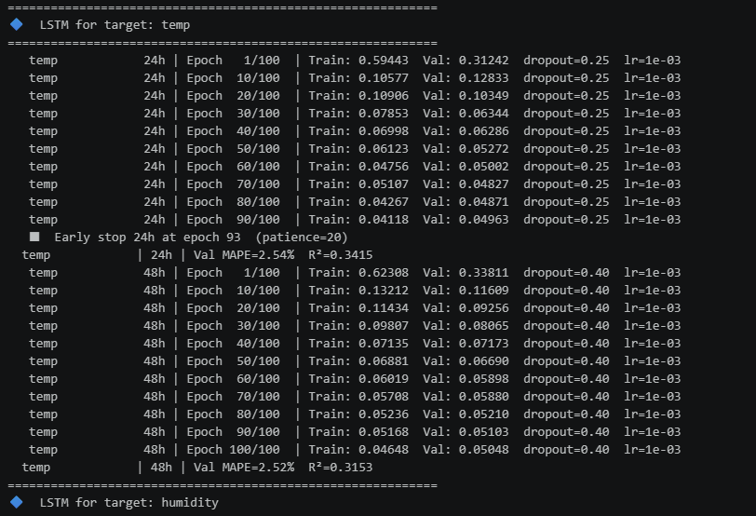
Fig. 4.18 LSTM Training Performance across Individual Weather Parameters
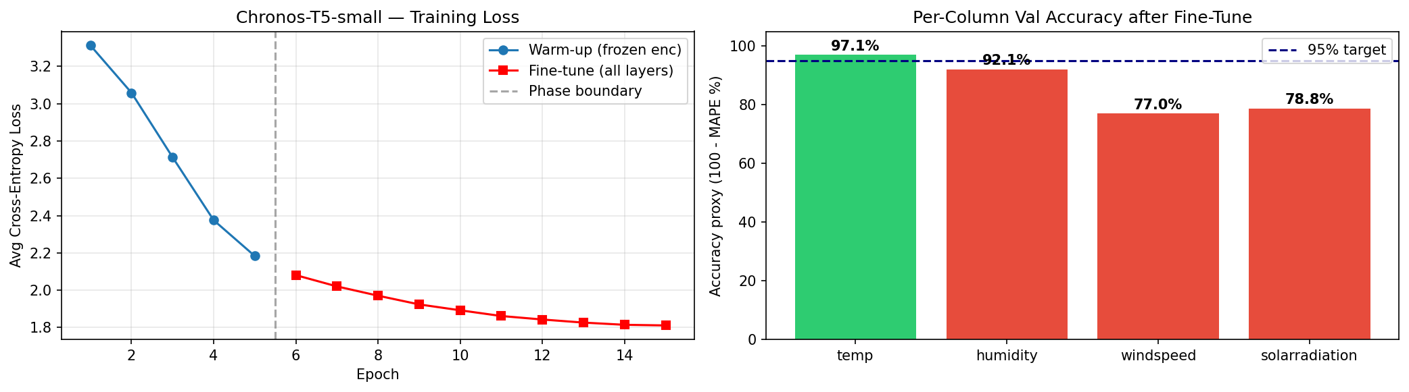
Fig. 4.19 Chronos Model Training Curve and Validation Accuracy after Fine-Tuning
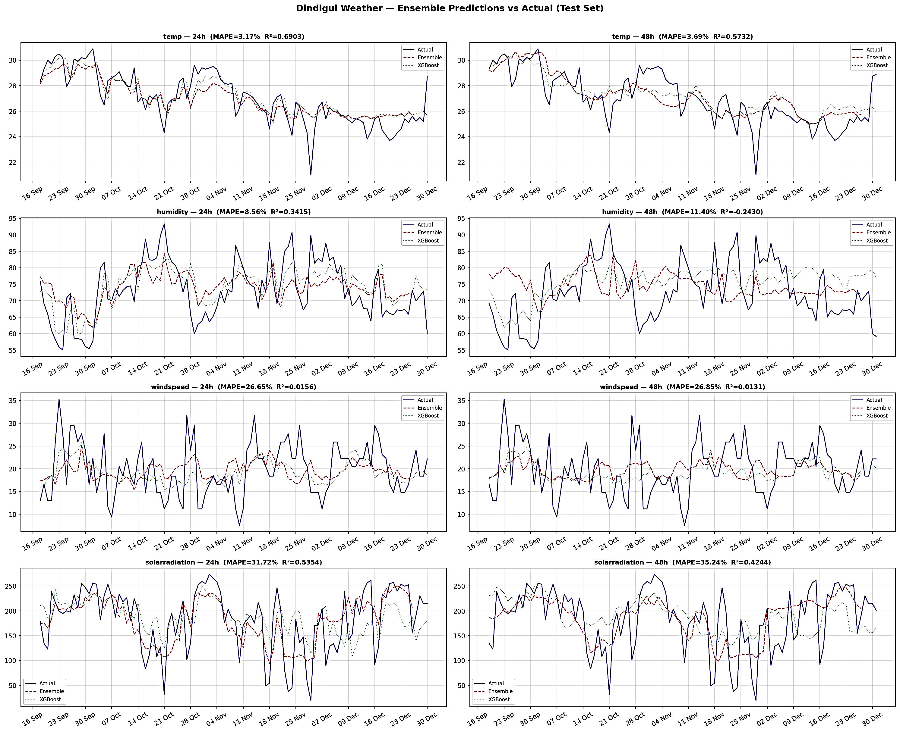
Fig. 4.20 Ensemble Weather Forecast Prediction versus Actual Values
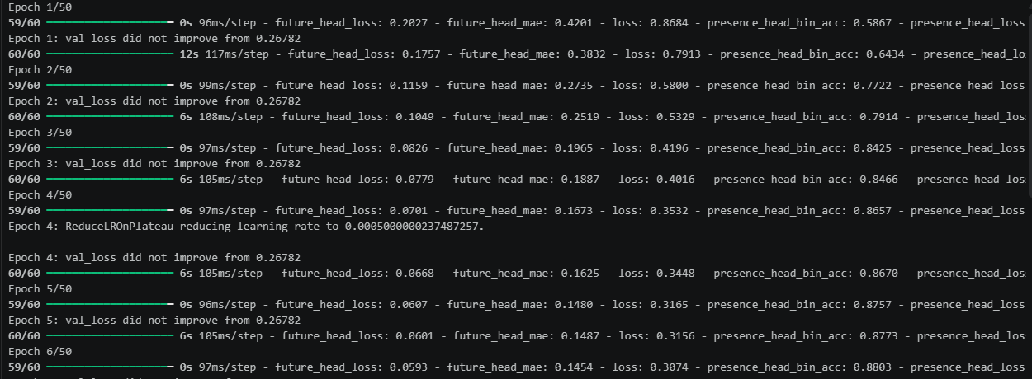
Fig. 4.21 LSTM Model Training Process for Disease Progression in Notebook Environment
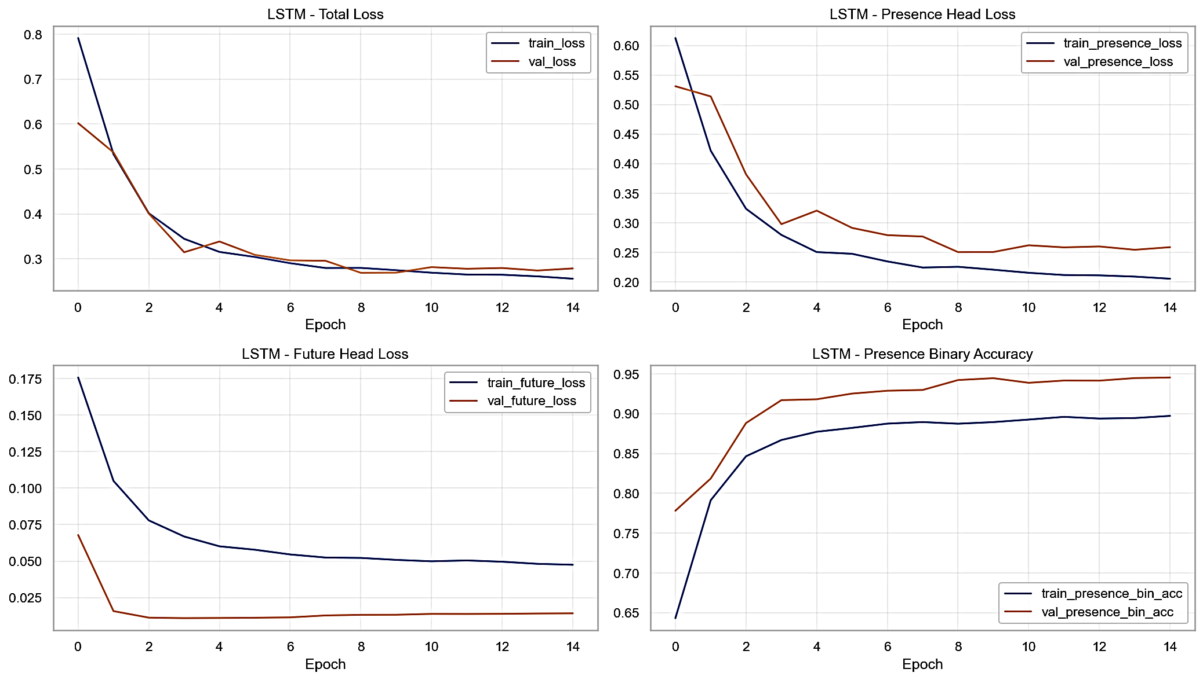
Fig. 4.22 LSTM Training Loss Curve for Disease Progression Model

Fig. 4.23 GRU Model Training Process for Disease Progression in Notebook Environment
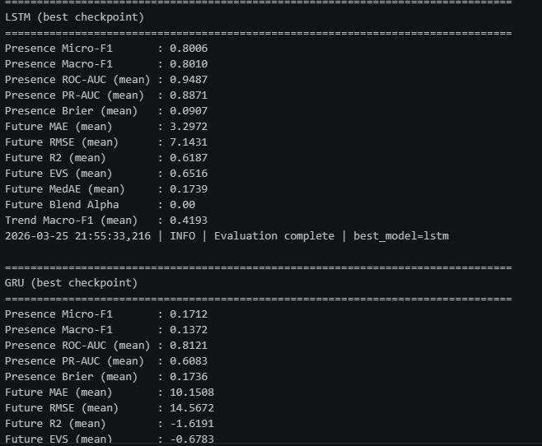
Fig. 4.24 Performance Analysis of LSTM and GRU Best Model Checkpoints
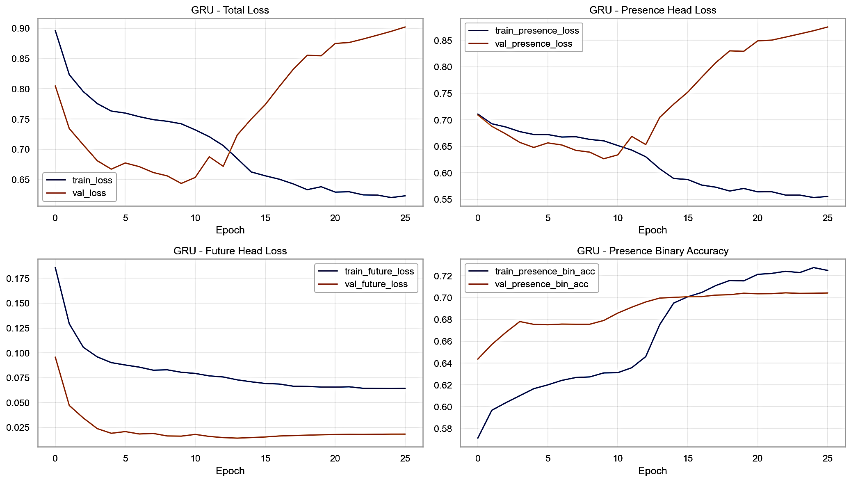
Fig. 4.25 GRU Training Loss Curve for Disease Progression Model
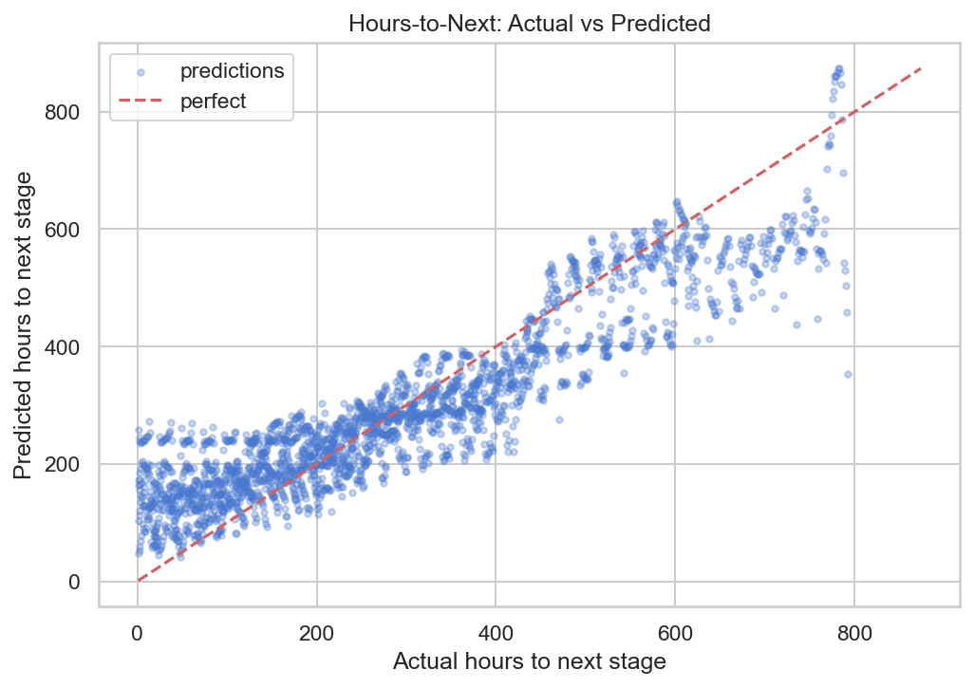
Fig. 4.26 Actual versus Predicted Hours to Next Growth Stage

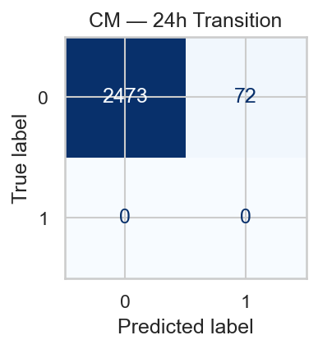
Fig. 4.27 Confusion Matrix for 24-Hour Growth Stage Transition Prediction
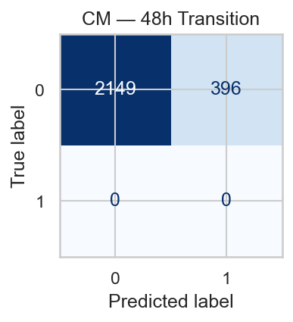
Fig. 4.28 Confusion Matrix for 48-Hour Growth Stage Transition Prediction
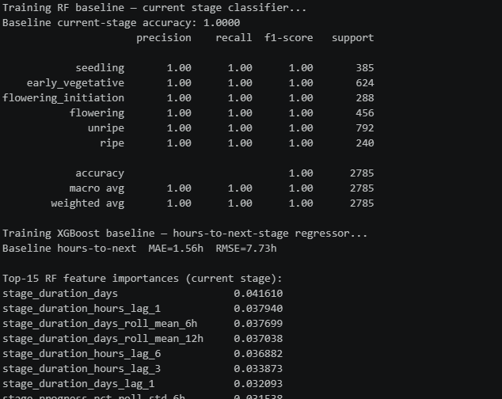
Fig. 4.29 Training Performance of Random Forest and XGBoost for Growth Progression
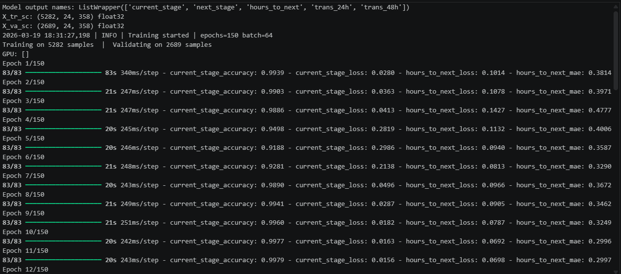
Fig. 4.30 LSTM Training of Growth Stage Progression Model

4.2.3 SYSTEM INTERFACE
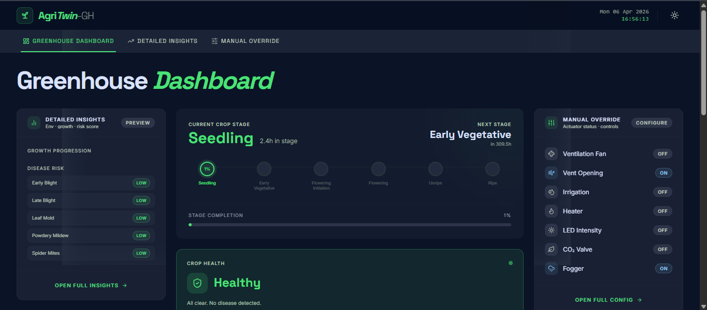
Fig. 4.31 Greenhouse Dashboard Interface in Dark Mode
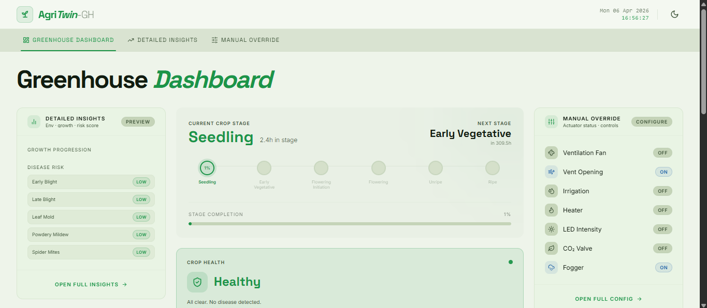
Fig. 4.32 Greenhouse Dashboard Interface in Light Mode
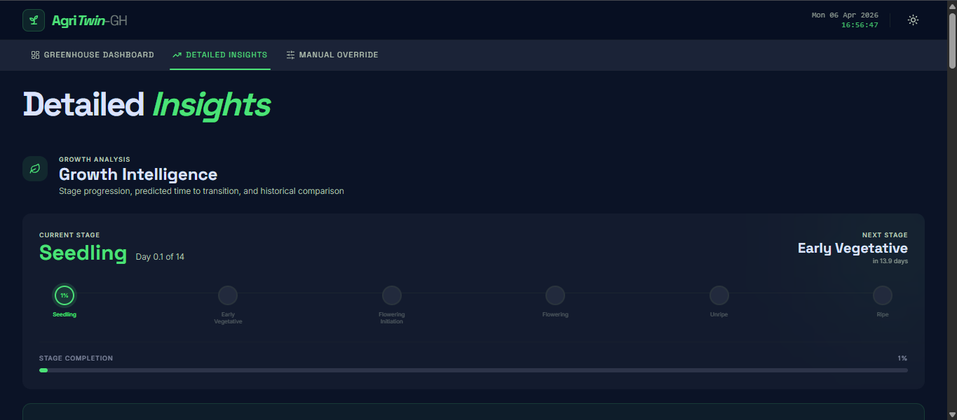
Fig. 4.33 Growth Intelligence Section in Detailed Insights Interface
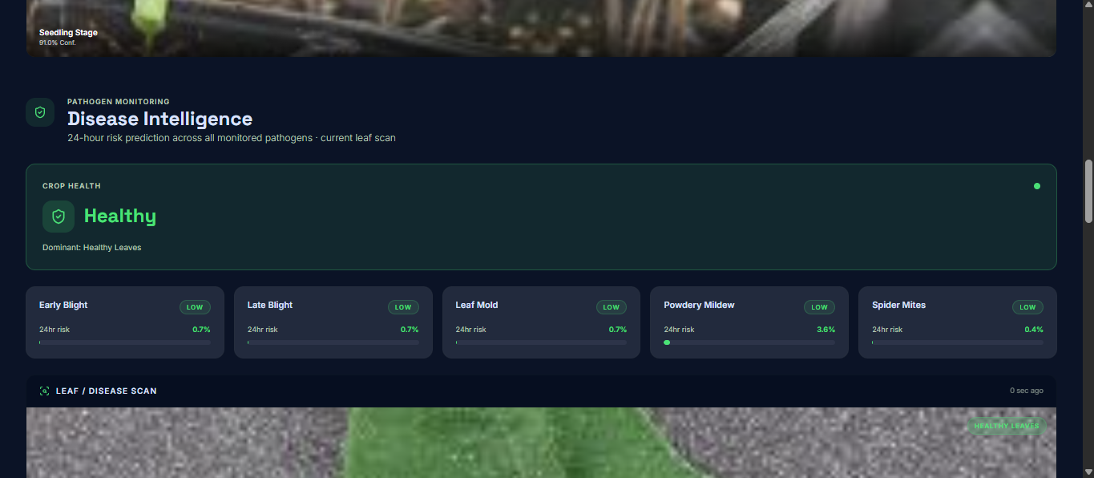
Fig. 4.34 Disease Intelligence Section in Detailed Insights Interface
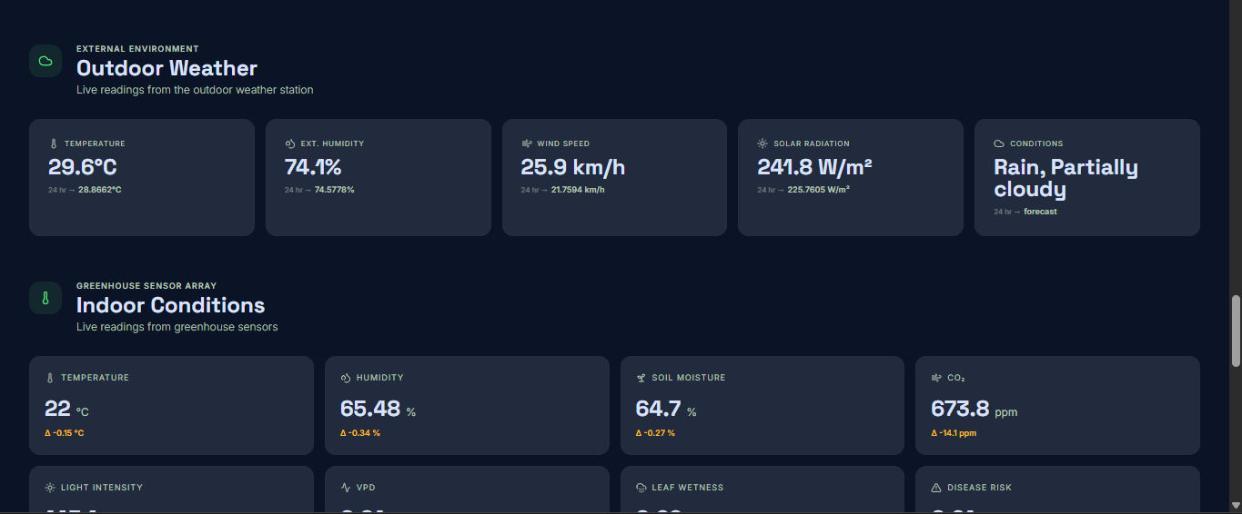
Fig. 4.35 Environmental Monitoring Section Showing Outdoor and Indoor Conditions
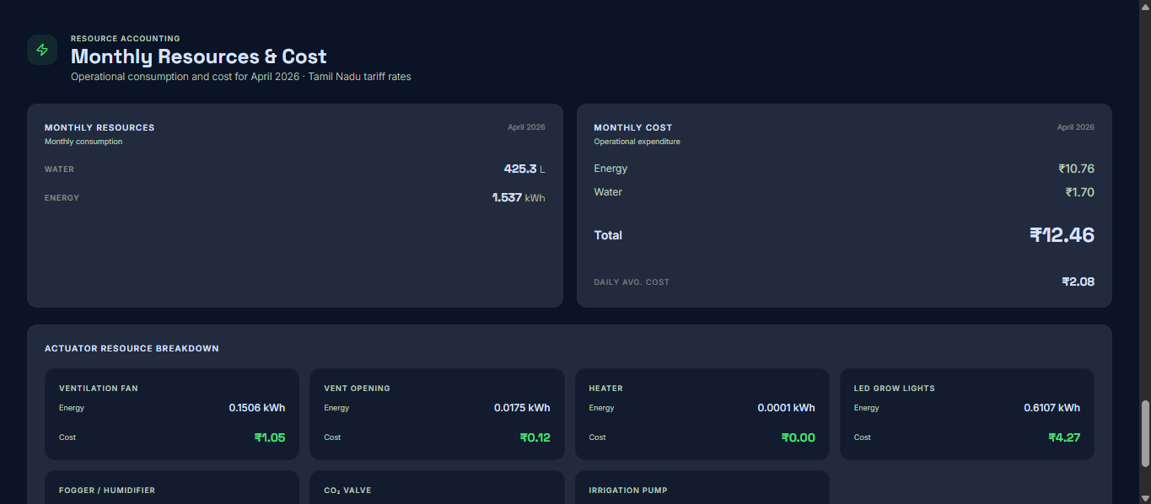
Fig. 4.36 Monthly Resource Utilization and Cost Analysis Section
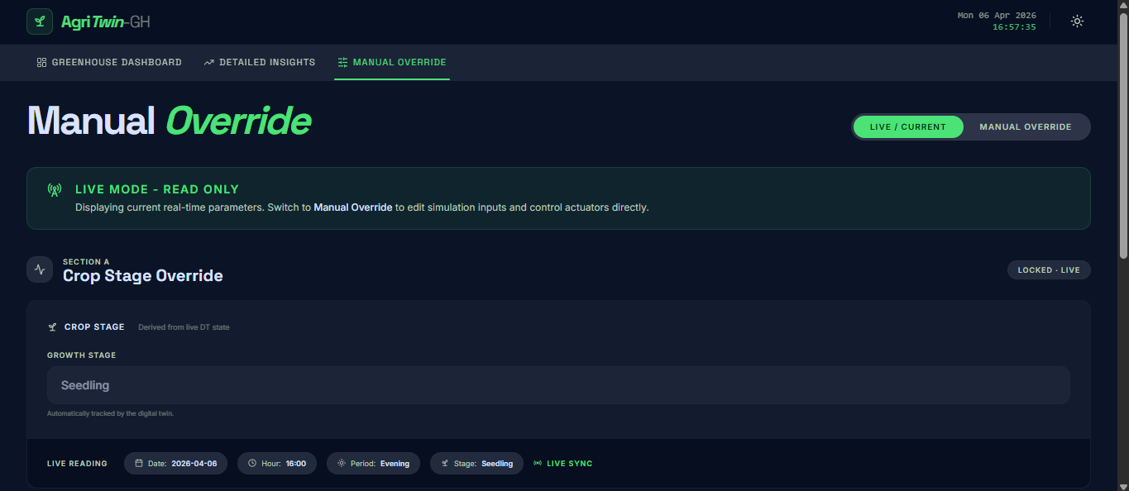
Fig. 4.37 Manual Override Interface for Growth Stage and Actuator Control

4.2.4 LOG FILES AND TERMINAL OUTPUTS
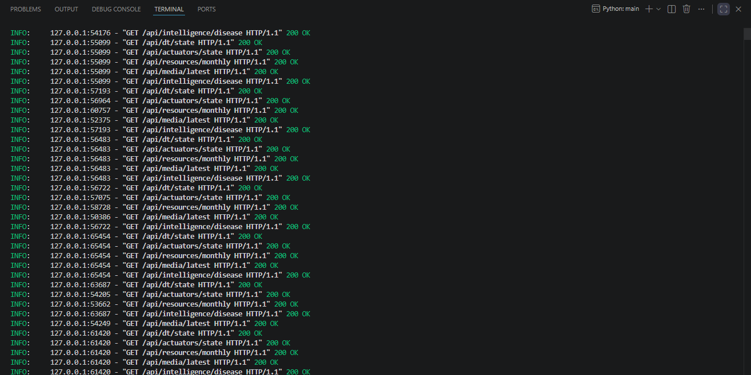
Fig. 4.38 FastAPI Endpoint Response in Terminal
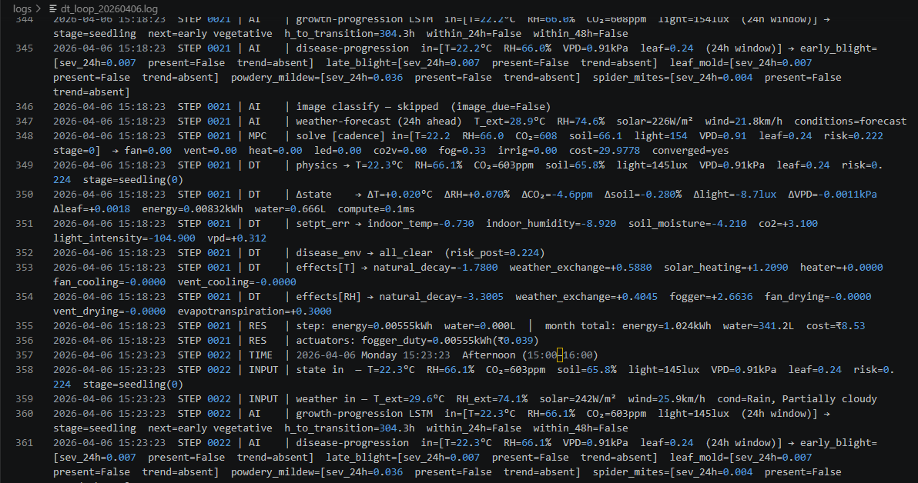
Fig. 4.39 Digital Twin Closed Loop Execution Log

4.2.5 3D GREENHOUSE ENVIRONMENT VISUALIZATION

Fig. 4.40 Front View of 3D Greenhouse Environment
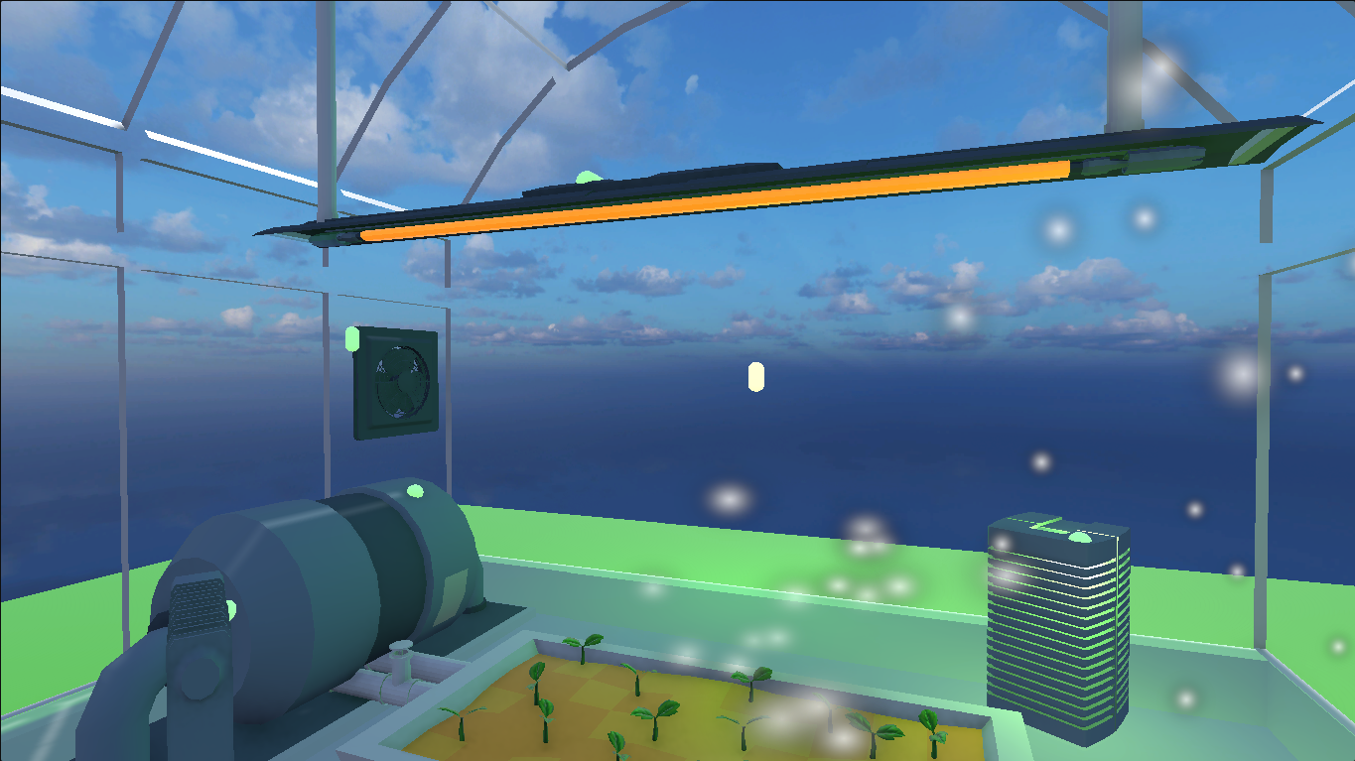
Fig. 4.41 Internal Right-Side View of Greenhouse in Active State
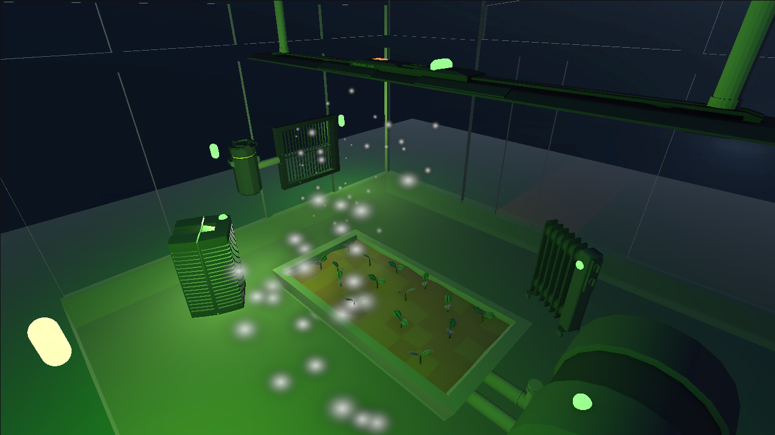
Fig. 4.42 Top-Left Perspective View of Greenhouse in Active State

Fig. 4.43 Greenhouse Exterior View under Evening Conditions
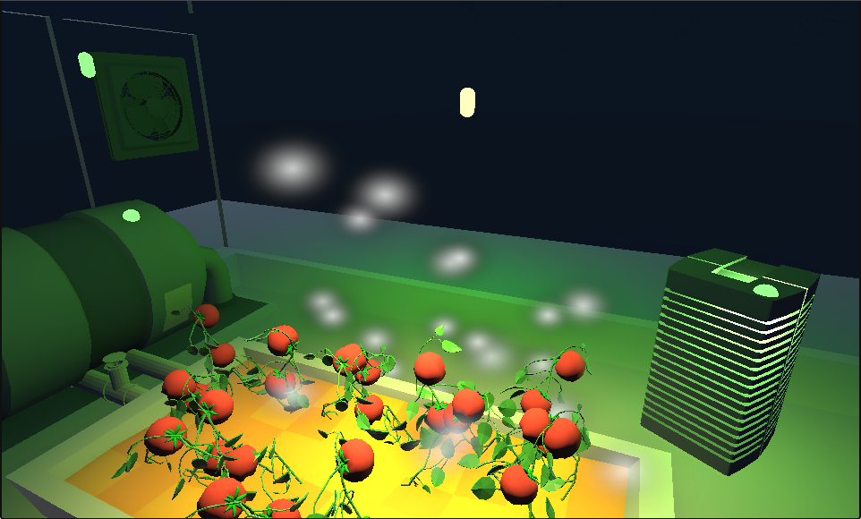
Fig. 4.44 Ripe Growth Stage Visualization inside 3D Greenhouse

CHAPTER 5
5. CONCLUSION
The AgriTwin-GH presents, an intelligent, software-based digital twin framework designed to enhance greenhouse management for tomato and strawberry cultivation through predictive, data-driven decision-making. The system integrates multi-source environmental data processing, image-based crop growth stage classification using EfficientNet models, plant disease detection, and time-series forecasting, combined with a Model Predictive Control (MPC)–driven digital twin for simulation and optimization. By adopting a modular architecture, the framework ensures clear separation of data processing, predictive analytics, and control layers, enabling scalability and extensibility. Unlike traditional reactive greenhouse systems, AgriTwin-GH introduces a proactive approach by continuously analyzing environmental and visual crop data to detect early signs of stress and disease, predict future crop states, and validate control strategies within a virtual greenhouse before real-world application. A key contribution is the sensor-independent digital twin paradigm, where curated datasets act as virtual sensors, significantly reducing infrastructure dependency while maintaining reliable system behavior representation. This makes the framework particularly valuable for cost-sensitive and resource-constrained agricultural settings. The system demonstrates strong potential to improve crop health, optimize water, energy, and fertilizer usage, reduce operational risks, and support climate-resilient agriculture, thereby contributing to sustainable and precision farming practices. Overall, AgriTwin-GH establishes a robust foundation for AI-driven greenhouse management systems with practical real-world applicability and scalability across diverse agricultural environments.
Future efforts will focus on including real-time IoT sensors to create complete synchronization between the physical greenhouse and the digital twin. This will allow accurate and ongoing environmental monitoring and control. The framework will also extend to include other crops and disease models beyond tomatoes and strawberries. Reinforcement learning techniques will be added to enable control strategies that adapt and optimize based on both historical and real-time system data. To boost climate resilience, data sources like regional weather forecasts, satellite-derived indicators, and localized climate patterns will be integrated. This will help the system predict external disturbances and proactively adjust greenhouse operations. The design will aim for high scalability and adaptability, ensuring that the framework can be quickly deployed across various greenhouse farms with little adjustment. Additionally, edge-based AI implementations will be examined to lower latency and improve robustness in environments with limited resources. Comprehensive evaluations will assess improvements in water, energy, and fertilizer efficiency, reduced carbon footprint, and overall climate-smart performance.

DATASETS USED
S. No | Dataset Name | Source | Description | Link
1 | PlantVillage | Kaggle | Image dataset containing healthy and diseased plant leaves used for plant disease classification. | https://www.kaggle.com/datasets/arjuntejaswi/plant-village
2 | Ripe and Unripe Tomatoes Dataset | Kaggle | Contains images used to classify tomato ripeness stages in greenhouse environments. | https://www.kaggle.com/datasets/adilshamim8/greenhouse-plant-growth-metrics
3 | Tomato Disease Dataset | Mendeley Data | Dataset containing tomato leaf images with various disease classes for detection models. | https://data.mendeley.com/datasets/c2x8rynybg/1
4 | Tomato-flower-3-class | Kaggle | Image dataset containing three classes of tomato flower stages for classification tasks. | https://www.kaggle.com/datasets/jawadulkarim117/tomato-flower-3-class
5 | TomatoPlantfactoryDataset | Mendeley Data | Dataset collected from controlled plant factory environments containing tomato growth images and data. | https://data.mendeley.com/datasets/8h3s6jkyff/1
6 | Tomato Plant Stages Dataset | Kaggle | Dataset containing images of different tomato plant growth stages for plant lifecycle analysis. | https://www.kaggle.com/datasets/arjunsudheer326/tomato-plant-stages-dataset

REFERENCES
[1] L. Caroprese, M. Pierantozzi, C. Lops, and S. Montelpare, “DL2F: A deep learning model for the local forecasting of renewable sources,” Computers & Industrial Engineering, vol. 187, 109785, 2024.
[2] E. Elbasi, N. Mostafa, C. Zaki, Z. AlArnaout, A. E. Topcu, and L. Saker, “Optimizing agricultural data analysis techniques through AI-powered decision-making processes,” Applied Sciences, vol. 14, no. 8018, 2024.
[3] M. Ghiasi, Z. Wang, M. Mehrandezh, and A. Mohammadi, “Optimal strategy for energy-efficient management of greenhouse climate control,” IEEE Open Access Journal of Power and Energy, vol. 12, pp. 1–14, Dec. 2025.
[4] T. He, M. Li, and D. Jin, “Deep learning-based time series prediction for precision field crop protection,” Frontiers in Plant Science, vol. 16, 1575796, 2025.
[5] D. A. Howard, Z. Ma, C. Veje, A. Clausen, J. M. Aaslyng, and B. N. Jørgensen, “Greenhouse industry 4.0 – digital twin technology for commercial greenhouses,” Energy Informatics, vol. 4, no. 1, pp. 1–20, May 2021.
[6] Y. Huo, Y. Liu, P. He, L. Hu, W. Gao, and L. Gu, “Identifying tomato growth stages in protected agriculture with StyleGAN3–synthetic images and Vision Transformer,” Agriculture, vol. 15, no. 120, 2025.
[7] D. S. Joseph, P. M. Pawar, and K. Chakradeo, “Real-time plant disease dataset development and detection of plant disease using deep learning,” IEEE Access, vol. 11, pp. 1–15, 2023.
[8] S. Kanakala and S. Ningappa, “Detection and classification of diseases in multi-crop leaves using LSTM and CNN models,” Journal of Innovative Image Processing, vol. 7, no. 1, pp. 161–181, Mar. 2025.
[9] A. Kaur and R. Kaur, “AI-enabled energy management for sustainable smart greenhouses: An integrated review,” Journal of Cleaner Production, vol. 382, pp. 1–15, 2024.
[10] D. K. Lee, B. K. Kang, Y. J. Kim, T. G. An, and Y. T. Chae, “A digital twin-based framework for precision tomato cultivation: Integrating XGBoost-based prediction with model predictive control,” SSRN Electronic Journal, 2024.
[11] S. R. Luna, M. P. García, and J. R. Torres, “Digital twin technology in greenhouse-based precision agriculture,” Computers and Electronics in Agriculture, vol. 209, pp. 107–119, 2023.
[12] B. V. Nikitha, N. K. S. Keerthan, P. Praneeth, and T. Amrita, “Leaf disease detection and classification,” Procedia Computer Science, vol. 218, pp. 291–300, Jan. 2023.
[13] A. Oad, S. S. Abbas, A. Zafar, et al., “Plant leaf disease detection using ensemble learning and explainable AI,” IEEE Access, vol. 12, pp. 156038–156052, 2024.
[14] A. Soussi, E. Zero, C. D. C. Herrera, et al., “Integrating digital twins and model predictive control for sustainable greenhouse management in smart agriculture,” IEEE Transactions on AgriFood Electronics, vol. 1, no. 1, pp. 1–17, 2025.
[15] A. F. Subahi and K. E. Bouazza, “An intelligent IoT-based system design for controlling and monitoring greenhouse temperature,” IEEE Access, vol. 10, pp. 1–12, 2022.
[16] R. A. Tathed, “Designing AI-driven platforms to transform agricultural ecosystems,” International Journal for Research Publication and Seminar, vol. 16, no. 2, pp. 249–268, Apr.–Jun. 2025.
[17] M. Umar, S. Altaf, S. Ahmad, H. Mahmoud, A. S. N. Mohamed, and R. Ayub, “Precision agriculture through deep learning: Tomato plant multiple diseases recognition with CNN and improved YOLOv7,” IEEE Access, vol. 12, pp. 49167–49180, Apr. 2024.

